44984 Yukon Inc.

2015 GEOCHEMICAL REPORT ON THE
Kate PROJECT

YMEP# 15-074

Located in the Dawson Mining District
NTS 115O 10/11/14/15
63°48’ N Latitude; 138°58’ W Longitude

GROUPING: HD03487

-Prepared for-

44984 Yukon Inc.

-Prepared by-

Paul D. Gray, P.Geo.

January 15, 2016

TABLE OF CONTENTS
TABLE OF CONTENTS 1
LIST OF APPENDICES 1
LIST OF TABLES 1
LIST OF FIGURES 2
1.0 SUMMARY 3
2.0 INTRODUCTION 5
3.0 PROPERTY DESCRIPTION AND LOCATION 6
4.0 ACCESSIBILITY, CLIMATE, LOCAL RESOURCES, INFRASTRUCTURE, PHYSIOGRAPHY 14
5.0 HISTORY 15
6.0 REGIONAL GEOLOGY AND MINERALIZATION 20
Regional Geology 20
Yukon-Tanana Structure 20
7.0 PROPERTY GEOLOGY AND MINERALIZATION 23
Geology 23
8.0 2015 EXPLORATION PROGRAM 25
9.0 DISCUSSION AND CONCLUSIONS 52
10.0 RECOMMENDATIONS 53

LIST OF APPENDICES
Appendix 1: References
Appendix 2: Statement of Expenditures
Appendix 3: Claim Data
Appendix 4: Compiled Tabulated Results - Soils XRF
Appendix 5: Compiled Tabulated Analytical Results - Rocks
Appendix 6: Compiled Tabulated Analytical Results - Soils
Appendix 7: Geophysical Survey Data
Appendix 8: Rock Sample Photos and Descriptions
Appendix 9: Certificates of Analyses
Appendix 10: Geologist’s Certificate

LIST OF TABLES
Table 1: Kate Project – Quartz Claims Summary List ………………………………………………..….………..15
Table 2: MINFILE occurrences near Kate Claim Block ………………………………………..……..….………..21
Table 3: Characteristics of selected orogenic lode systems in West Central Yukon………………….………..15
Table 4: Kate Property: XRF Statistical values for As, Pb, Zn, and Cu…………………………………………..21
Table 5: Kate Property: XRF v. Chemical Assay Pb ……………………………………………………………....15
Table 6: Kate Property: XRF v. Chemical Assay Zn ……………………………………………………..………..21
Table 7: Kate Property: XRF v. Chemical Assay Cu ………………………………………………..……………..15
Table 8: Kate Property: XRF v. Chemical Assay As ……………………………………………….……………..21
Table 9: Select Rock samples collected from Kate Summary Table……………………………..……………..15
Table 10: Kate Property: Residual Magnetic Field Statistics ……………………………………...……………..21

LIST OF FIGURES

Figure 1: Yukon Location Map……………………………………………………………………………………….…6
Figure 2: Regional Location Map – Access and Claim Block Boundary ………………………….…………….....7
Figure 3: Kate Project Quartz Claim Map – MINFILE Occurrences ………………………………………………..8
Figure 4: Tenure Map – North Sheet…………………………………………………………………………….…….9
Figure 5: Tenure Map – South Sheet………………………………………………………………………………..24
Figure 6: Distribution of age determinations for mineralization at White Gold and the Klondike ………….…28
Figure 7: Simplified Regional Geology ……………………………………………………………………….……..32
Figure 8: Regional Geology Map ……………………………………………………………………………..……..33
Figure 9: Property Geology Map………………………………………………………………………………………34
Figure 10: Kate Project – Zone Location Map…………………………………………………...…………………..35
Figure 11: Kate Project – Soil Sample Location Map ………………………………………….…………………….7
Figure 12: Kate Project – Mack Zone Soil Sample Results As ……………………………………………………..8
Figure 13: Kate Project – Mack Zone XRF Soil Sample Results Pb ……………………………………………….9
Figure 14: Kate Project – Mack Zone XRF Soil Sample Results Zn ………………………...…………………..24
Figure 15: Kate Project – Mack Zone XRF Soil Sample Results Cu ………………………...…………………..28
Figure 16: Kate Project – Mack South Zone Soil Sample Results Pb XRF and Au Chemical Assays ……...32
Figure 17: Kate Project – Mack South Zone Soil Sample Results Zn XRF and Au Chemical Assays ……....33
Figure 18: Kate Project – Mack South Zone Soil Sample Results Cu XRF and Au Chemical Assays ….……34
Figure 19: Kate Project – Mack South Zone Soil Sample Results As XRF and Au Chemical Assays …...…..35
Figure 20: Kate Project – Ridge Road Zone Soil Sample Results As XRF and Au Chemical Assays ..……….7
Figure 21: Kate Project – Friday Zone Soil Sample Results As XRF and Au Chemical Assays…………….…..8
Figure 22: Kate Project – Friday Zone Soil Sample Results Pb XRF and Au Chemical Assays…………….….9
Figure 23: Kate Project – Friday Zone Soil Sample Results Zn XRF and Au Chemical Assays ……………..24
Figure 24: Kate Project – LNX Zone Soil Sample Results As XRF ……………………………………………...28
Figure 25: Kate Project – Mack Zone Rock Sample Locations – Chemical Assays Au ……………………....32
Figure 26: Kate Project – Residual Total Field Magnetic Anomaly Map …………………………………….…..33
Figure 27: Kate Project – Airborne and Ground Residual Magnetic Field – Mack Zone ……………….………34

SUMMARY

The Kate property is an early stage lode mineral exploration project located in a mature placer gold development-production region of the Klondike, Yukon Territory. The Project consists of 383 Quartz Claims totaling 7,525 hectares that lies approximately 50 kilometres South of Dawson City, YT within the Dawson Mining District. The property is owned 100% by Tara Christie and exploration program are conducted by 44984 Yukon Inc.
The Klondike District is well known for its mineral endowment, particularly within the prolific placer creeks in the area, and has been prospected, explored and exploited by individuals and companies since the late 1800’s. As such, there exist 30 proximal and germane MINFILE occurrences in and around the Kate Project, the bulk of which are described as Vein-Au-Quartz. Interestingly, there are only a few drilled prospects in the District, however many of the more advanced targets have been actively explored in recent years (since 2010) including the King Solomon Dome, Lonestar, and Rosebute gold exploration properties. This recent exploration of the 2010’s has consisted primarily of extensive geochemical soil sampling, staged geophysical surveys (airborne and ground-based), and more limited diamond drilling, reverse circulation drilling and bulldozer trenching. No drilled prospects or MINFILE occurrences exist within the Kate Claim Block.
The quartz mineral claims that constitute the Kate Property were acquired by staking by Tara Christie from 2010 through 2015 and were staked to cover under-explored areas in the Klondike that were interpreted to have the potential to host precious metals mineralization given the prevalence of placer gold in the surrounding (downstream) drainages. Additionally, publicly available geophysical and geologic information from neighboring mineral exploration work (including MINFILE reports, and more recent work by Klondike Star, J. Christie and B. Kreft) identified the area as prospective. The resultant Kate Claim Block forms an unusual overall outline due to the prevalence of historic quartz claim blocks in the area (i.e. on Hunker Dome and Gold Run Creek) combined with the fact land acquisition via staking was complicated by coeval staking from other parties.
During the summer of 2015, 44984 Yukon Inc. conducted a focused regional mineral exploration YMEP supported exploration program on the Kate property. The mineral exploration programs were undertaken in two phases totalling 66 days and under the direct supervision of the author. Phase I ran from July 10 – July 19 and Phase II from August 28 - September 6, both of which consisted of ridge and spur reconnaissance-type geochemical soils surveys combined with prospecting and geologic mapping, in addtion Phase II included targeted magnetic surveys. The primary focus of the exploration program was soils geochemistry (via complete XRF and threshold chemical analyses) and based on the anomalous As-in-soil results of the Phase I reconnaissance survey, detailed geochemical surveys and total magnetic intensity geophysical surveys were carried out over targeted areas during the Phase II program.
The XRF instrumentation utilized during the program proved to be a reliable tool towards identification of geochemically anomalies and resulted in the identification of five (5) high priority anomalous zones: Mack South, Mack North, Ridge Road, Sulphur Creek, and LNX.
Based on the anomalous As-in-soil results of the Phase I reconnaissance survey, follow-up detailed geochemical surveys and total magnetic intensity (TMI) geophysical surveys were subsequently undertaken. The culminating efforts of the geochemical surveys have resulted in the identification of five (5) distinct geochemically anomalous zones: Mack South, Mack North, Ridge Road, Friday Gulch, and LNX. The TMI surveys cover a very small area in the Mack South and Mack North Zones.
In total, 951 soil samples were collected and analyzed by XRF instrumentation during the 2015 exploration program. Of these 951 soils collected and XRF analyzed, 103 were selected for chemical analyses by ICP and Fire Assay for gold. The soil samples selected for chemical assay were based upon threshold As and related Au pathfinder elemental XRF Results and general location (proximity to anomalously reported XRF results); analysis of the chemical assay vs. XRF assay proved a strong correlation and have bolstered the usage of XRF Instrumentation with all go-forward mineral exploration on the Kate Claim Block. In addition, 46 rocks collected during the property reconnaissance sampling were selected for chemical analysis.
The 2015 Kate Project mineral exploration program was successful in the delineation of several soil geochemical anomalies +/- related magnetic anomalies which are potentially related to mineralized structures within the Project bounds.
Continued, targeted follow-up exploration work by systematic soils and rock sampling programs involving access construction, extended and in-fill soil sample grids, power auger sampling and focused trenching is warranted. Detailed analysis of downslope transport directions should be a priority for any trenching and soil profile programs. Based on results from such programs, diamond drilling targeting source of mineralization may be considered.
Sustained mineral exploration across the Property is encouraged as there is high potential to discover additional mineralized zones and structures.

INTRODUCTION

During the summer of 2015, 44984 Yukon Inc. Gold Corp (“44984 Yukon Inc.”) conducted a focused regional YMEP supported exploration program on the Kate Property.
These 2015 exploration initiatives represented the first ever Property-wide, systematic mineral exploration activities every undertaken on the Kate Project and were designed to examine baseline soil geochemical responses to XRF and Chemical analyses across the project. Project objectives were accomplished by ridge and spur reconnaissance-type geochemical soils surveys combined with prospecting and geologic mapping. The main focus of the exploration program was soils geochemistry (via complete XRF and threshold chemical analyses) and based on the anomalous As-in-soil results of the Phase I reconnaissance survey, detailed geochemical surveys and total magnetic intensity geophysical surveys were carried out over targeted areas during the Phase II program.
In total, 951 soils were collected and analyzed by XRF instrumentation, of these samples 103 were selected for chemical analyses by ICP and Fire Assay for gold based on a selection criteria o threshold As and related Au pathfinder elemental XRF Results and general location (proximity to anomalously reported XRF results); Review of chemical analysis vs. XRF assay proved a strong correlation and have bolstered the usage of XRF Instrumentation with all go-forward mineral exploration on the Kate Claim. Five (5) high priority anomalous zones: Mack South, Mack North, Ridge Road, Sulphur Creek, and LNX were identified from the 2015 exploration programs.
The Kate Project’s mineral exploration potential, has begun to be tested by the last season’s initial property reconnaissance and property wide soil/rock sampling programs. As (+/- Au) in soils have proven to be reliable indictors of potentially mineralized corridors and establishing vectors thereon. Results to date merit detailed follow-up exploration including powered soils auger sampling, extension and infill soil sampling grids, extended geophysical surveys, detailed rock sampling and mapping; and, if warranted, access construction and targeted trenching of the Mack Zone. Additionally, continued regional soils collection is recommended to advance the determination of potentially mineralized structures within the Property Bounds. The litholigies and structures within the Kate Project area permissive of gold +/- silver (and possibly base metals) mineralization and more exploration work to define this potential is warranted in any following mineral exploration programs.
Assessment work for this program was filed on Grouping HD03487 in September and October 2015, applying $30,000 of the total of $48,000 work program to assessment work credits and extending the mineral claims all to expiry dates in 2018 or later. As there were numerous claim expiry dates within the grouping, some claims were common dated. The full value of this program was not used for assessment work purposes and only work eligible for assessment work has been included in the work filings. This report represents the final Assessment Report required to backup these applied costs as well as to satisfy 2015 YMEP and Yukon Mineral Assessment reporting requirements.

PROPERTY DESCRIPTION AND LOCATION

The Kate property consists of 383 Quartz Claims totaling approximately 7,525 hectares (as detailed in Figures 1 -5, Table 1 and Appendix C) lies approximately 50 kilometres South of Dawson City, YT within the Dawson Mining District (Figures 1 - 5). The property is centred at 63°48’ N Latitude; 138°58’ W Longitude near King Solomon Dome and Indian River. The Project area is covered by NTS map sheets NTS 115O 10/11/14/15.
The office of the Yukon Mining Recorder lists Tara Christie as owner of 100% of all claims, and Ms. Christie’s Company, 44984 Yukon Inc., operates the mineral exploration activities thereon.
The location of quartz claims in the Yukon is determined by the position of initial and final posts on the ground along a straight location line not exceeding 1,500 feet. None of these claims have been surveyed. The quartz claims confer rights to mineral tenure, whereas surface rights are held by the Yukon Territory.

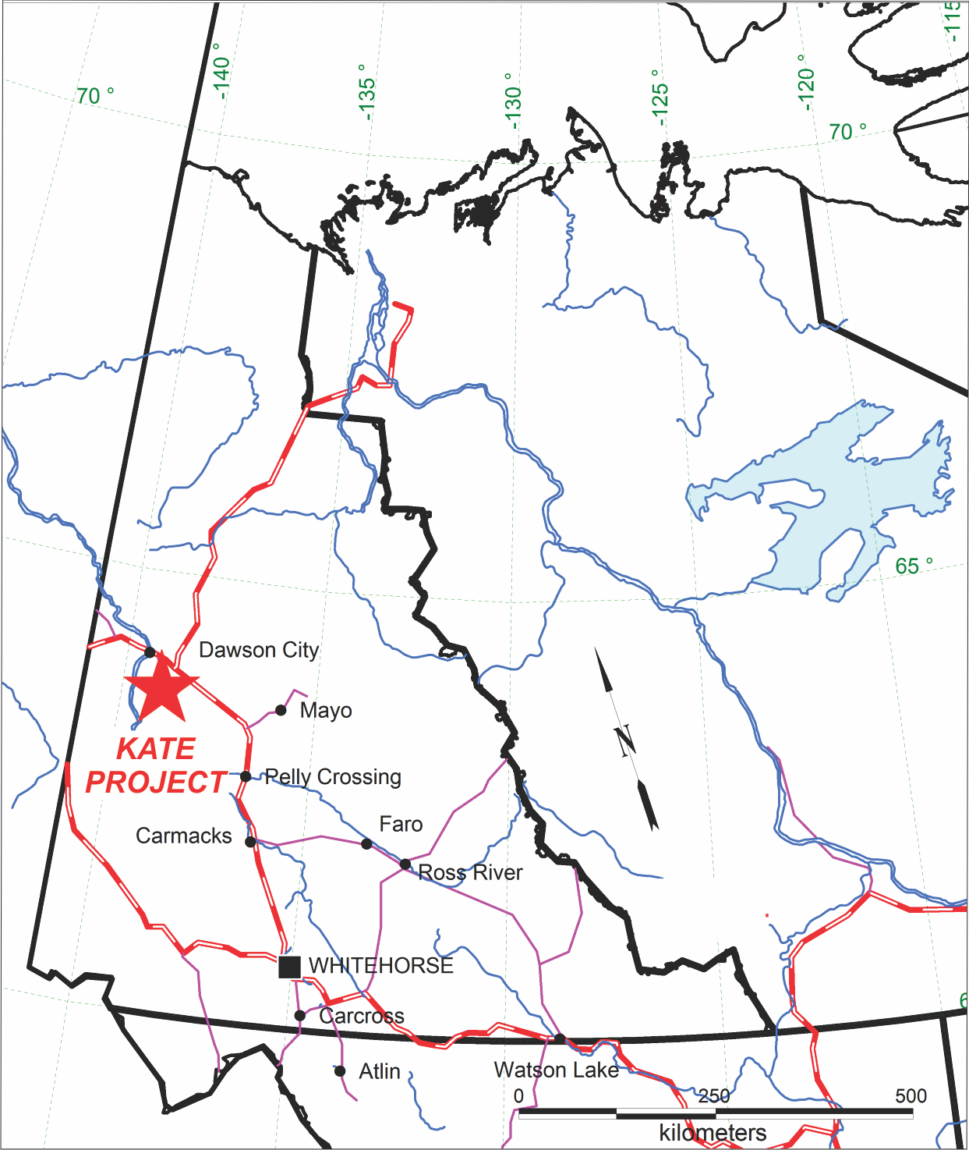

Figure 1: Yukon Location Map
Table 1: Kate Project – Quartz Claims Summary List
Grant Number | Tenure Type | Claim Name | Claim Number | Owner Name | Recorded Date | Expiry Date
YD93189-92 | Quartz | Eye | 1-4 | Tara Christie - 100% | 10/29/2010 | 10/28/2015
YD93159-80 | Quartz | Eye | 7-28 | Tara Christie - 100% | 10/21/2010 | 10/20/2015
YD93160 | Quartz | Eye | 8 | Tara Christie - 100% | 10/21/2010 | 10/20/2015
YD93181-87 | Quartz | Eye | 30-37 | Tara Christie - 100% | 10/29/2010 | 10/28/2015
YD93153-58 | Quartz | Eye | 39-44 | Tara Christie - 100% | 10/29/2010 | 10/28/2015
YD93195 | Quartz | Eye | 51 | Tara Christie - 100% | 10/29/2010 | 10/28/2015
YD62611-98 | Quartz | LNX | 1-78 | Tara Christie - 100% | 6/18/2010 | 12/15/2015
YD12101-02 | Quartz | LNX | 79-80 | Tara Christie - 100% | 10/8/2010 | 10/7/2016
YD93297-99 | Quartz | LNX | 81-83 | Tara Christie - 100% | 10/8/2010 | 10/7/2016
YD93101-110 | Quartz | LNX | 84-93 | Tara Christie - 100% | 10/8/2010 | 10/7/2016
YD12174-87 | Quartz | SB | 1-14 | Tara Christie - 100% | 10/8/2010 | 10/7/2016
YD12188-91 | Quartz | SB | 16-19 | Tara Christie - 100% | 10/8/2010 | 10/7/2016
YD12192-99 | Quartz | SB | 40-47 | Tara Christie - 100% | 10/8/2010 | 10/7/2016
YD93236-44 | Quartz | SB | 70-79 | Tara Christie - 100% | 10/8/2010 | 10/7/2016
YD93138-39 | Quartz | SB | 80-81 | Tara Christie - 100% | 10/8/2010 | 10/7/2016
YD12200 | Quartz | SB | 81 | Tara Christie - 100% | 10/8/2010 | 10/7/2016
YD93140-44 | Quartz | SB | 82-86 | Tara Christie - 100% | 10/8/2010 | 10/7/2016
YD93152 | Quartz | SB | 100 | Tara Christie - 100% | 10/29/2010 | 10/28/2015
YD93201-22 | Quartz | SD | 1-22 | Tara Christie - 100% | 10/8/2010 | 10/7/2015
YD93233-35 | Quartz | SD | 23-25 | Tara Christie - 100% | 10/8/2010 | 10/7/2015
YD93224-32 | Quartz | SD | 26-35 | Tara Christie - 100% | 10/8/2010 | 10/7/2016
YD93246 | Quartz | SD | 37 | Tara Christie - 100% | 10/8/2010 | 10/7/2015
YD93252-65 | Quartz | SD | 40-53 | Tara Christie - 100% | 10/8/2010 | 10/7/2015
YD93135-37 | Quartz | SD | 54-57 | Tara Christie - 100% | 10/8/2010 | 10/7/2015
YD93266-81 | Quartz | SD | 58-73 | Tara Christie - 100% | 10/8/2010 | 10/7/2015
YD93267 | Quartz | SD | 59 | Tara Christie - 100% | 10/8/2010 | 10/7/2015
YD93129-134 | Quartz | SD | 74-79 | Tara Christie - 100% | 10/29/2010 | 10/28/2015
YD93282-96 | Quartz | SD | 80-94 | Tara Christie - 100% | 10/8/2010 | 10/7/2015
YD93121-28 | Quartz | SD | 95-102 | Tara Christie - 100% | 10/29/2010 | 10/28/2015
YC98327-20 | Quartz | SD | 193-201 | Tara Christie - 100% | 10/29/2010 | 10/28/2016
YD12103-24 | Quartz | WJK | 1-22 | Tara Christie - 100% | 10/8/2010 | 10/7/2015
YD12161-71 | Quartz | WJK | 23-31 | Tara Christie - 100% | 10/8/2010 | 10/7/2016
YD12167 | Quartz | WJK | 32 | Tara Christie - 100% | 10/8/2010 | 10/7/2016
YD12173 | Quartz | WJK | 33 | Tara Christie - 100% | 10/8/2010 | 10/7/2016
YD12172 | Quartz | WJK | 34 | Tara Christie - 100% | 10/8/2010 | 10/7/2016
YD12166 | Quartz | WJK | 35 | Tara Christie - 100% | 10/8/2010 | 10/7/2016
YD93111-120 | Quartz | WJK | 36-45 | Tara Christie - 100% | 10/8/2010 | 10/7/2016
YC98311-13 | Quartz | WJK | 138-140 | Tara Christie - 100% | 10/29/2010 | 10/28/2016
YD93150-51 | Quartz | WJK | 141-142 | Tara Christie - 100% | 10/29/2010 | 10/28/2015
YD93301-2 | Quartz | WJK | 143-144 | Tara Christie - 100% | 10/29/2010 | 10/28/2015
YF47319-35 | Quartz | K | 1-17 | Tara Christie - 100% | 9/11/2015 | 9/11/2016

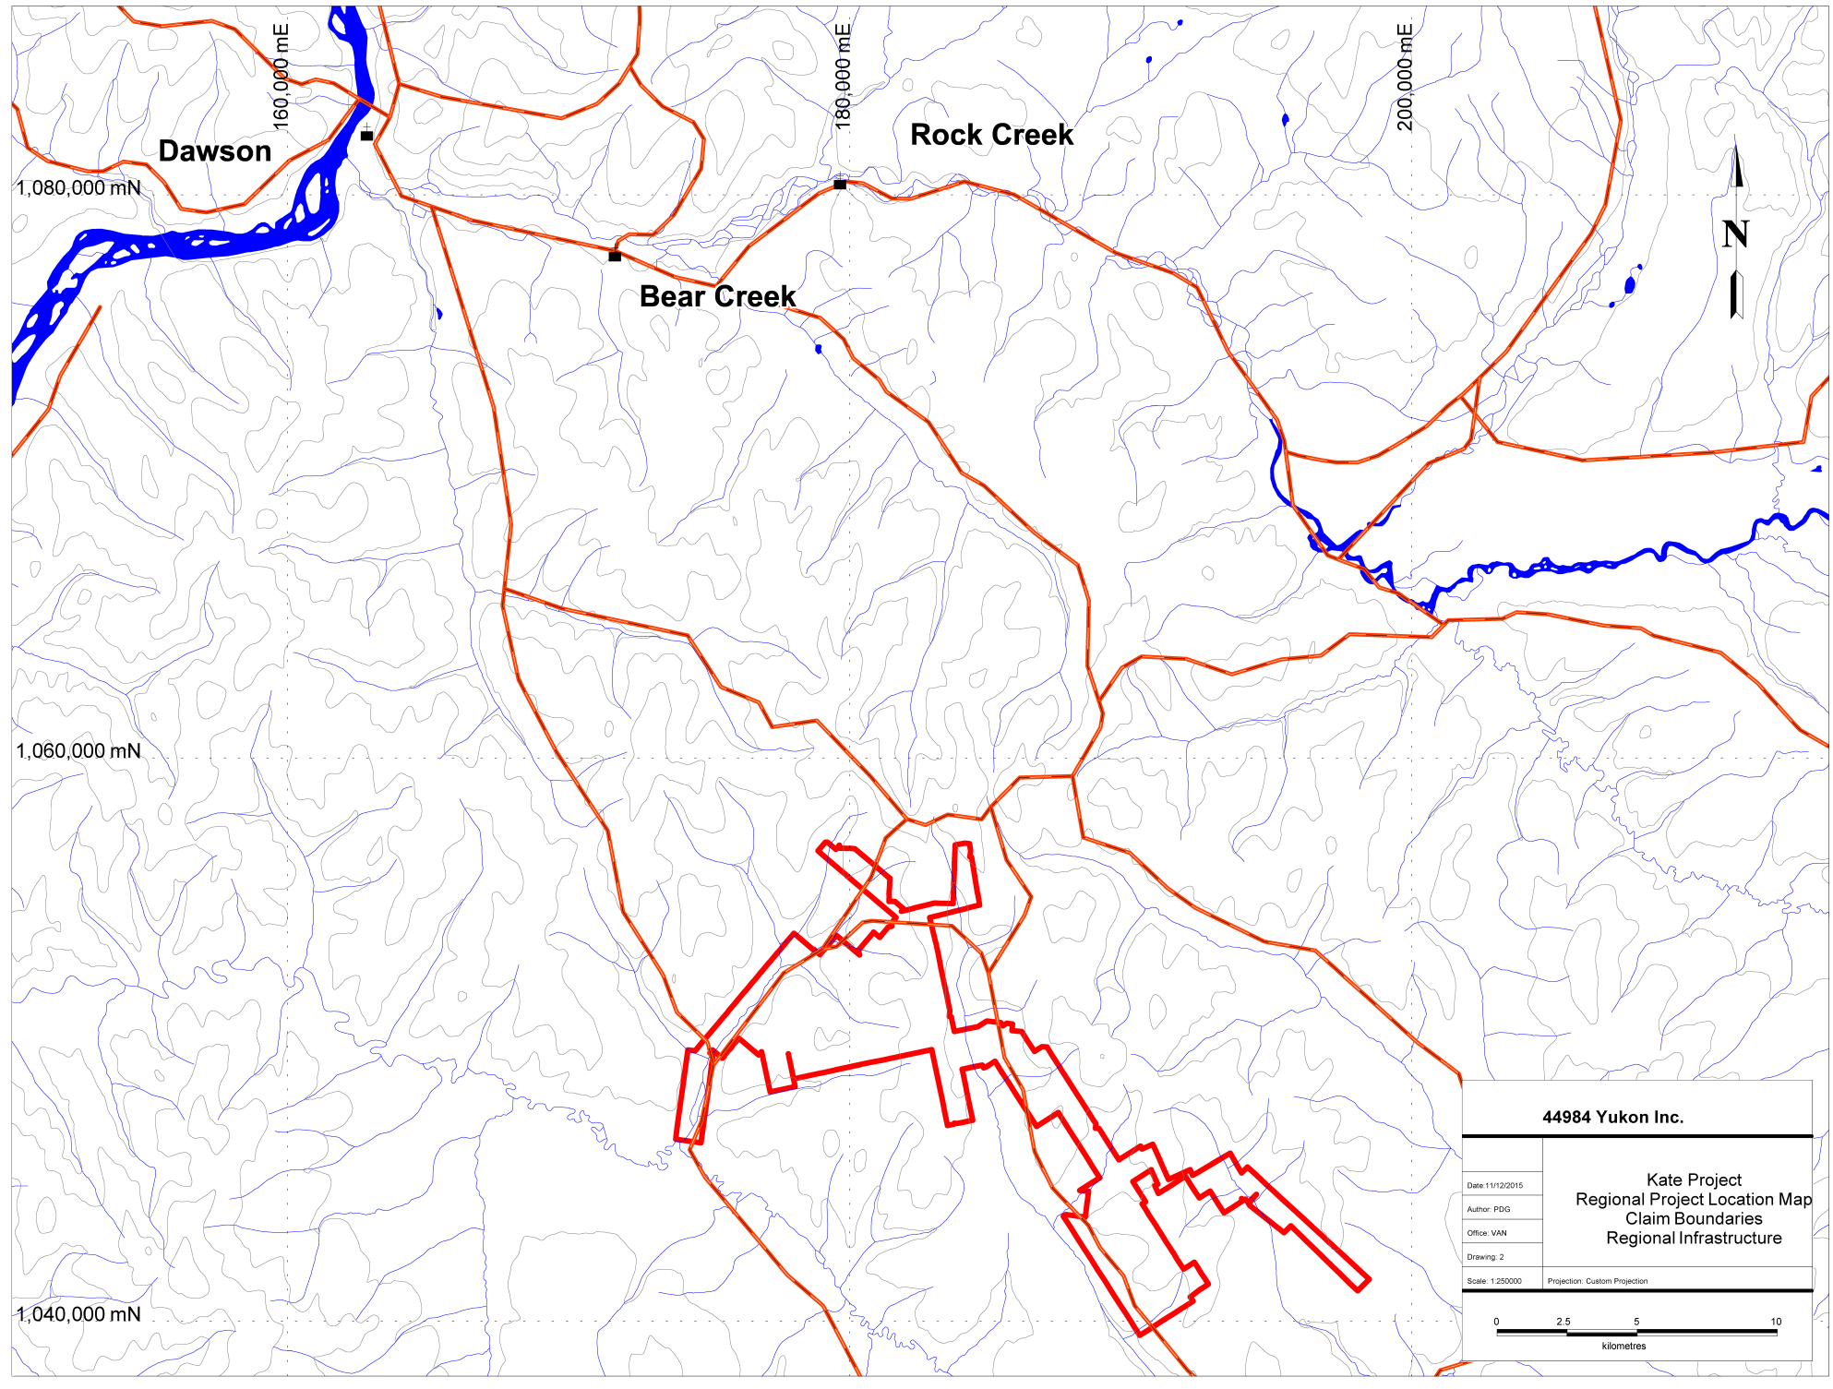

Figure 2: Kate Project Regional Location Map – Access and Claim Block Boundary

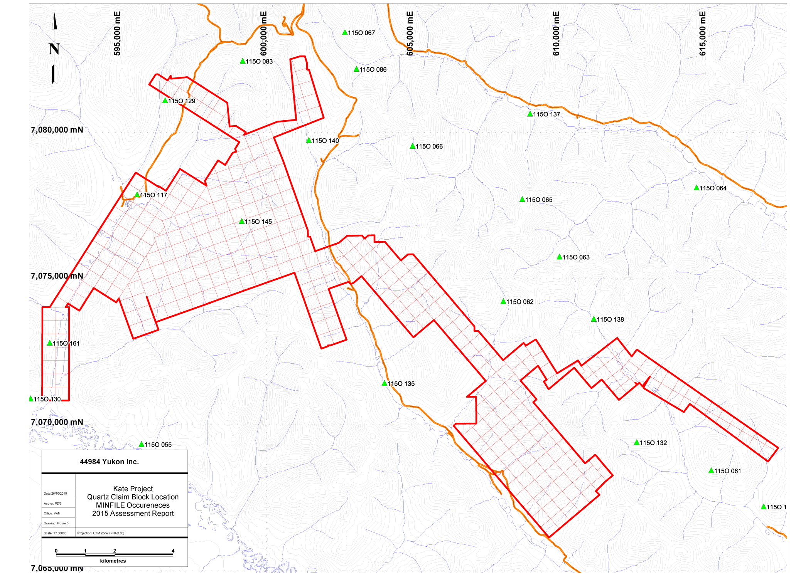

Figure 3: Kate Project Quartz Claim Map – MINFILE Occurrences
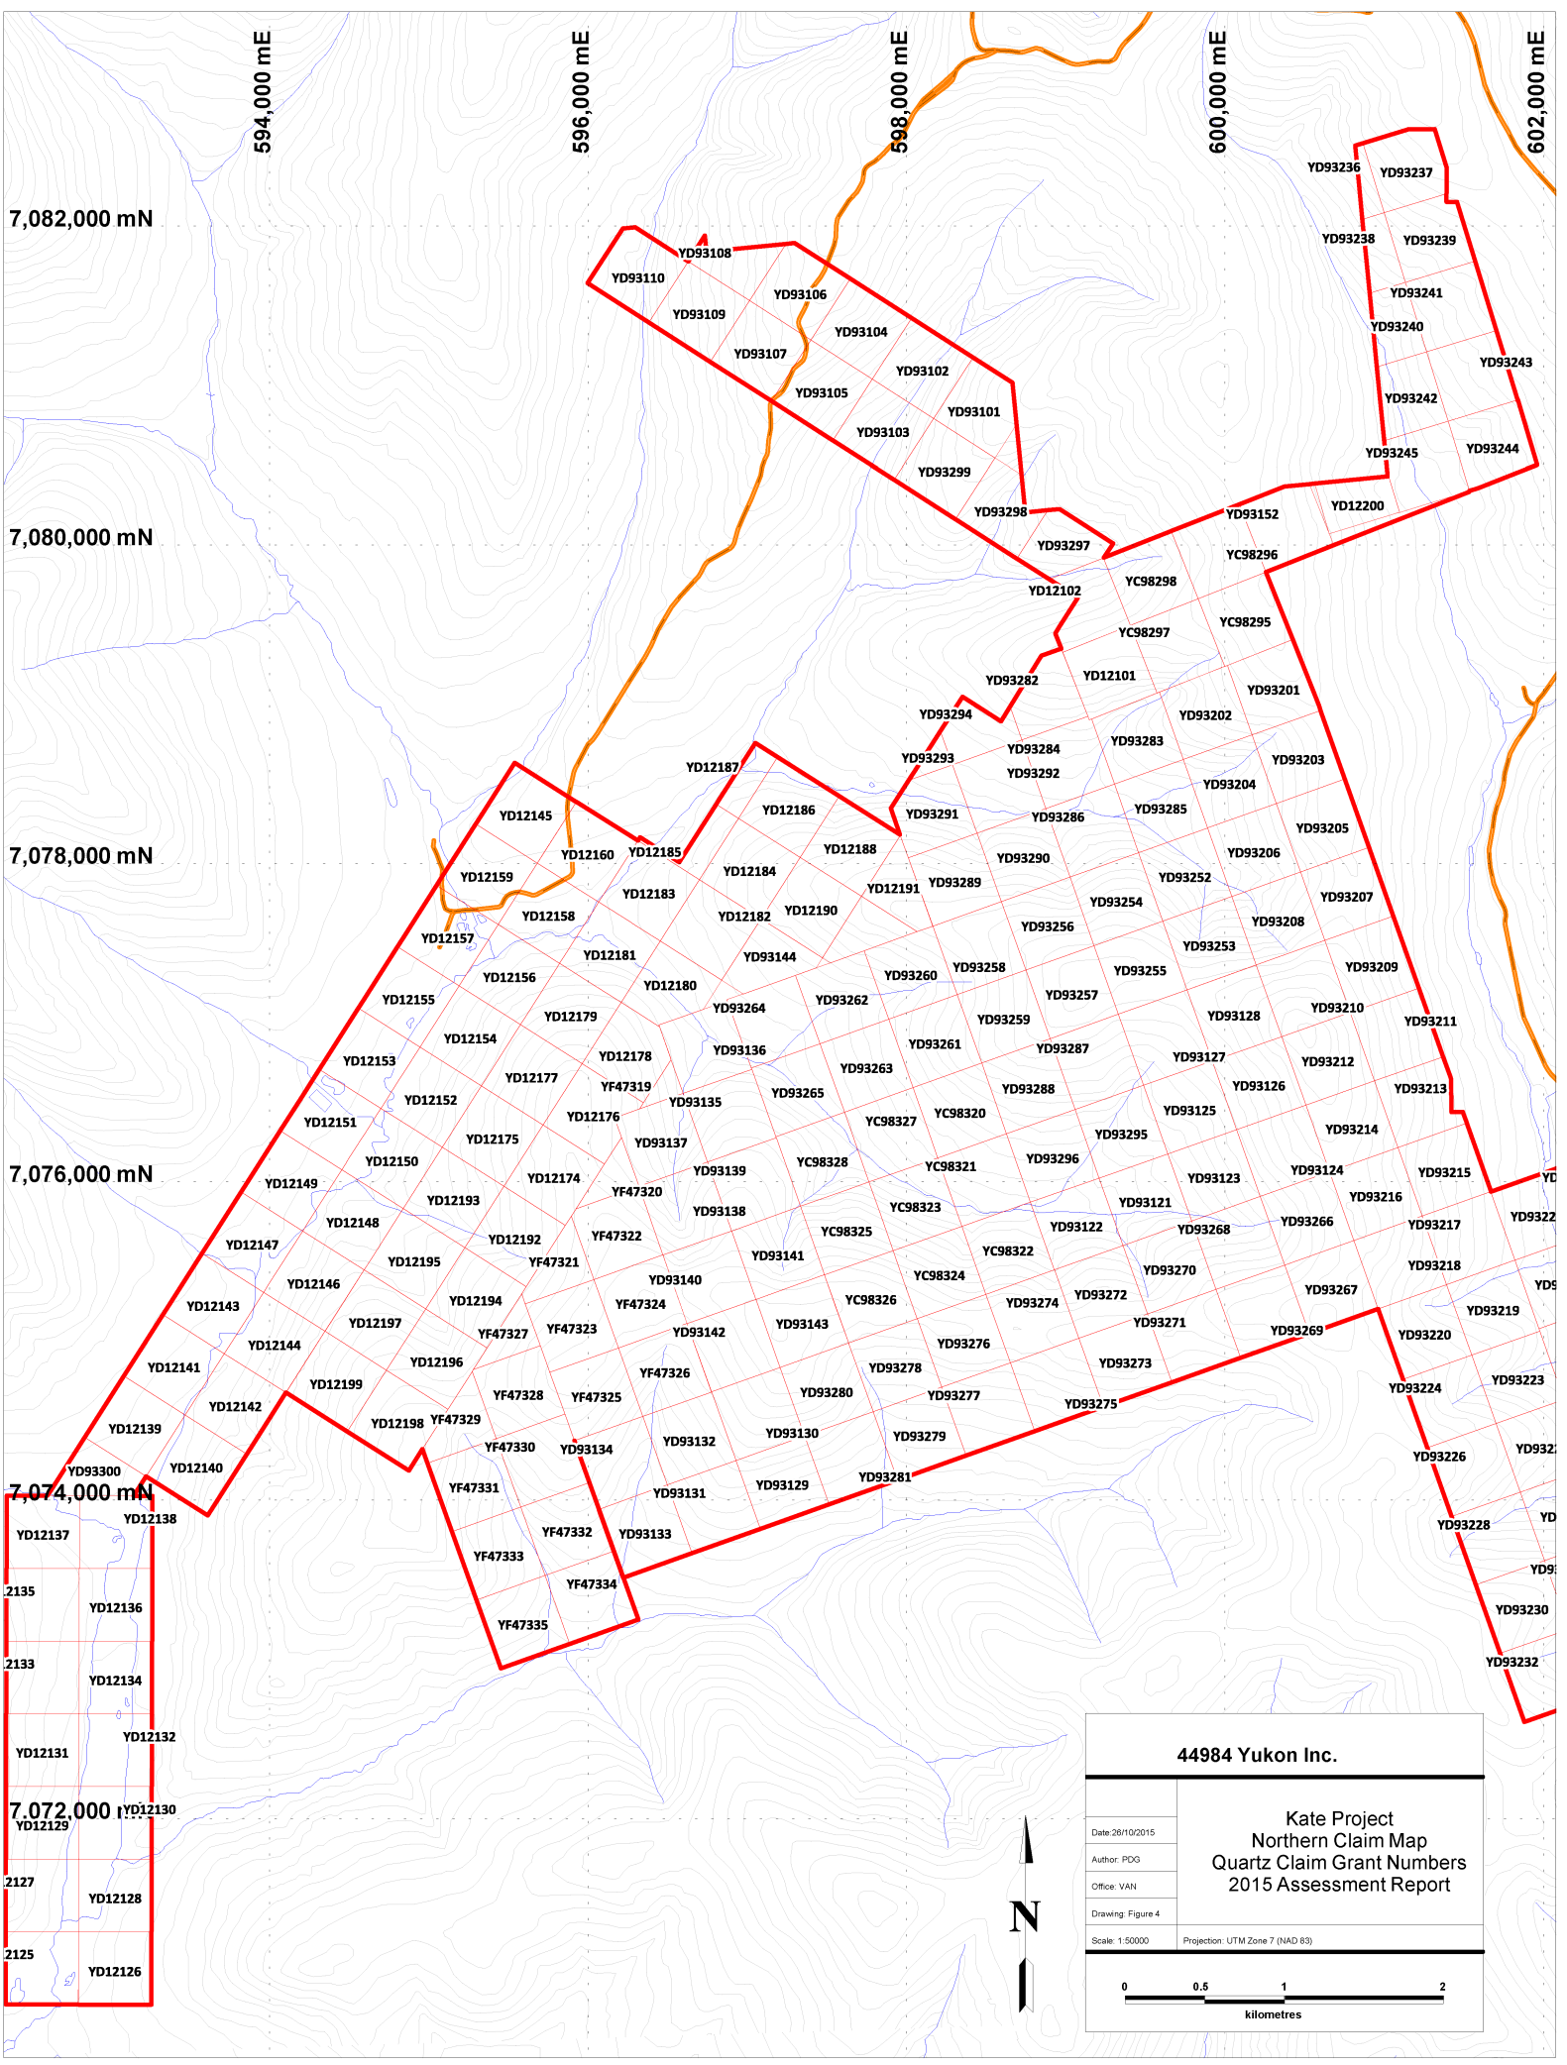

Figure 4: Tenure Map – North Sheet

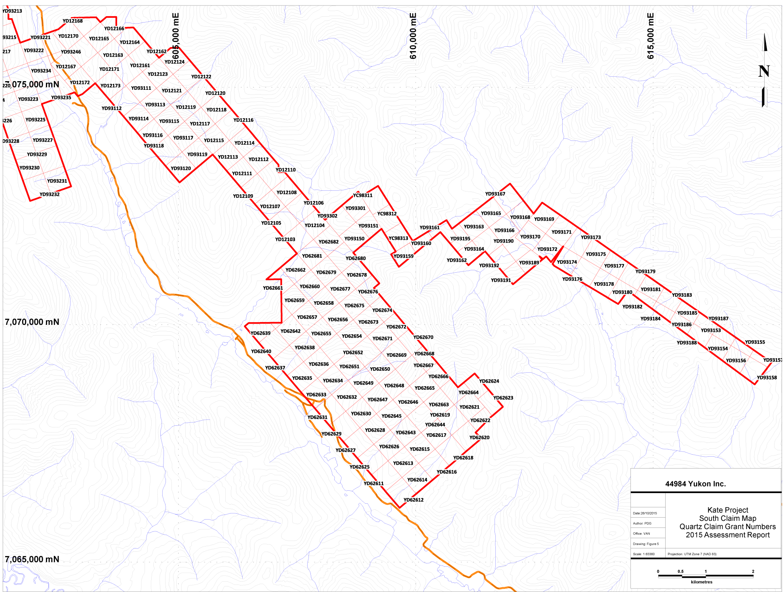

Figure 5: Tenure Map – South Sheet

ACCESSIBILITY, CLIMATE, LOCAL RESOURCES, INFRASTRUCTURE, PHYSIOGRAPHY

The Kate Project claims are easily accessed by the Bonanza and Hunker Roads, as well as portions of the Quartz and Sulphur Creek Roads (Figure 2) in the Klondike Gold Fields that lie approximately 50 km south of Dawson City, Yukon. Those claims that are immediately accessible via the well maintained network of existing roads are within a 1 hour drive from Dawson City. Dawson City itself is located approximately 500 km from Whitehorse, YT and is accessed via the well maintained, year-round paved, Klondike Highway. Bonanza and Hunker Creeks offer summer maintained graded gravel roads linking with Dawson City and the Klondike Highway, as well as the Dawson City airport; a full service airfield with regularly scheduled flights. Several smaller, gravel airstrips exist in the significant placer workings of the Eldorado and Indian River valley floors. Dawson City is the closest population centres and affords all facilities; hotels, restaurants, grocery/hardware stores, and fuel bunkers.
Several full service and fully supported exploration camps are located within the contemporary placer workings in the Indian River Drainage, and provide a more proximal, alternate to accommodations in Dawson City.
The Kate Property covers an area of modest to subtly rolling terrain, with elevations that range from approximately 450 metres ASL in the valley bottoms to 1,100 metres ASL on the ridgelines. In general, the area is covered by second growth spruce, poplar, birch and alder, with higher elevation ridges dominated by buckbrush (willow/birch).
The climate of the claim block, and region can be described as sub-arctic, with a low annual precipitation. The “summer”, or field workable portion of the season, begins in late May and lasts through mid-October annually. A few centimetres of snow fall is common in early October and can remain on the ground therefrom. Winter temperatures can fall to -40°C during the January through February period, however in the past decade winters in the region have ben milder than in previous years. Rainfall in summers is variable as some years can be excessively dry and others excessively wet. Water supplies are commonly available at valley bottoms,

HISTORY

The Kate project is comprised of 383 contiguous claims that were staked by Tara Christie from 2010 - 2015, and are 100% owned by Tara Christie. The claims were staked to cover under-explored areas in the Klondike that were interpreted to have the potential to host precious metals mineralization given the prevalence of placer gold in the surrounding (downstream) drainages. Additionally, publicly available geophysical and geologic information from neighboring mineral exploration work (including MINFILE reports, and more recent work by Klondike Star, J. Christie and B. Kreft) identified the area as prospective. The resultant Kate Claim Block forms an unusual overall outline due to the prevalence of historic quartz claim blocks in the area (i.e. on Hunker Dome and Gold Run Creek) combined with the fact land acquisition via staking was complicated by coeval staking from other parties.
The Klondike District is renowned for its mineral endowment, particularly within the prolific placer creeks in the area, and has been prospected, explored and exploited by individuals and companies since the late 1800’s. As such, there exist 30 proximal and germane MINFILE occurrences listed in Table 1 and shown in Figure 3. The majority of these MINFILE occurrences are described as Vein-Au-Quartz and there are only a few drilled prospects. No drilled prospects or MINFILE occurrences exist within the Kate Claim Block.
There have been several periods of focused hardrock mineral exploration in the area since the late 1800’s and specifically since 2010, there has been continuous grassroots to advanced exploration on much of the adjoining claim blocks owned by other parties, particularly those owned or under option by, Klondike Gold (“KG”), Kestrel Resources (“KES”) (claims optioned from Bernie Kreft), Taku Gold Corp (“TG”) and Pacific Ridge Resources (“PR”) - claims optioned from Shawn Ryan, and the property optioned by Centerra Gold for the 2014 season.
In addition to the recent work by the exploration companies listed above, the Yukon Gold Project, led by the Mineral Deposit Research Unit (“MDRU”) of the University of British Columbia joined with industry partners to undertake a large-scale study of the Region beginning in 2012. This study targeted the poorly understood geology of the west-central Yukon in relation to mineralization styles, particularly in the White Gold Area, where exploration successes by Underworld Resources on the White Gold Property and Kaminak Gold Corporation on their Coffee Project have led to a new understanding of the genesis of mineralization in this region of the Yukon.
The MDRU report is focused on new geological information that was garnered from the period of intense exploration from 2010 to 2012 and concentrated on the evolution of these recently discovered gold deposits. In summary of this study’s findings, gold-bearing orogenic veins in the Klondike and White Gold Areas of west-central Yukon have been shown to be Jurassic in age (Figure 6 and Table 3) and host rock compositions are referenced as important controls on the metal associations. In the Klondike Schist, the mineralization is thought to be low grade VMS style with typical Au- AS-Pb+/- Cu-Zn signatures.

Table 2: MINFILE occurrences near Kate Claim Block
MINFILE number |  | Name | Description | Status | Main Commodity
115O | 60 | BURNHAM |  | Anomaly
115O | 61 | PAYNE (AIME,KENTUCKY LODE) | Vein Au-Quartz | Prospect
115O | 92 | GRANVILLE |  | Unknown
115O | 132 | DEVINE (KENTUCKY LODE) | Vein Au-Quartz | Prospect
115O | 133 | SULPHUR |  | Drilled Prospect
115O | 134 | CARON | Vein Au-Quartz | Drilled Prospect | Gold Silver
115O | 62 | BRIMSTONE |  | Unknown
115O | 63 | GOLD RUN |  | Prospect
115O | 64 | PORTLAND | Vein Au-Quartz | Prospect
115O | 65 | DOMINION (PATTERSON, QUEEN DOME) | Vein Au-Quartz | Showing
115O | 66 | LLOYD | Vein Au-Quartz | Prospect
115O | 67 | HUNKER DOME (DOME LODE) | Vein Au-Quartz | Prospect
115O | 68 | MITCHELL | Vein Au-Quartz | Drilled Prospect | AG, Au, Cu, Pb, Zn
115O | 83 | GREENBACK |  | Anomaly
115O | 86 | GOLDEN ROD |  | Unknown
115O | 117 | BLANCE |  | Unknown
115O | 125 | MELBA |  | Anomaly
115O | 129 | SCHRAMM |  | Drilled Prospect
115O | 135 | SULPHUR |  | Drilled Prospect
115O | 136 | GATENBY |  | Drilled Prospect
115O | 137 | DOM |  | Prospect
115O | 138 | COWAN |  | Prospect
115O | 140 | BRADY |  | Drilled Prospect
115O | 145 | BLUE SKY |  | Unknown

Figure 6: Distribution of age determinations for mineralization at White Gold and the Klondike, in reference to crystalline ages of post-metamorphic magmatic units in the Yukon Tanana Terrane. From Allan, et al., 2012.

Table 3: Documented characteristics of selected orogenic lode systems in the west-central
Yukon. (Note: MINFILE 066 Lloyd is near the claim block). From Allan, et al., 2012.

In the Klondike region, the Klondike Schist is noted to have regional variations in composition, with orogenic enrichment of the metals/elements of: Au, As, Pb, Cu, Hg, and Ag as highlighted in Table 3 above. The mineralization and alteration are pyritic, and ferroan, carbonate and quartz associations are common. Moreover, pyrite, arsenopyrite, galena, tetrahedrite, are predominantly associated with occurrences of gold mineralizationo. The mineralization in the Klondike is structurally controlled, and Allan et al. (2012) suggest that the reactive rock units, inclusive of the magnetite bearing mafic Klondike Schist, may control gold mineralization in the district via sulphidation.
Gold bearing vein orientations in the area are interpreted to trend along three main directions; North, 120° and 90°, indicating N-S, E-W and SE structures have been mineralized. Allan, et al. (2012) mapped portions of the interpreted fault structures inferred to be related to Jurassic orogenic gold mineralization from the White Gold and Klondike (shown overlain on a regional magnetic survey compilation) and their observations collaborated similar EW structures had not been found in the Klondike region.

REGIONAL GEOLOGY AND MINERALIZATION

Regional Geology

YUKON-TANANA TERRANE

The Bonanza-Eldorado-Hunker region is dominated by the Devonian-Mississippian Klondike Schist, member of the Yukon-Tanana Terrane, a macro-geological terrane which extends from east from Alaska to the southern Yukon and into British Columbia. The Yukon-Tanana Terrane include lithologies of continental affinity which are in turn overlain by volcanic arc assemblages; including back-arc and island arc formations (e.g: Colpron, 2001; Piercey et al., 1999; Murphy, 2004).
The Klondike Schist and its associated terrane members have been tectonically deformed over multiple periods and therefore are characterized by a range of metamorphic grades from lower greenschist to amphibolite facies on a Regional Scale (e.g., Mortensen et al., 1992; Roots et al., 2003). These polydeformed lithologies have been intruded by Mississippian to Permian aged granitoids (e.g., Nelson et al., 2000, Liverton et al., 2005). Mortensen et al. (1992) and D’El-Rey Silva et al. (2001) present detailed structural analyses that indicate the terrane is consistent with protracted deformation during a continuous east-northeast directed accretion and resultant crustal shortening (Liverton, 2011).
The Yukon-Tanana Terrane is preserved along this paleo-accretionary wedge in a series of fault-bounded fragments which extend from southern B.C. to Alaska (Nelson and Friedman, 2004; Dusel-Bacon et al., 2004) representing a remnant continental margin within which the later Paleozoic volcanic assemblages were emplaced. Nelson and Friedman (2004) postulate the Yukon-Tanana Terrane represents the basement for the Quesnellia Terrane which was, at that time, sutured to Yukon-Tanana.

Yukon-Tanana Structure

Within the Klondike and the Yukon-Tanana Terrane similar styles of deformation including F1 folding which has been rearranged from original bedding into alignment with axial planar foliation, the result of which is that F1 fold hinges are rarely exposed. It was during this period of ductile that the lithologies were metamorphosed to chlorite-biotite facies (and more rarely, to amphibolite facies grades). F2 folds have been defined as isoclinal, predominantly E to NE vergent. In the Klondike, third folding F3 produced open folds over the district and this deformation is pervasive at outcrop scales (Liverton, 2011).
The Klondike region is underlain by three thrust fault bounded assemblages that make up the mid Permian Klondike Schist (Rushton et al., 1993).
- Assemblage III – a carbonaceous quartz-muscovite phyllites, schists and marbles
- Assemblage II – a micaceous and chloritic quartzite, feldspathic quartzite, marble and calcareous schists which is intruded by the Mt. Burnham orthogneiss.
- Assemblage I – complex assortment of:
  - Quartz augen schists
  - The Sulphur Creek orthogneiss
  - Chloritic schists, metagabbros, amphibolites, quartzites and felsic schists.

Figure 7: Simplified Regional Geology. (from Allan, et al, 2012)

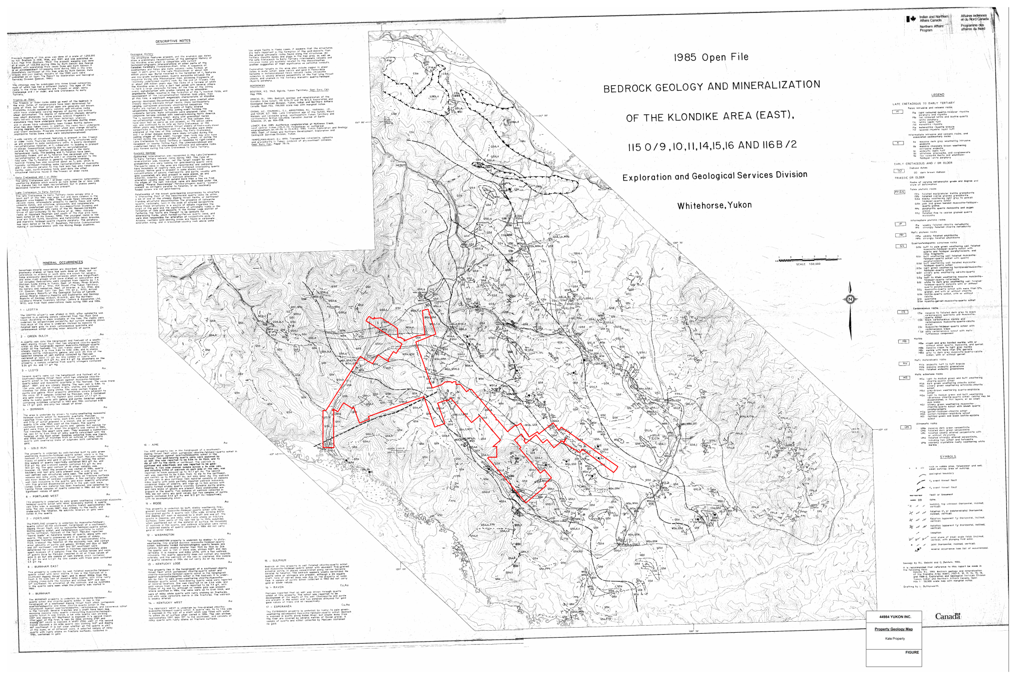

Figure 8: Regional Geology – modified from Open File 1985-1 – Kate Claim Boundary Shown

PROPERTY GEOLOGY AND MINERALIZATION

Geology

Regional mapping by Debicki, Mortensen, Mackenzie and others shows that the general area of the Kate mineral claim block is underlain by Late Permian, Klondike Schist with portions of the Sulphur Creek orthogniess nearby. Bedrock exposure is sparse to non-existent in the area where the Kate Mineral Claims were worked in 2015. That stated, subcrop and float exposures are in general agreement with the YGS mapping of the claim area. In summary, it can be stated the property is underlain by chlorite schist of the Carboniferous to Permian Klondike Schist with a relatively shallow dipping foliation.
Where exposure exists in the area, the Klondike Schist shows a well-developed L-S tectonite characterized by a combination of linear (“L”) and planar (“S”) fabrics. Workers have attributed four distinct phases of deformation (D1-D4) to progressive fabric development within the Schist, however not all the deformation phases are seen within thte lithological package. Generally, resultant fold styles are lithologically controlled (Liverton, 2011). Each of these phases of deformation is further described below:

- D1 - Ductile Phase with isoclinal folds.

- D2/S2 – Kilometre-Scale macroscopic antiformal structures.

- D3 – Tight folds of S2 with a prominent NW trend.

- D4 - Conjugate angular kink folds of the penetrative foliation.

Klondike Quartz Vein Systems

Rushton et al. (1993) presents two types of quartz veins in the Klondike District, and by extension, the Kate Claim Block:
- foliaform veins - metres thick, concordant with transposed bedding predominatly lenticular – no gold mineralization
- discordant veins – Gold bearing, sub metre thick, continuous along strike sulphide mineralization (pyrite, minor galena, chalcopyrite and tetrahedrites)

According to YGS mapping The Kate Project is underlain by units of felsic schists of the Klondike Schist, as well as sections of the Sulphur Creek Orthogneiss package.

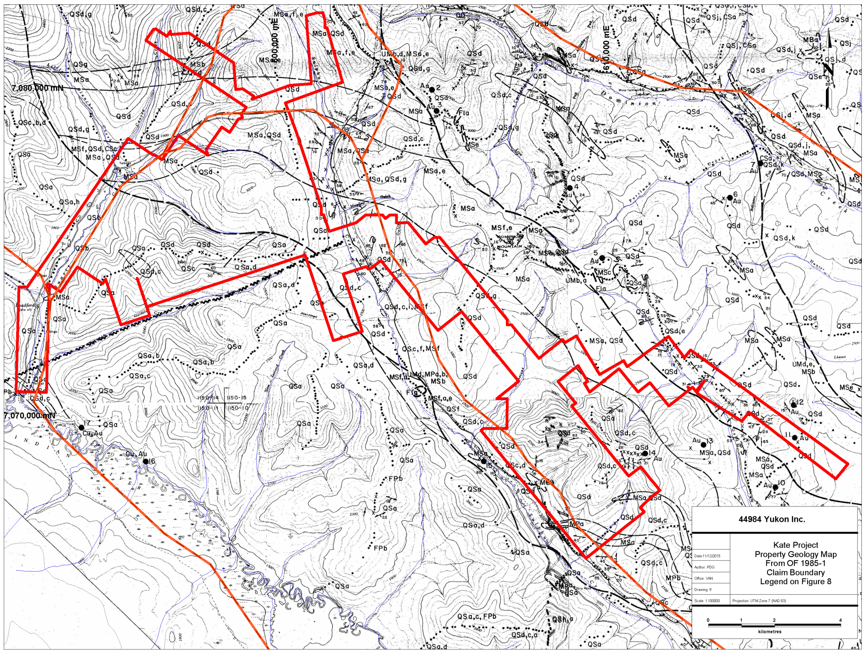

Figure 9: Property Geology – from OF 1985-1; Legend on Figure 8

2015 EXPLORATION PROGRAM

Summary

In July 2015 44984 Yukon Inc. conducted a focused regional mineral exploration program on the Kate Project in two phases, Phase I from July 10 – July 19 and Phase II from August 28 – September 6, 2015, for a total of 66 man-days on the Project.

The 2015 Kate mineral exploration project consisted of a ridge and spur reconnaissance-type geochemical surveys combined with prospecting and geologic mapping. The primary focus of the exploration program was soils geochemistry (via complete XRF and threshold chemical analyses) and based on the anomalous As-in-soil results of the Phase I reconnaissance survey, detailed geochemical surveys and total magnetic intensity geophysical surveys were carried out over targeted areas during the Phase II program.

The XRF system proved an excellent tool to identify geochemically anomalies and resulted in the identification of five (5) high priority anomalous zones: Mack South, Mack North, Ridge Road, Sulphur Creek, and LNX.

Based on the anomalous As-in-soil results of the reconnaissance survey, follow-up detailed geochemical surveys and total magnetic intensity (TMI) geophysical surveys were carried out. The culminating efforts of the geochemical surveys have resulted in the identification of five (5) distinct geochemically anomalous zones: Mack South, Mack North, Ridge Road, Friday Gulch, and LNX. The TMI surveys cover a very small area in the Mack South and Mack North Zones.

Figure 10 highlights the location of the following detailed Anomalous Zones:

A total of 951 soil samples were collected and analyzed by XRF instrumentation during the 2015 exploration program. Locations of the soil sample stations were determined by GPS and are shown in Figures 11 and listed in Appendix 4.

Of the 951 soils collected and XRF analyzed, 103 were selected for chemical analyses by ICP and Fire Assay for gold. The soil samples selected for chemical assay were based upon threshold As and related Au pathfinder elemental XRF Results and general location (proximity to anomalously reported XRF results); analysis of the chemical assay vs. XRF assay proved a direct correlation and have bolstered the usage of XRF Instrumentation with all go-forward mineral exploration on the Kate Claim. In addition, 46 rocks collected during the property reconnaissance sampling were selected for chemical analysis. Appendices 4, 5 and 6 present the XRF and chemical analytical data in raw form for soils and rocks respectively; Appendix 8 presents photographs and notes of collected rock samples, and Appendix 9 presents the analysis certificates.

8.1.1 Mack South
Mack South geochemical anomaly is located on a ridge just south of the confluence of Mack and Quartz Creeks. The Mack South Zone is delineated by an As-in-soil anomaly as well as Pb, Zn, and Cu-in-soil anomalies (Figures 12, 13, 14, 15). Au-in-soil appears to have excellent correlation with the Pb/Zn/Cu-in-soil anomalies (Figures 16, 17, 18). The As-in-soil anomaly does not appear to correlate with the Au-in-soil anomalies (Figure 19). The multi-element-in-soil anomaly is open in all directions. The dimensions of the Mack South geochemical anomaly is approximately 2km (NW-SE) by 1km (SW-NE). The Mac South geochemical anomaly is coincident with two 2015 ground magnetic survey intensity highs and corresponds well to magnetic intensity linears from the same survey (Figure 27).

8.1.2 Mack North
Mack North geochemical anomaly is located on a ridge just east of the confluence of Mack and Quartz Creeks. The Mack North Zone is delineated by an As-in-soil anomaly as well as Pb-in-soil anomalies (Figures 12 and 13). The soil anomaly is open to the north and south. The dimensions of the Mack North geochemical anomaly are approximately 1.2km (E-W) by 0.175km (N-S). The geochemical anomalies are coincident with a magnetic intensity linears (Figure 27).

8.1.3 Ridge Road
Ridge Road geochemical anomaly is located on the Quart Creek road just south from the Quart Creek / Bonanza Road junction. The Ridge Road Zone is delineated by an As-in-soil (Figures 20). The soil anomaly is bounded by the property boundaries. The Ridge Road geochemical anomaly is part of a larger geochemical trend that covers Klondike Gold, 44984 Yukon Inc. and Shawn Ryan properties.

8.1.4 Friday Gulch
Friday Gulch Zone is located on the east and west slopes of Sulphur Creek road north and south of the confluence of Sulphur Creek and Friday Gulch. The Friday Gulch Zone is identified by As, Pb and Zn-in-soil anomalies (Figures 21, 22 and 23) There is currently insufficient data to delineate a trend to the three different soil anomalies in this zone.

8.1.5 LNX
LNX geochemical anomaly is located on two ridges on the east side of Sulphur Creek just southeast of the confluence of Sulphur and Brimstone Creeks. The LNX Zone is delineated by an As-in-soil anomaly (Figure 24). The soil anomalies have not been sufficiently followed up to determine the size and trend to this zone.

8.2 Soil Survey
A total of 951 soil samples were collected during the 2015 exploration program. Locations of the soil sample stations were determined by GPS and are shown in Figures 11 and listed in Appendix X. Samples were taken from the B/C horizon and were taken from depths between 10 and 60 cm and placed in a labelled KRAFT bag with a sample tag. All samples collected were analyzed using a portable XRF (Olympus Innov-X Delta Premium XRF). Soil samples were dried and transferred into a thin plastic bag (Glad Sandwich Bag) and placed into the XRF work station and analyzed under a 3 beam SOIL setting of 30:30:30. Soil locations and XRF results can be found in Appendix 4.

Statistical values for As, Pb, Zn and Cu are presented in Table 4. Background concentrations as well as weak and strong anomaly concentration cutoffs were established using box plots. Defining Q1 and Q3 to be the first and third quartile and IQR to be the interquartile range (Q3 – Q1), the background concentration cutoff is defined as: Background < Q3 + (1.5*IQR); A strong anomaly is defined as: Strong anomaly > Q3 + (3*IQR). A weak anomaly is defined as greater than the background but less than a strong anomaly.

Table 4: Kate Property: XRF Statistical values for As, Pb, Zn, and Cu
 | As (ppm) | Pb (ppm) | Zn (ppm) | Cu (ppm)
Min | <5 | <5 | 14.3 | <10
Max | 656 | 857 | 429 | 133
Average | 21.9 | 19.4 | 68.8 | 22.5
Median | 10.4 | 11.4 | 60 | 21
Q1 | 6.25 | 9.1 | 50.3 | 15
Q3 | 22.75 | 15.4 | 74 | 28
IQR | 16.5 | 6.3 | 23.7 | 13
Background | 47.5 | 24.85 | 109.55 | 47.5
S. Anomaly | 72.25 | 34.3 | 145.1 | 67
50 perc | 10.4 | 11.4 | 60 | 21
60 perc | 13.8 | 12.5 | 64 | 23
70 perc | 19.3 | 14.2 | 71 | 26
80 perc | 27.4 | 17.4 | 80 | 29
90 perc | 49 | 30.1 | 100 | 35
95 perc | 68.55 | 54.5 | 134 | 41

One-hundred-three (103) anomalous metal-in-soil samples identified in the XRF analysis were selected for commercial laboratory analysis (Acme Labs). Samples received by the commercial lab were dried at 60ºC and 100g were sieved with an 80mesh (0.180mm). From the sieved fraction 0.5 grams and 30 grams were digested in separate aqua regia solutions and analyzed with by ICP-ES (for multi-element / AQ300) and ICP-MS (for gold / AQ130). Twenty-two (22) samples returned Au concentrations >20ppb with a maximum of 345.7 ppb Au. The certificate of analyses can be found in Appendix 9.
There was a good linear correlation between commercial lab (y-axis) and XRF (x-axis) results for elements: arsenic (slope = 1.5213, R² = 0.9430), lead (slope = 1.991, R² = 0.8782), zinc (slope = 1.088, R² = 0.8546), copper (slope = 1.3901, R² = 0.7209), and manganese (slope = 0.8536, R² = 0.7574); see Tables 5 – 8.

8.3 Prospecting
Outcropping exposure on the Kate property is limited. There were three common types of subcrop/float identified on the Kate property during the 2015 Property work program (quartz, bronze/buff weathered muscovite-feldspar-quartz schist and green quartz-chlorite schist). Forty-six (46) rock samples (float and subcrop) were collected during the course of the 2015 Kate exploration program. Locations, descriptions and photos of all samples collected can be found in Appendices 5 and 8. Samples collected from the Mack Zone are described in more detail in section and 8.3.1 and within Table 9.

Table 5: Kate Property: XRF v. Chemical Assay Pb

Table 6: Kate Property: XRF v. Chemical Assay Zn

Table 7: Kate Property: XRF v. Chemical Assay Cu

Table 8: Kate Property: XRF v. Chemical Assay As

8.3.1 Mack Zone
Thirty-five rock samples were collected from the Mack Zone (Figure 25). No samples were anomalous in gold, however, a number of samples were anomalous in As, Pb and Zn. Four samples collected from the Mack South area (KR3, 4, 9 and 10) returned As-in-rock anomalies that could explain the As-in-soil anomalies found on Figure 25 - Inset. Three samples collected from the Mack South area (KR10, 15 and 18) have returned Pb-in-rock anomalies that could explain the Pb-in-soil anomalies found on Figure 16. No samples collected, to-date, in the Mack South Zone can explain the Au-in-soil anomaly.

Table 9: Select Rock samples collected from Kate Summary Table
Sample Name | Description | As (ppm) | Pb (ppm) | Zn (ppm) | Cu (ppm) | Au (ppb)
1566251 | Quartz-Chlorite Schist: Abundant magnetite and pyrite | 17 | 73 | 178 | 38 | 14.9
1566252 | Quartz-Chlorite Schist: Abundant magnetite and pyrite | 4 | 91 | 132 | 19 | 7.9
KR3 | Quartz and Quartz-Muscovite Schist: Pervasive Oxidation (Moderately) | 510 | 24 | 23 | 5 | 35.9
KR4 | Quartz-Muscovite Schist: Pervasive Oxidation (Moderately), Pervasive Silicification (Strong) | 748 | <3 | 14 | 3 | 2.7
KR9 | Quartz: Discrete Oxidation (Strong along fractures and in cavities) | 429 | 34 | 6 | 4 | 6.3
KR10 | Quartz: Discrete Oxidation (Strong along fractures and in cavities) | 116 | 106 | 48 | 7 | 4.3
KR15 | Quartz-Muscovite Schist: Pervasive Oxidation (weak), Pervasive Silicification (weak) | 17 | 113 | 64 | 33 | 1.1
KR18 | Quartz: Discrete Oxidation (Strong along fractures and in cavities) | 21 | 575 | 2 | 2 | 6.3

8.4 Ground-Mag Geophysical Survey

A ground magnetic survey was carried out in the Mack Zone of the Kate property. The ground survey was carried out over the Mack Zone to resolve smaller magnetic variations that the airborne magnetic survey carried in 2000 (GSC Open File 3992) could not resolve. The airborne survey was carried out with an average traverse line spacing of 500m with control line flown at 3.5km intervals. The helicopter flight height was maintained at an average ground clearance of 120m. The traverse lines were roughly NE-SW. The residual magnetic field for the magnetic airborne survey is shown in Figure 26 with the Kate claim outline shown.

Figure 27 shows the Mack Zone with residual total magnetic field from the airborne survey (Figure 27a) and the residual total magnetic field from the ground survey carried out during the 2015 field season overlain on the residual total magnetic field from the airborne survey (Figure 27b). From comparison of Figure 27a and 27b we can see that the ground survey has identified a magnetic anomaly between flight-path lines (Mack South Zone) and that there are magnetic linear features that are only detectable in the detailed ground mag surveys.

Statistical values for the residual magnetic field are presented in Table 10. Magnetic high and low anomalies were defined as those values more than the 90th percentile and less than 10th percentile, respectively.

Table 10: Kate Property: Residual Magnetic Field Statistics
 | RMF (nT)
Min | -59.95
Max | 183.86
Average | 93.22
5 perc | 60.48
10 perc | 65.17
Q1 / 25 perc | 74.73
Q2 / 50 perc | 95.41
Q3 / 75 perc | 110.57
90 perc | 118.66
95 perc | 126.19
IQR | 35.86

Grid Information

Two magnetic total field surveys were carried out in the Mack Zone. In the Mack South Zone 8.367 line km’s were collected with an average station spacing of 12.5m. Line spacing is 100m with control lines spaced at 200m. There were 715 individual station readings covering an area of 1.252km2. In the Mack North Zone 7.758 line km’s were collected with and average station spacing of 12.5m. Line spacing varied between 100m and 200m. There were 596 individual station readings covering an area of 1.466km2.

Survey Parameters and Instrumentation

The magnetic survey utilized a stationary base unit to record the magnetic field to allow for the removal of the diurnal variation in the measured data. The base station recorded data at 3 second intervals. The mobile units recorded the total magnetic field every 12.5m alone the grid line traverses. Calibration measurements were taken by the mobile units at the start and end of each day to account for level shifts between the different instruments and to get a sense of the error in the data. The physical location of the base station and the calibration station are 594859E/7068432N and 594840E/7068430N, respectively.

Geophysical Techniques – Magnetic Survey Method

Magnetic intensity measurements are taken along survey traverses and are used to identify metallic mineralization related to magnetic material in the ground (e.g., magnetite and/or pyrrhotite). Magnetic data are also used as a mapping tool to distinguish rock types and to identify faults, bedding, structure and alteration zones. Line and station intervals are usually determined by the size and depth of the exploration targets.

The magnetic field has both amplitude and direction. The most common technique used in mineral exploration is to measure just the amplitude component using an overhauser magnetometer. The instrument digitally records the survey line, station, total magnetic field and time of day at each station. After each day of surveying, data are downloaded to a computer for archiving and further processing.
The earth’s magnetic field is continually changing (diurnal variations) so field measurements are calibrated to these variations. The most accurate technique is to establish a stationary base station magnetometer to continually monitor and record the magnetic field over the course of a day. The base station and field magnetometers are synchronized on the basis of time and computer software is used to correct the field data for the diurnal variations.

Data Processing – Acquisition and Quality Assurance Measures

On each day of surveying, geophysical and location information was dumped to external computers for archiving and data processing. Initial quality control of the data was completed by the survey crew at the camp for final quality control, processing and mapping.

Location information measured in the field (ground distances, slopes, azimuths, and GPS control points) are imported into a database. Within the database, automatic calculations are performed to generate UTM coordinates for every survey station. A visual review can then be performed to verify the locational information.

The Magnetic data is corrected for diurnal variation using the following formula:

Data_{res}=Data_{raw}−Data_{base}

where Data_{res} is the residual corrected data, Data_{raw} is the raw data from the mobile magnetometer, Data_{base} is the base station reading for the same time period. In the final spreadsheet, suspect or poor quality points are flagged and removed. Calibration readings are verified to ensure the morning and afternoon readings are within set tolerances to determine instrumentation repeatability and noise of operator. In addition, any static shifts (differences) between multiple the instruments or even between the different days can be corrected for.

Equipment – GSM-19 Overhauser combination Magnetometer & VLF-EM

Resolution: 0.01 nT, magnetic field gradient
Accuracy: 0.2 nT over operating range
Range: 20,000 to 120,000 nT
Gradient Tolerance: Over 10,000 nT/meter
Reading: Initiated by keyboard depression, external trigger or carriage return via RS-232C
Input/Output: 6 Pin weatherproof connector, RS-232C, and optional analog output
Power Requirements: 12V 200 mA peak (during polarization)
30 mA standby
300 mA peak in gradiometer
Power Source: Internal 12V, 1,9 Ah sealed lead-acid battery standard, other optional
External 12V power source can be used
Battery Charger: Input: 110/220V AC, 50/60 Hz and/or 12V DC
Output: 12V dual level charging
Oper. Temperature: -40C to 60C
Battery Voltage: 10V min. to 15V max.

Analytical Method
All exploration soil and rock from the 2015 Kate Project were analyzed at Bureau Veritas Commodities Canada Ltd. (formerly Acme Analytical Laboratories) of Vancouver, B.C. utilizing the MA-200, 45-element analytical package with FA430 Fire Assay with Gravimetric finish for gold on all samples. All samples were processed at 4498 Yukon’s Indian River exploration camp and shipped to the Laboratory’s preparation facility in Whitehorse, YT where samples were sorted and crushed to appropriate particle size (pulp) and representatively split to a smaller size for shipment to the lab’s Vancouver analysis facility.

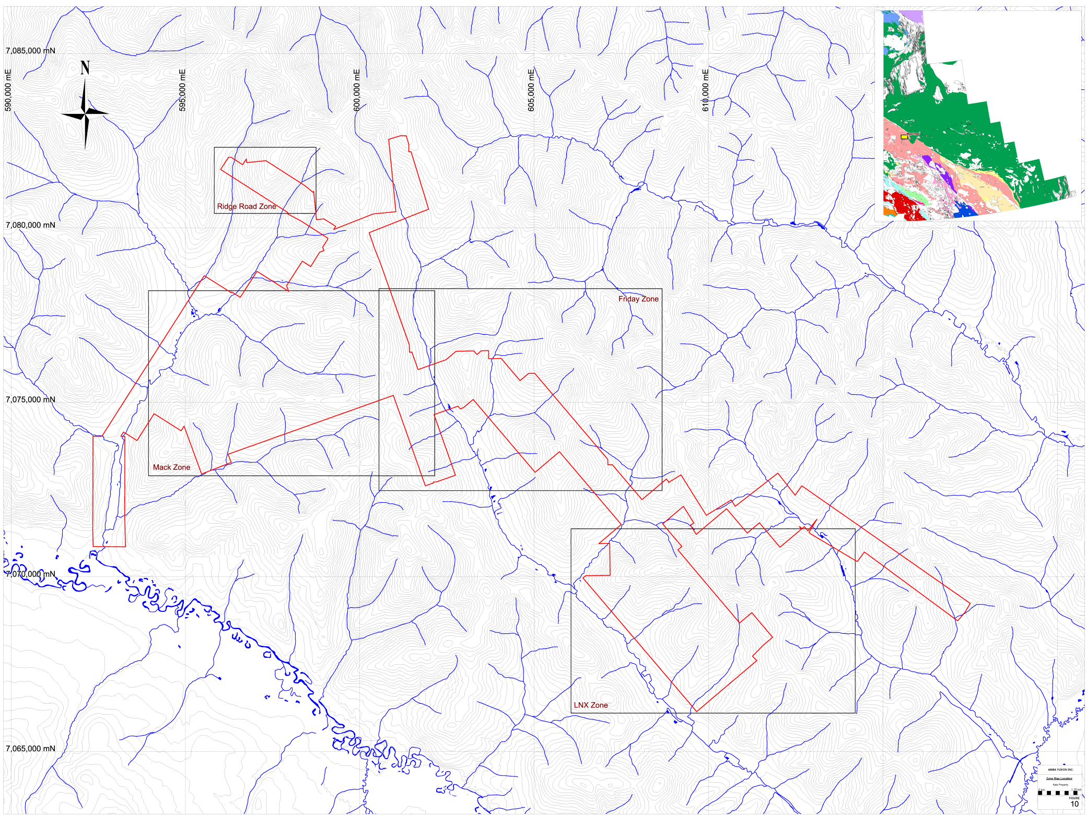

Figure 10: Kate Project – Zone Location Map

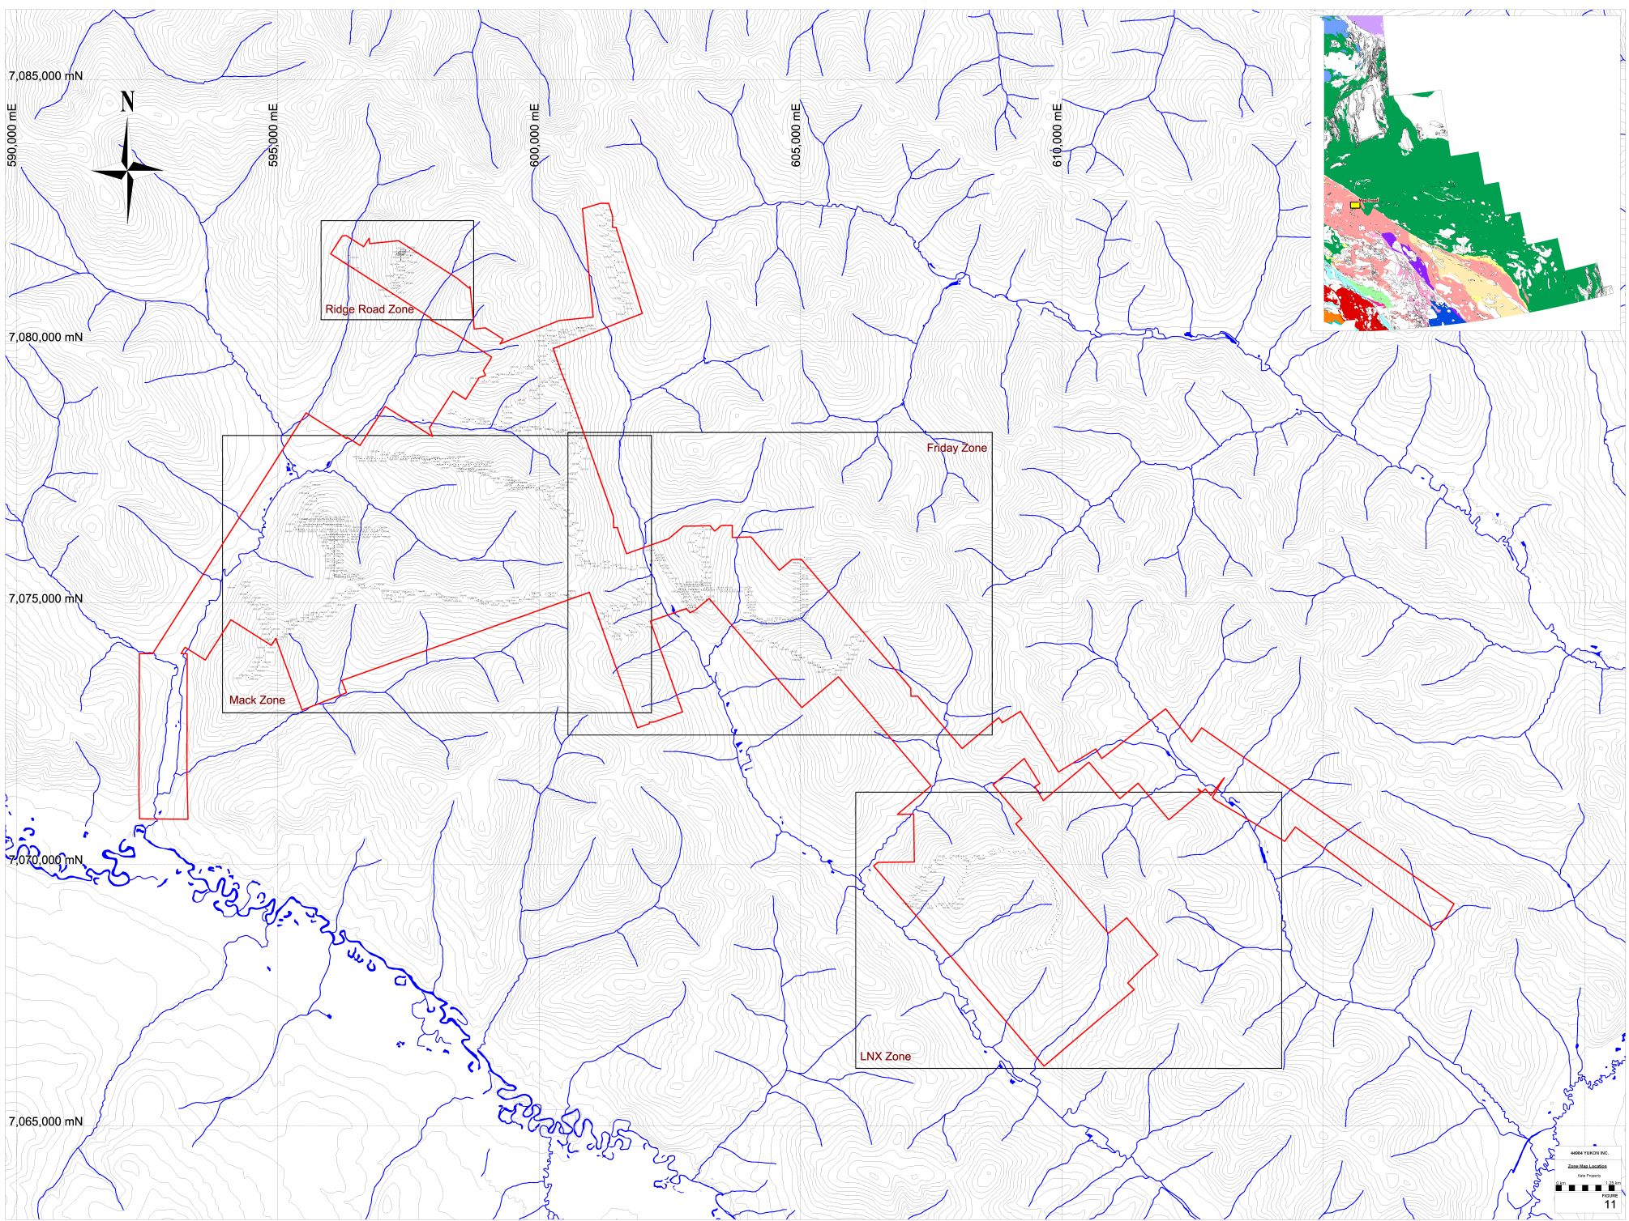

Figure 11: Kate Project – Soil Sample Location Map

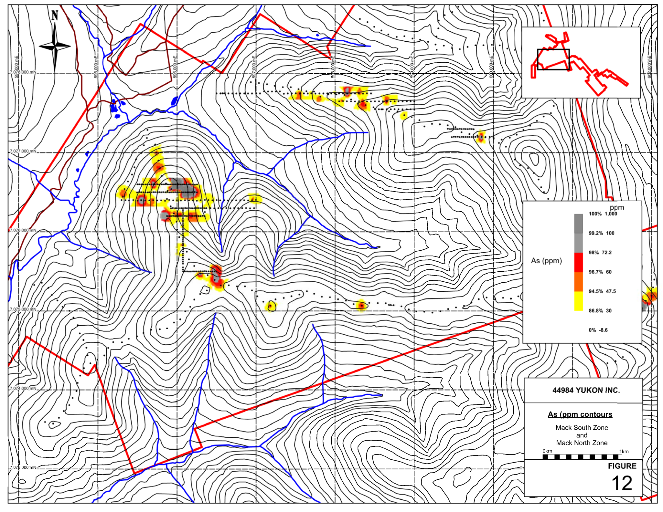

Figure 12: Kate Project – Mack Zone Soil Sample Results As

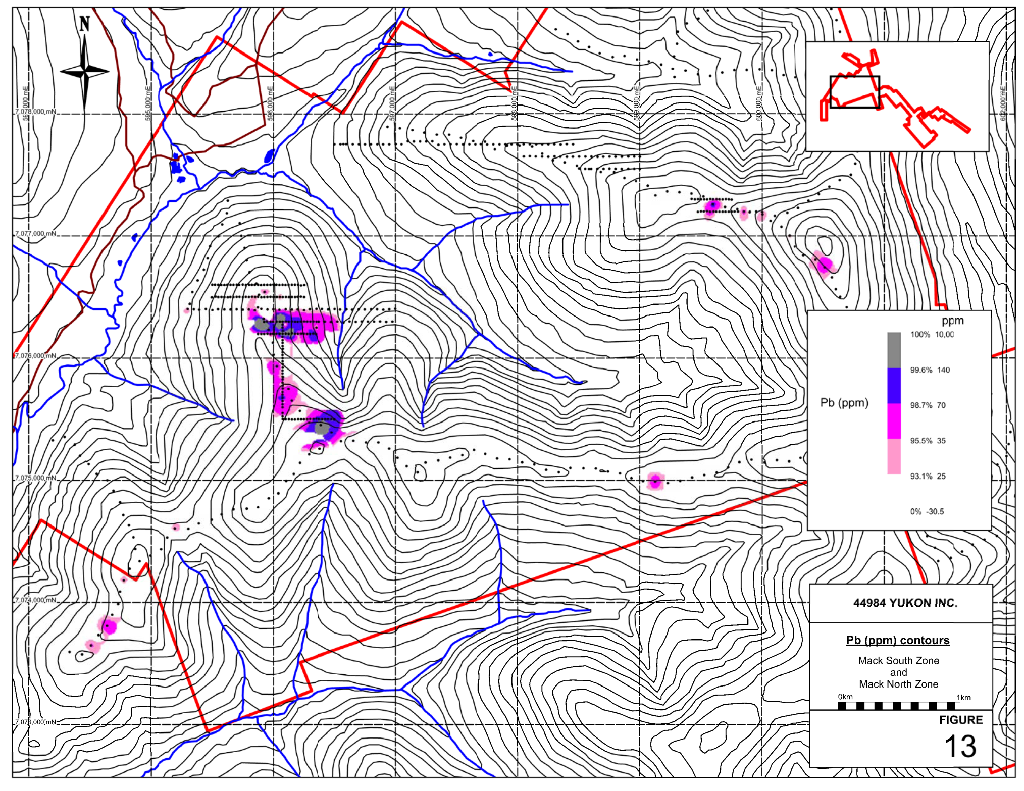

Figure 13: Kate Project – Mack Zone XRF Soil Sample Results Pb

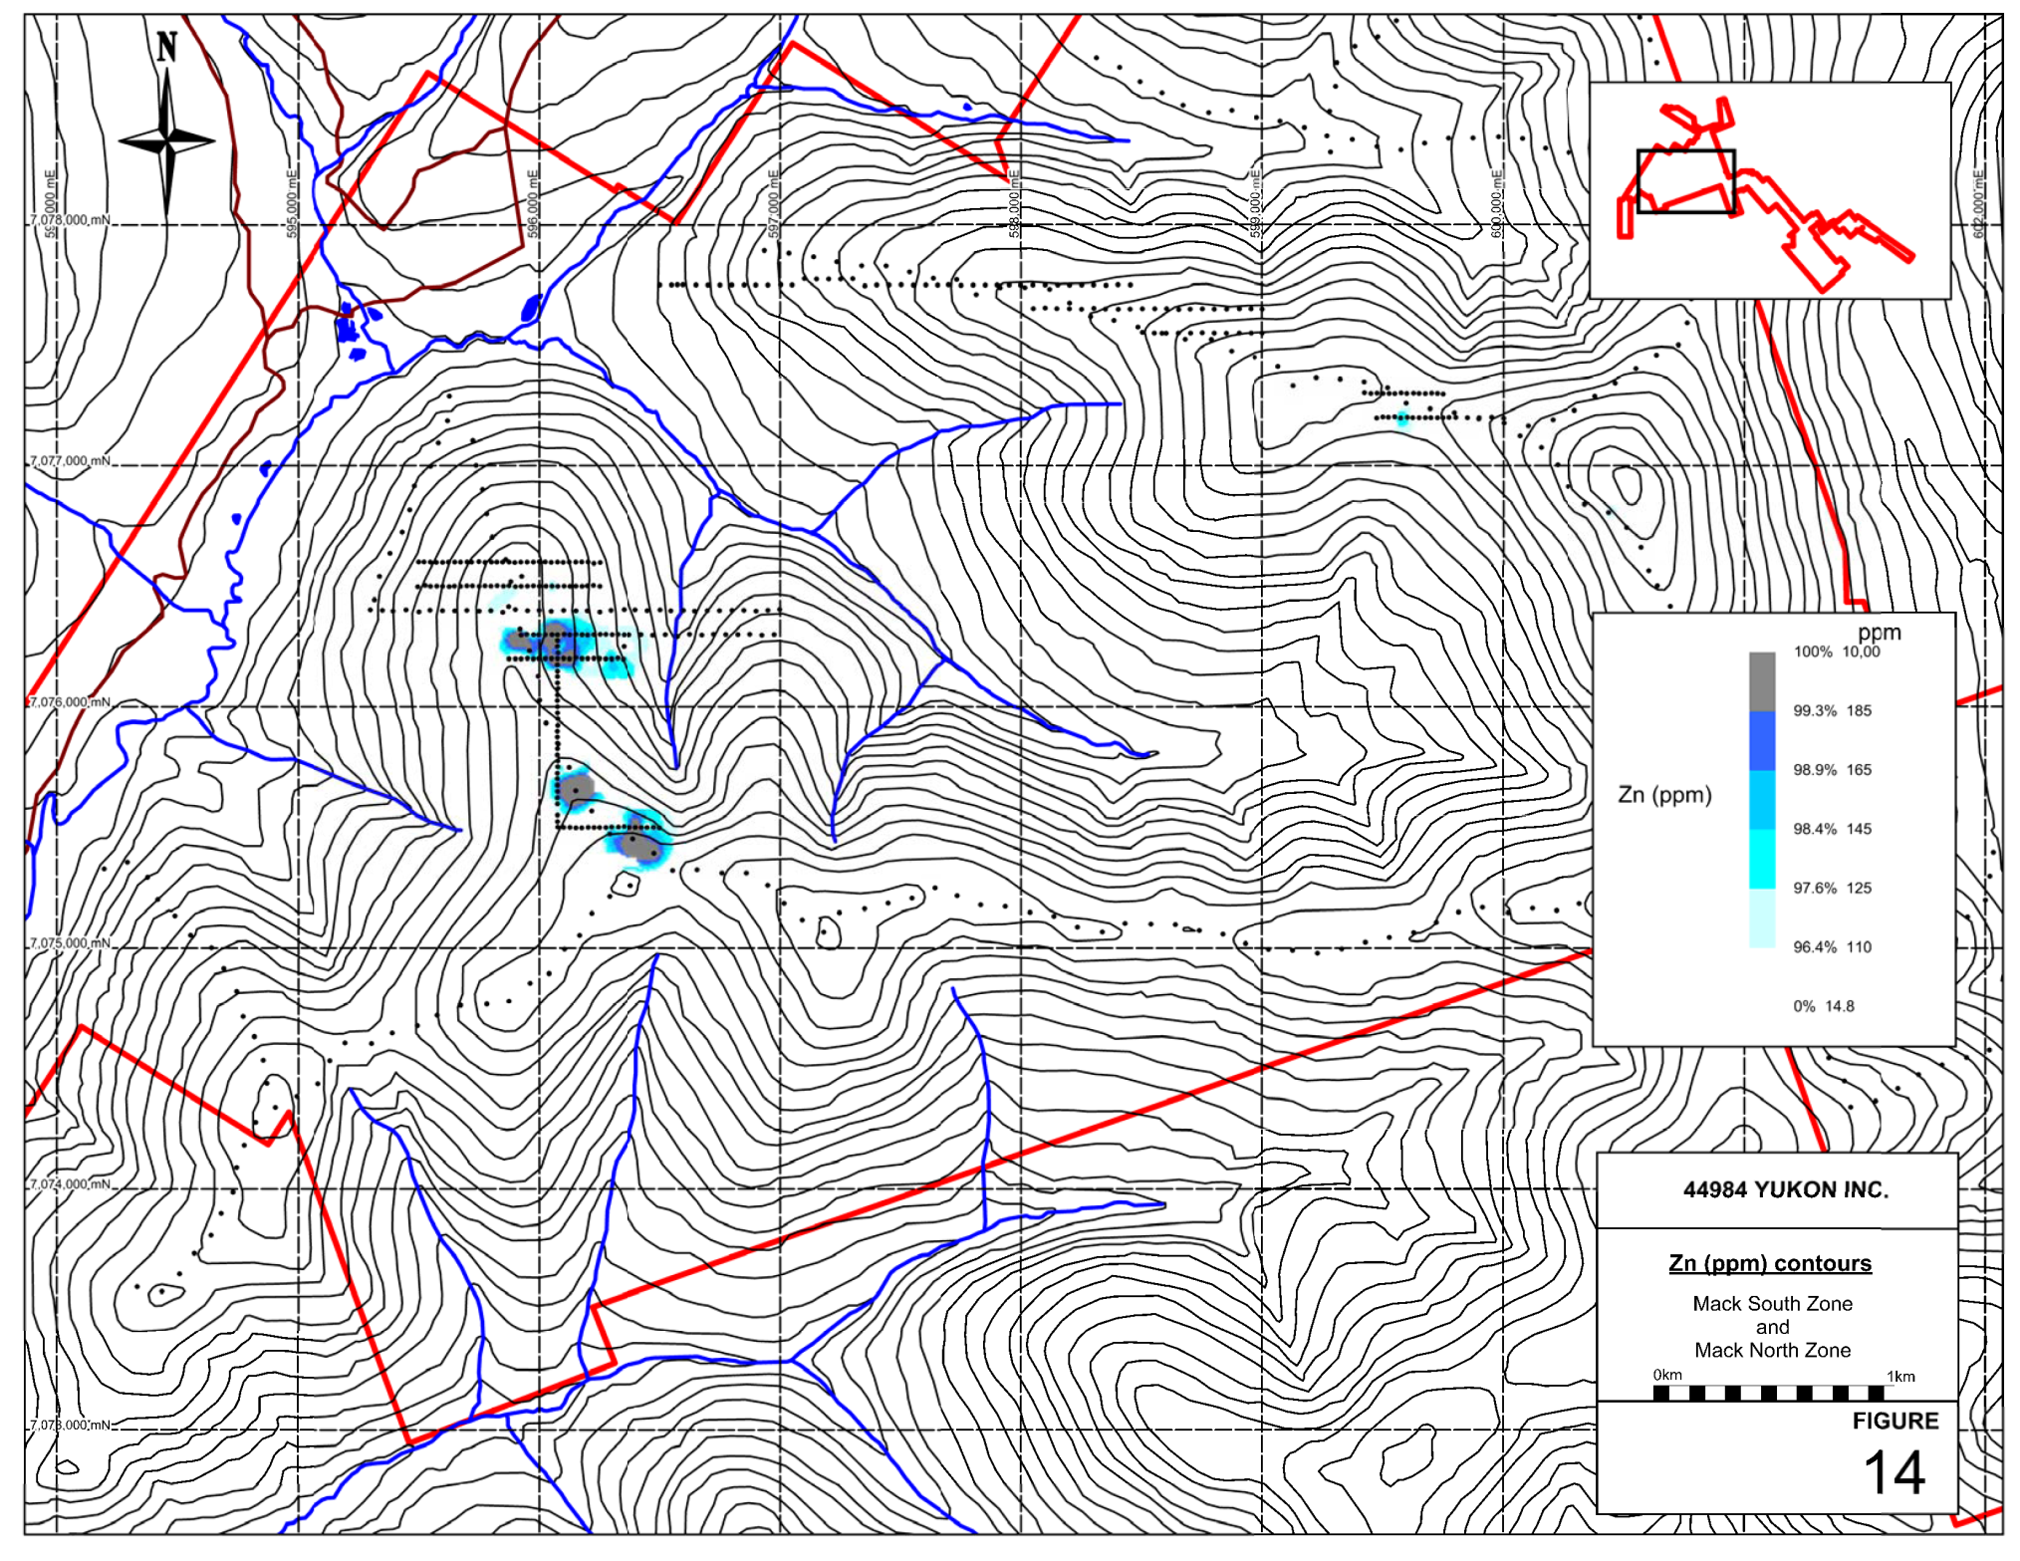

Figure 14: Kate Project – Mack Zone XRF Soil Sample Results Zn

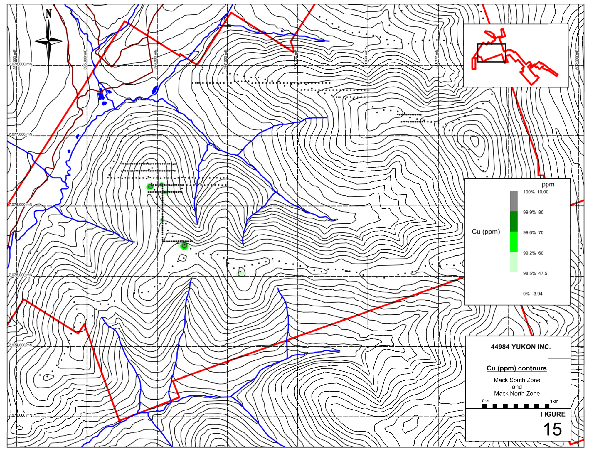

Figure 15: Kate Project – Mack Zone XRF Soil Sample Results Cu

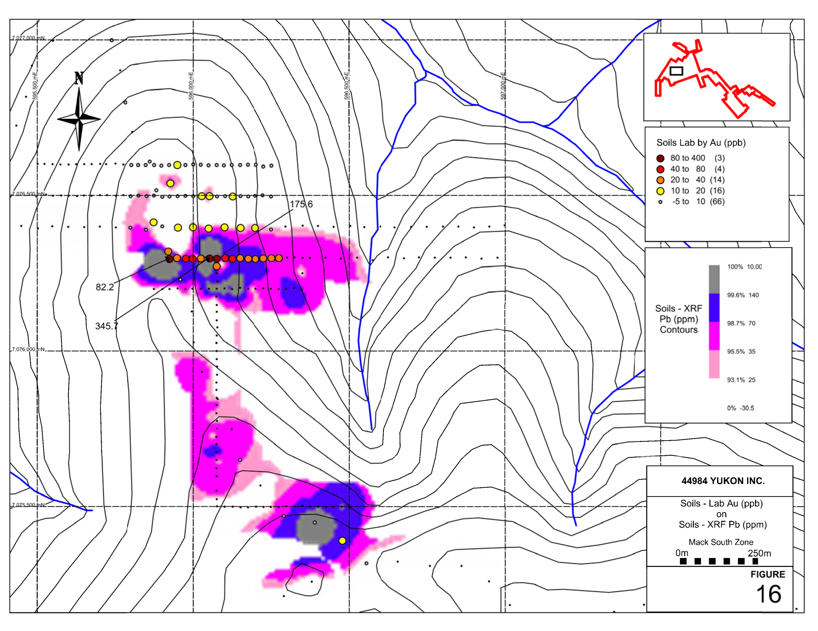

Figure 16: Kate Project – Mack South Zone Soil Sample Results Pb XRF and Au Chemical Assays

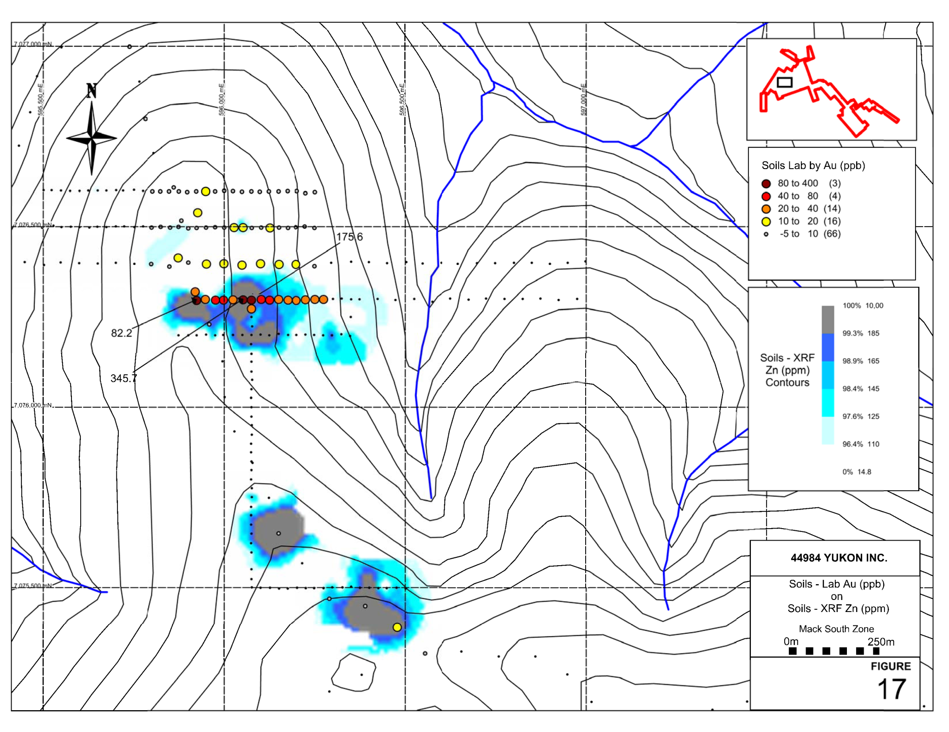

Figure 17: Kate Project – Mack South Zone Soil Sample Results Zn XRF and Au Chemical Assays

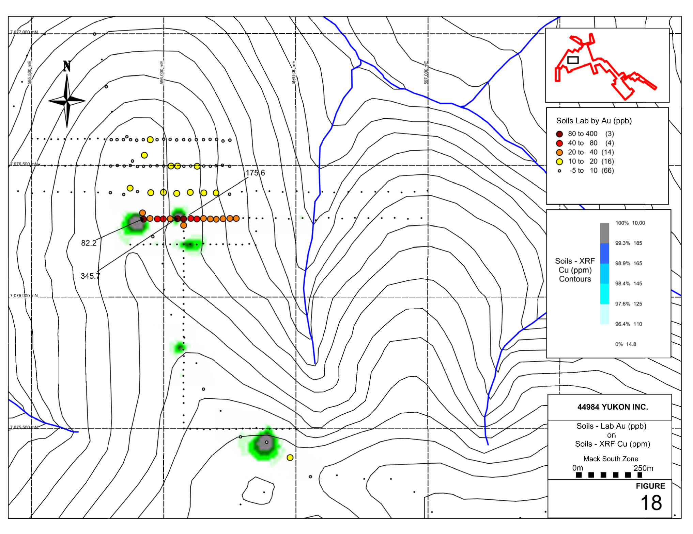

Figure 18: Kate Project – Mack South Zone Soil Sample Results Cu XRF and Au Chemical Assays

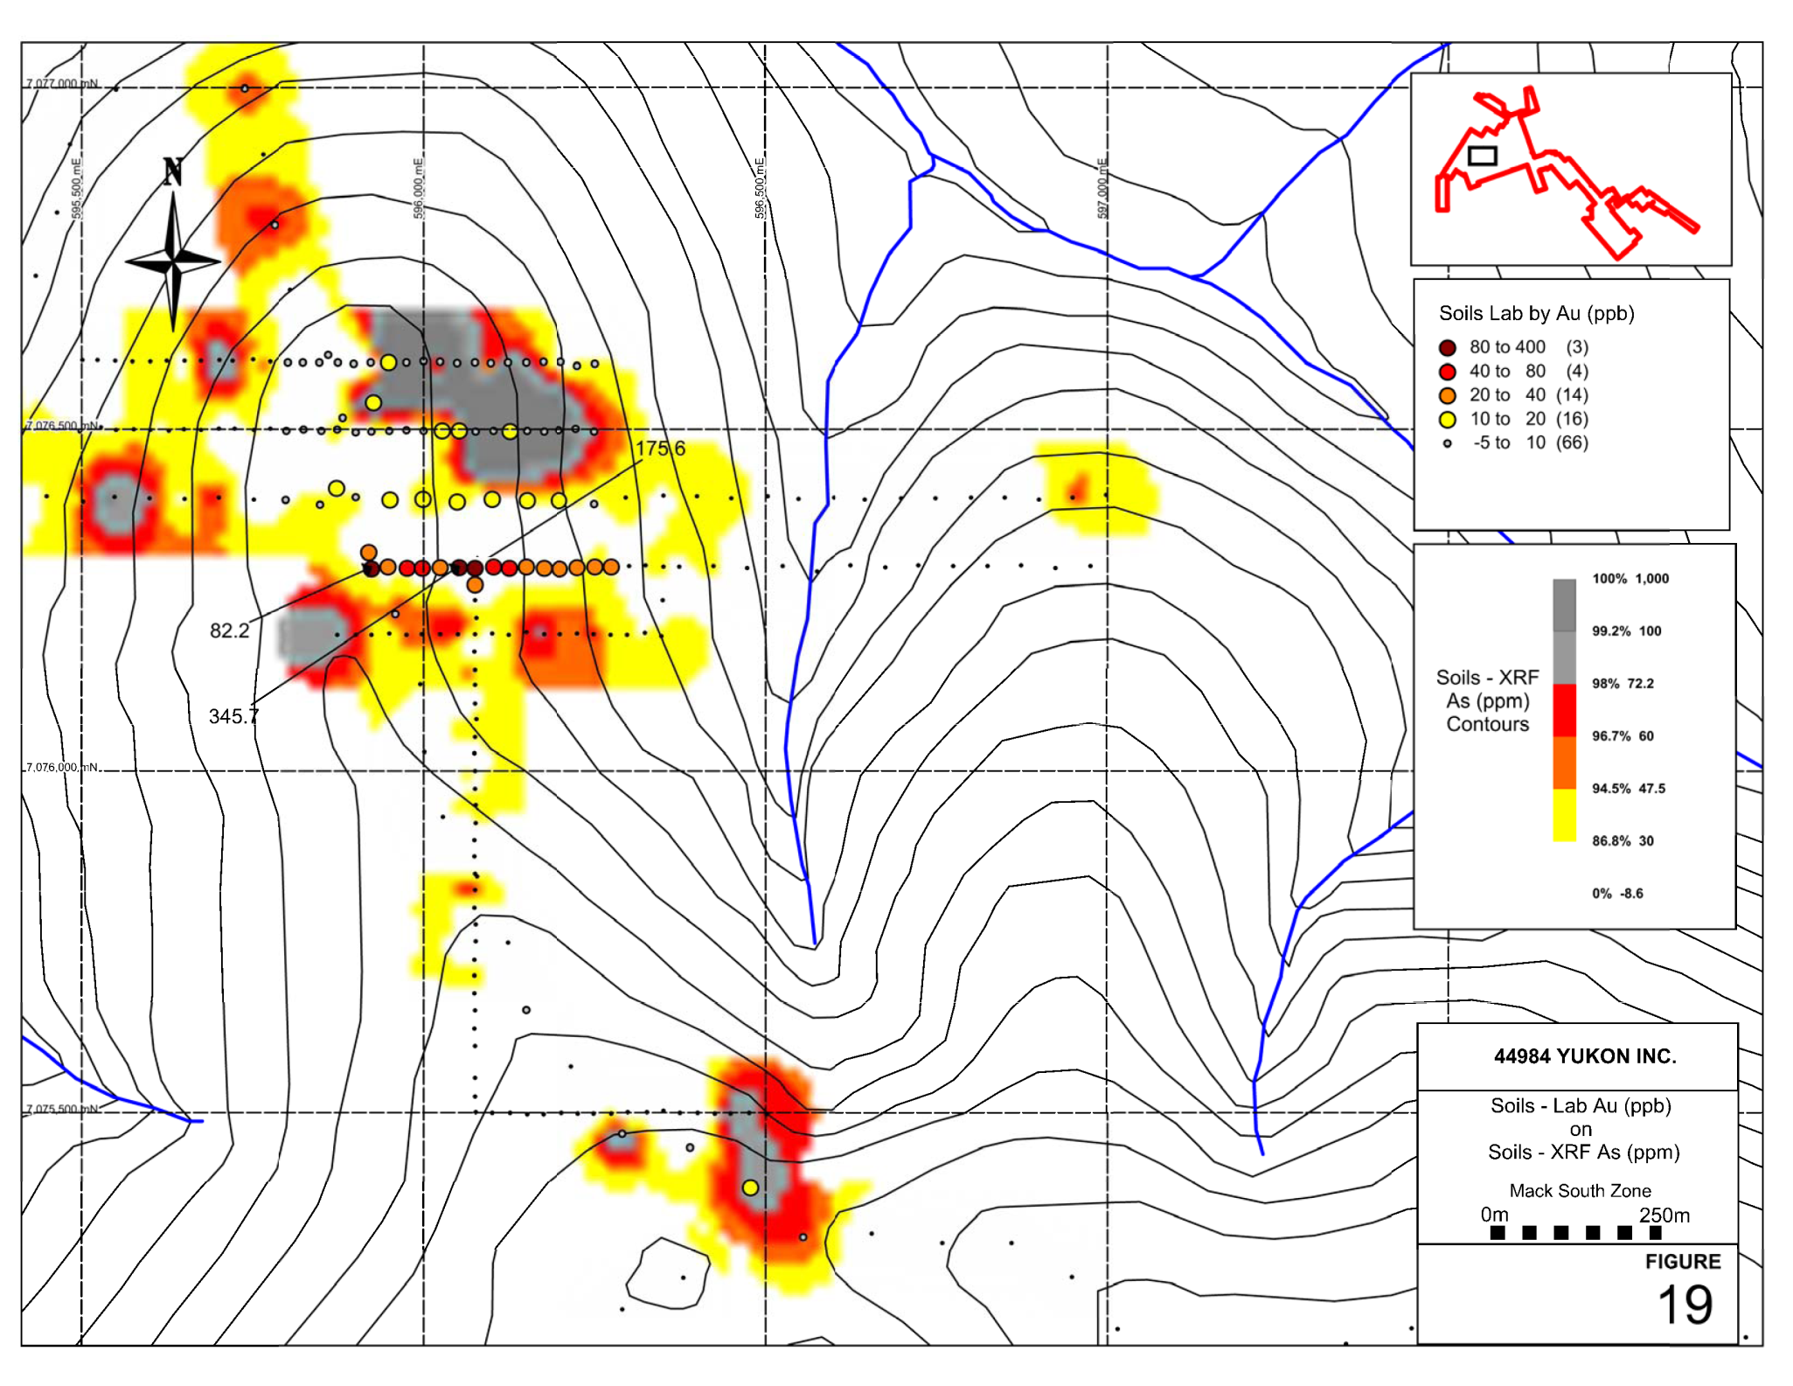

Figure 19: Kate Project – Mack South Zone Soil Sample Results As XRF and Au Chemical Assays

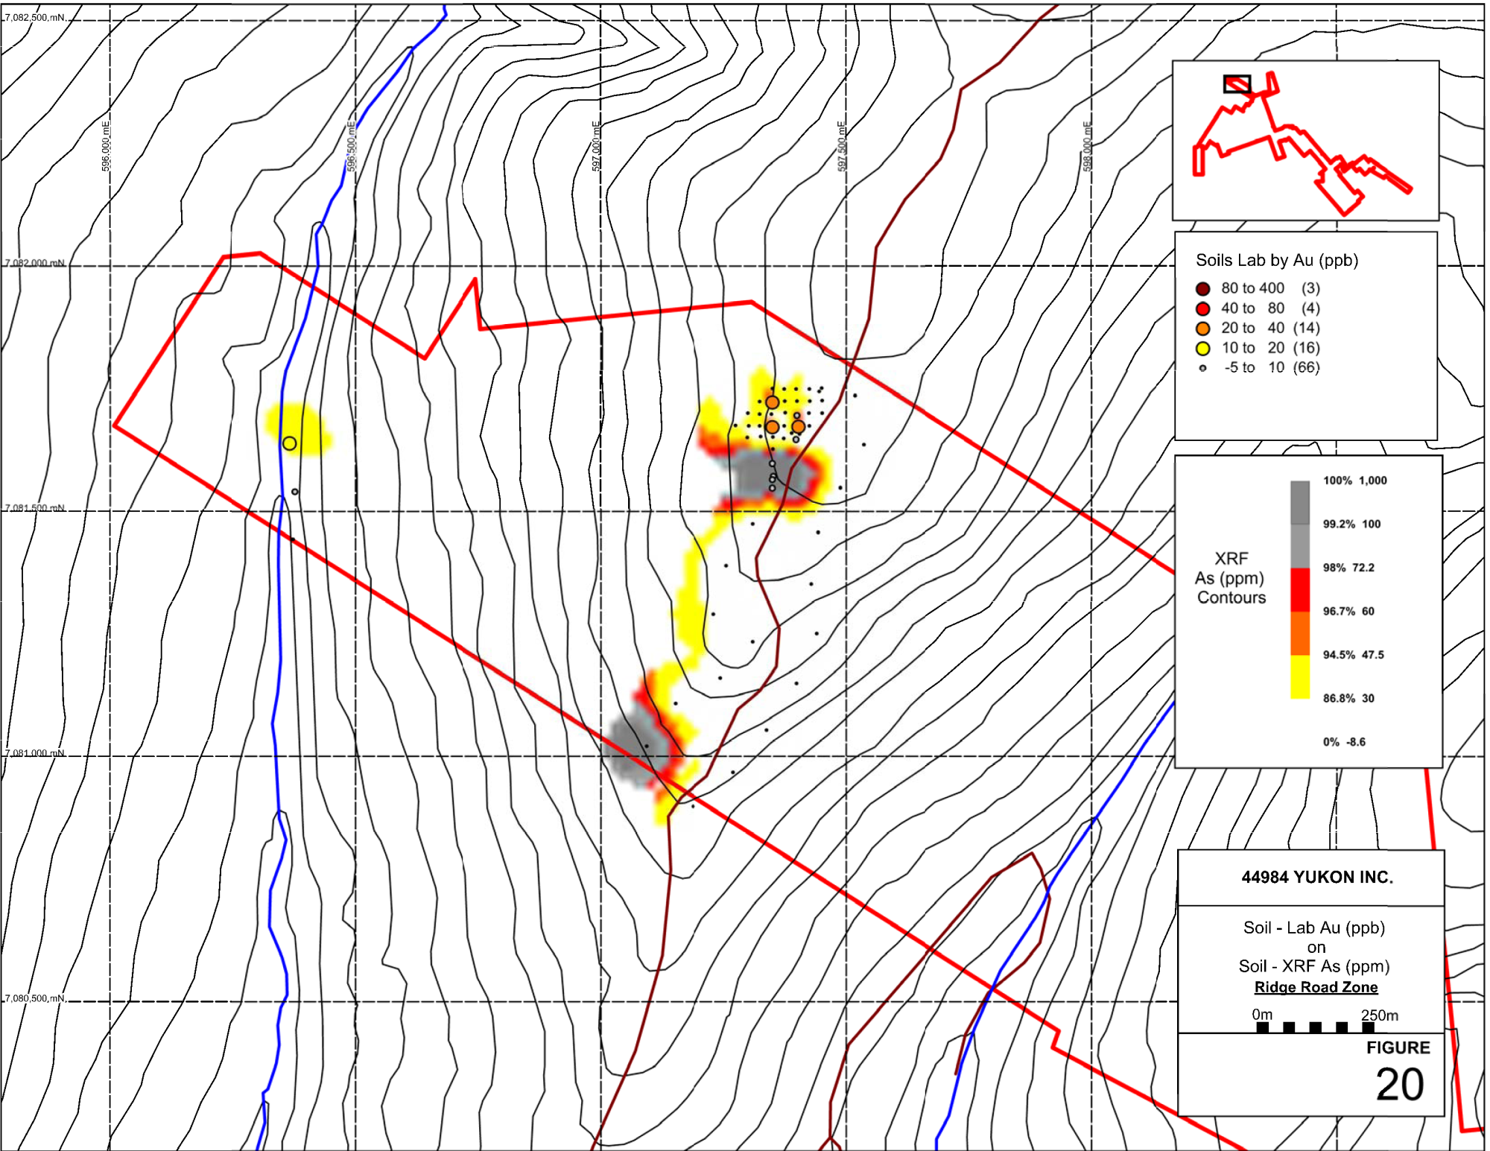

Figure 20: Kate Project – Ridge Road Zone Soil Sample Results As XRF and Au Chemical Assays

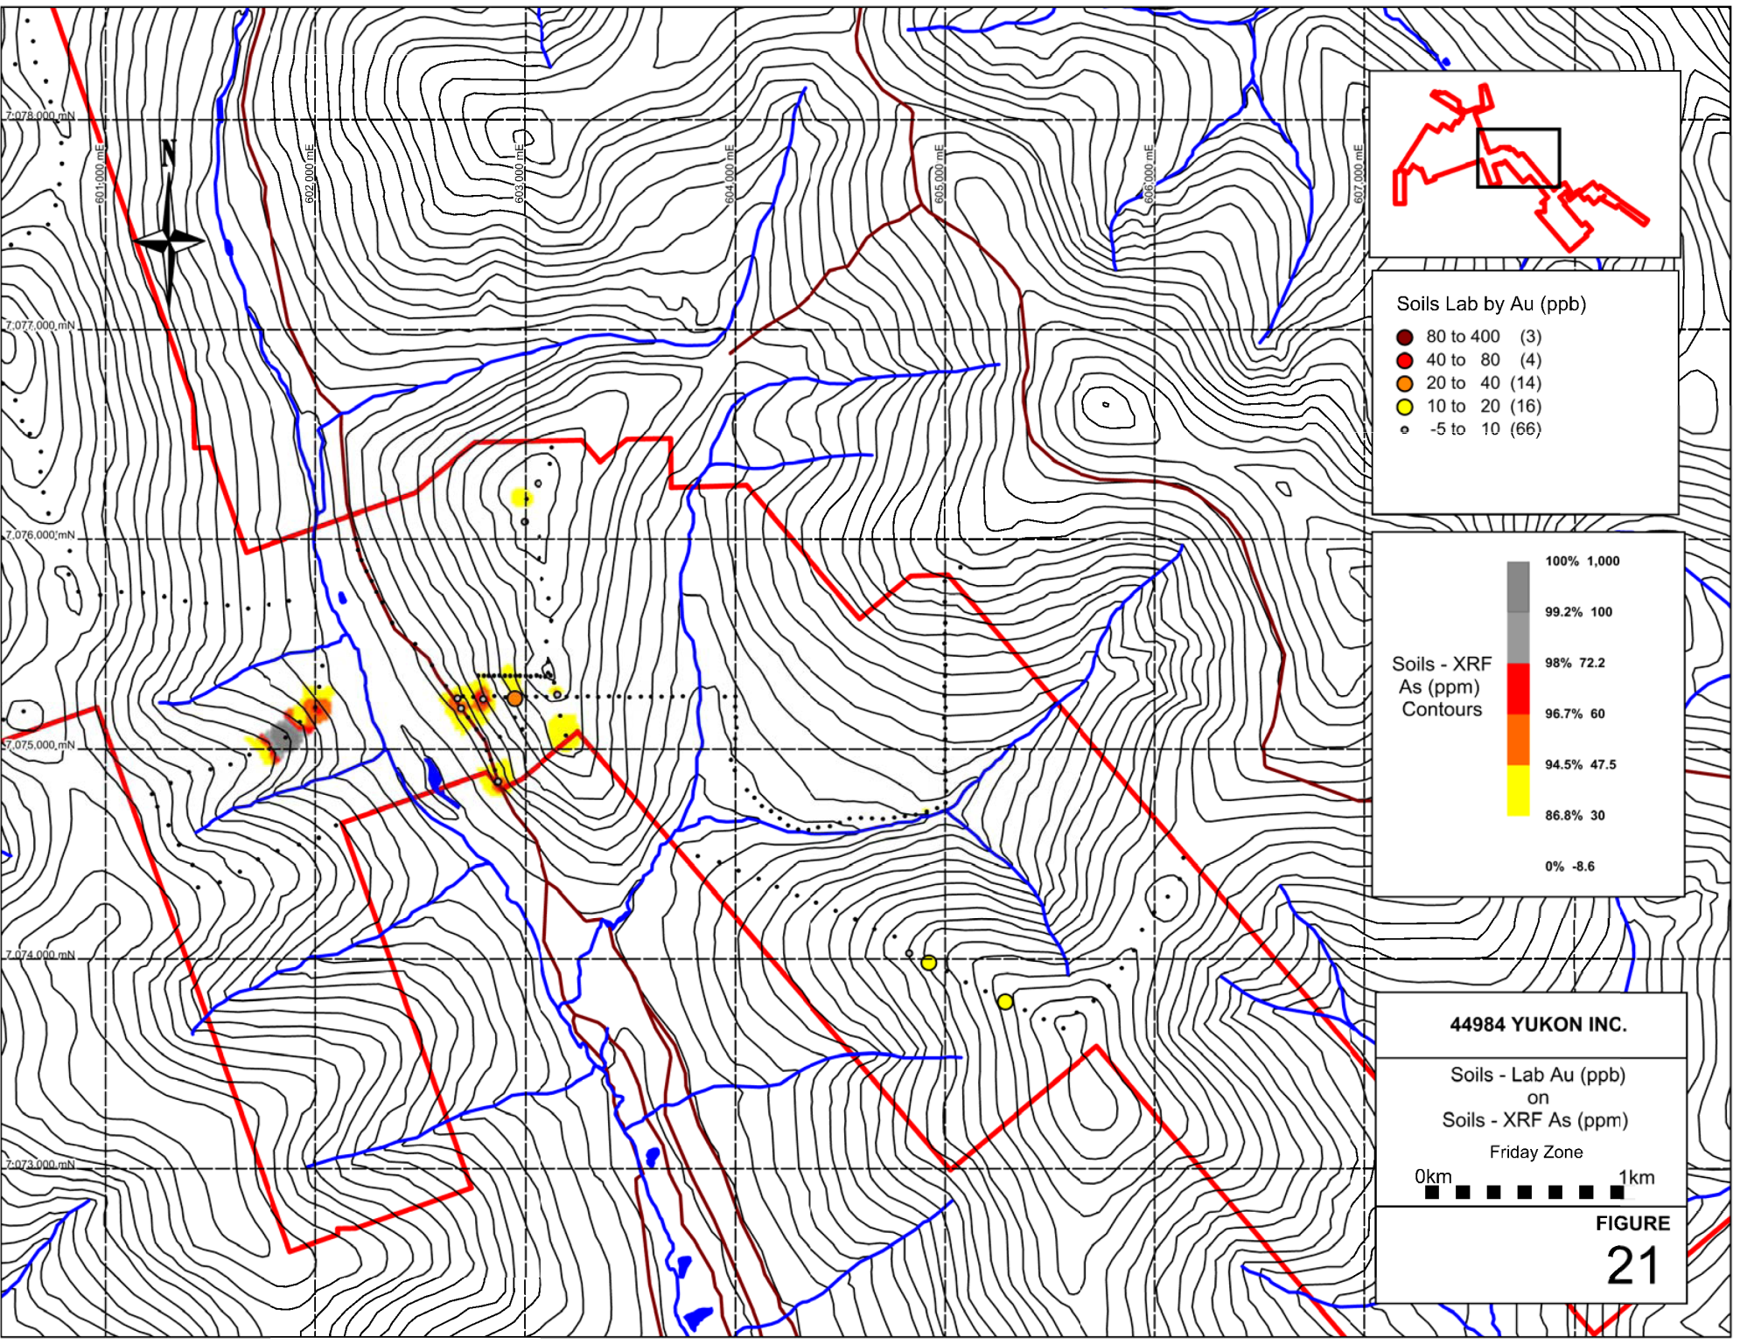

Figure 21: Kate Project – Friday Zone Soil Sample Results As XRF and Au Chemical Assays

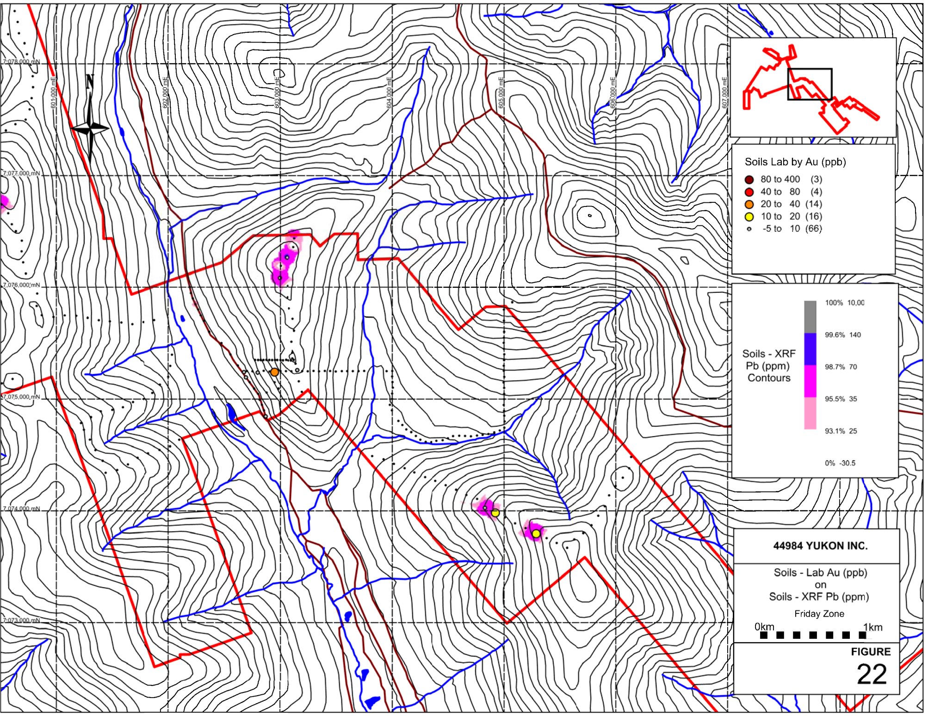

Figure 22: Kate Project – Friday Zone Soil Sample Results Pb XRF and Au Chemical Assays

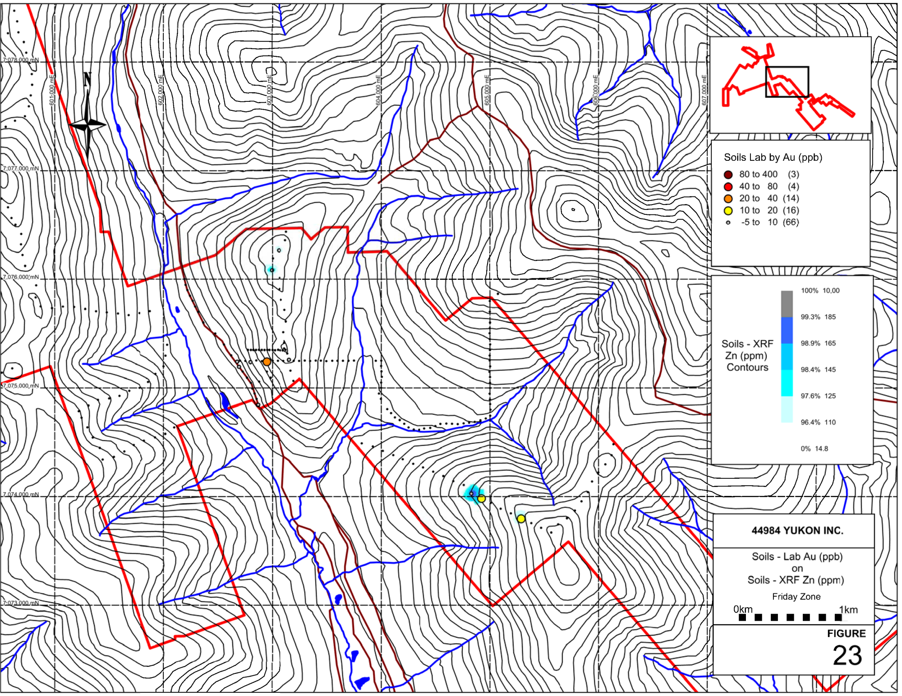

Figure 23: Kate Project – Friday Zone Soil Sample Results Zn XRF and Au Chemical Assays

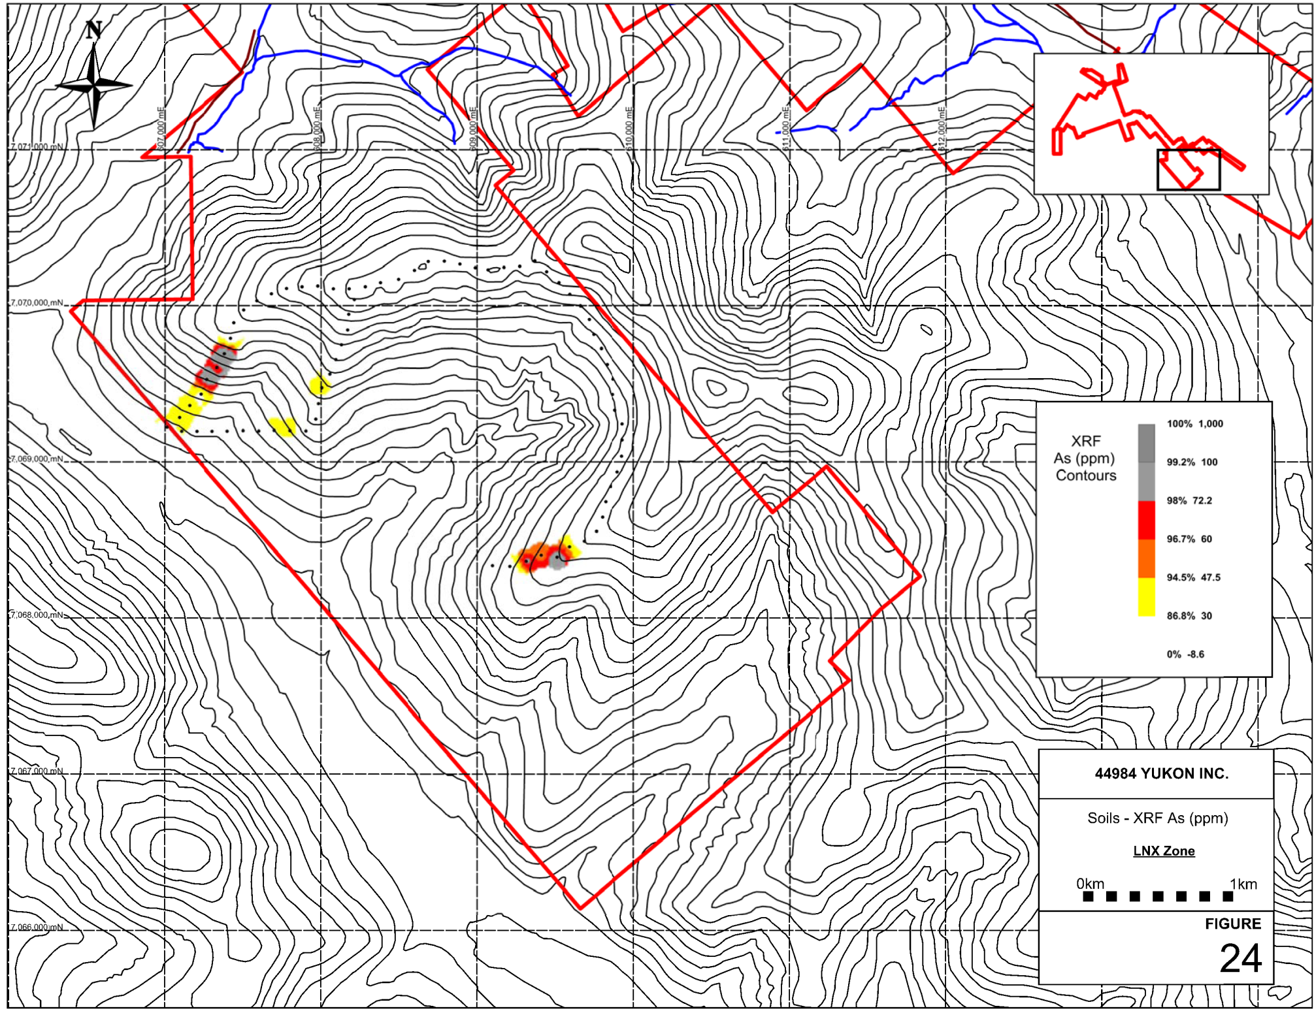

Figure 24: Kate Project – LNX Zone Soil Sample Results As XRF

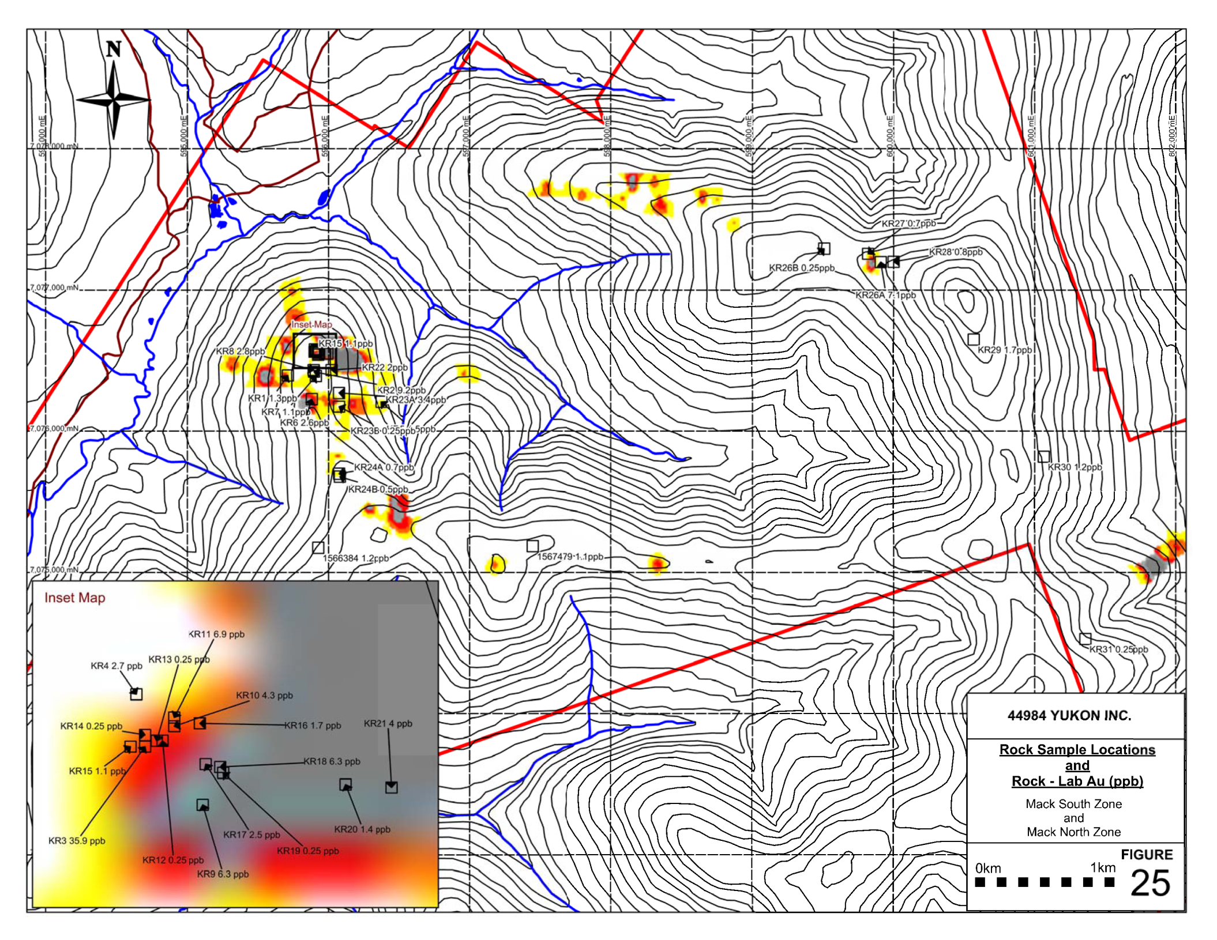

Figure 25: Kate Project – Mack Zone Rock Sample Locations – Chemical Assays Au

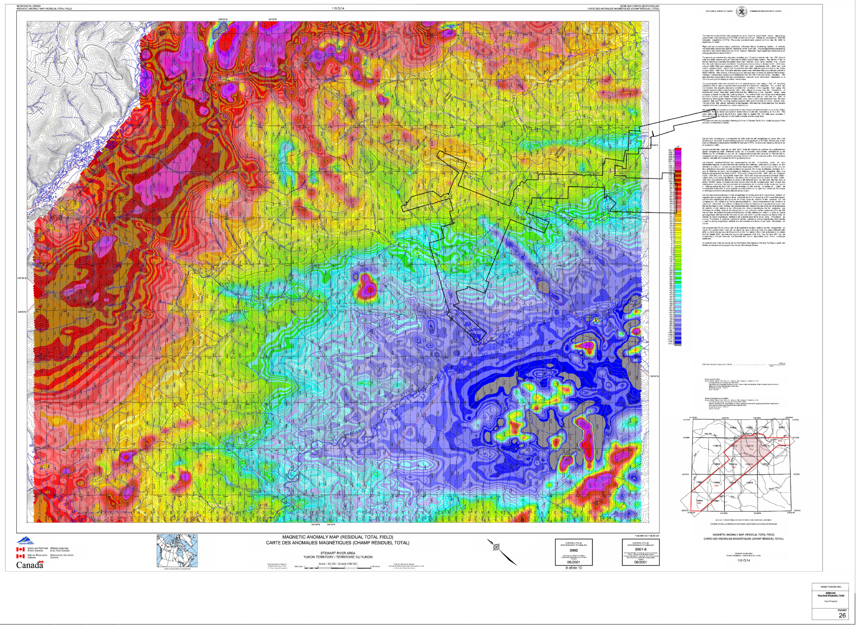

Figure 26: Kate Project – Residual Total Field Magnetic Anomaly Map – after OF 2001-8
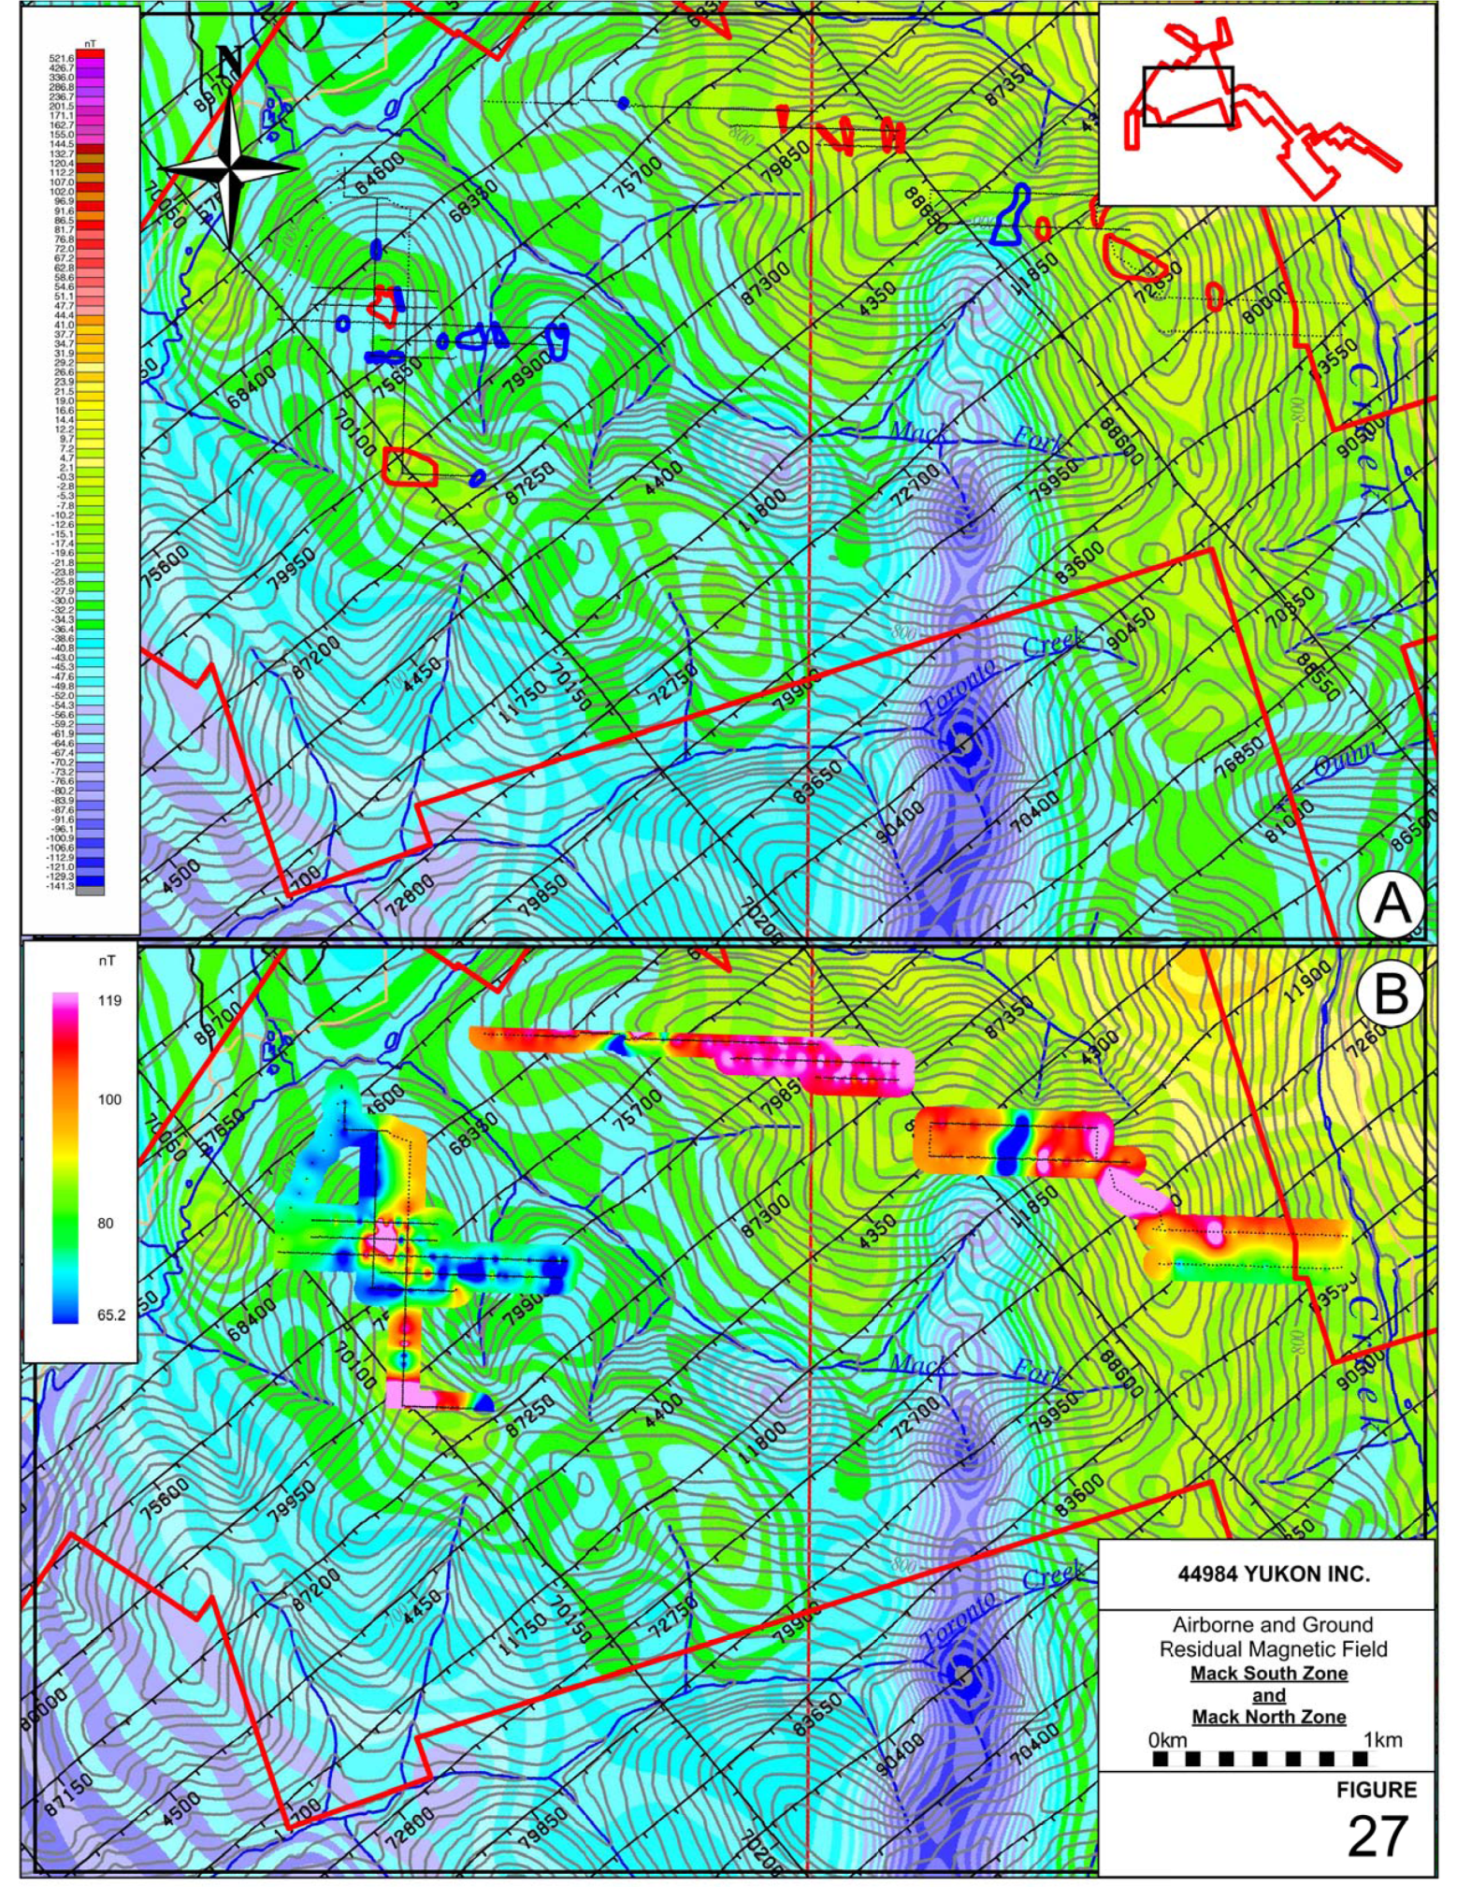

Figure 27: Kate Project – Airborne and Ground Residual Magnetic Field – Mack Zone – after OF 2001-8

DISCUSSION AND CONCLUSIONS

The 2015 Kate Project mineral exploration program was successful in completing the first systematic, Property-wide soil reconnaissance survey the Property has seen. The 2 phase geological, geochemical and geophysical program identified 5 distinct soil anomaly (predominantly base metals) targets which warrant follow-up and soil grid expansion and potentially targeted trench programs.
XRF Instrumentation proved to be a reliable exploration tool for identification of potentially mineralized structures and should be utilized to augment all exploration going forward on the Kate Project. Moreover, ground magnetic surveys also were demonstrated to be a useful exploration tool towards the identification of structural trends and lithological boundaries. In specific, XRF samples reporting Pb and Zn appear to be solid pathfinder elements for Au-in-soils via chemical analyses. Arsenic, does not have a strong correlation to Au-in-soils via chemical assay, and more work on these relationships should be a focus of next-step exploration.
Follow-up soils surveys should focus on determination of soil profiles on each of the target areas and utilize a powered auger to increase sample collection depth – this will allow for the review of sample depth in relation to element analysis.
Targeted follow-up exploration work by systematic soils and rock sampling programs involving access construction, extended and in-fill soil sampling, trenching is warranted; particularly on the Mack and Friday Creek Zones.
Continued, ridge and spur based soil geochemical surveys across the Property are strongly encouraged as there is high potential to discover additional mineralized zones and structures. Particular attention should be paid to the large, consistent, magnetic low identified from previous airborne surveys of the district – and this interpreted structure should be a the focus of first-pass soils XRF initiatives.
The Kate Project lies within an area well known for placer gold deposits, the lode source of which has never been determined, and as such, offers an intriguing Project for prospecting and more advanced mineral exploration programs. The 2015 program has begun, baseline type data collection for the Project area, and in the process has defined multiple soil anomalies which require further exploration.

RECOMMENDATIONS

- A follow-up program of grid based soil sampling to extend the Mack Zone soil anomaly discovery and grids to the North, East, West and South on 50m spaced lines on 25 m centres.

- Target regional airborne magnetics low that transects the centre of the Project with soils and ground based magnetics to delineate mineralization potential of linear

- Follow-up Friday Creek Zone base metals anomalies with tight soils grid and ground prospecting

- Continued usage of XRF Instrumentation as exploration tool

- Power auger soil sampling program (full soil profile analysis) – correlation to hand auger results

- Future geochemical programs should focus on lead and zinc as a primary vector to Au mineralization along with Au geochemistry and to a lesser extent As

- Petrographic analysis of collected hand samples with sulphide mineralization

- Detailed review of soil transport directions on targets areas – downslope/cross slope movement

- Property wide Terrain Suitability Analysis (with soils compilation analysis)

- Reinterpretation of structures from the available airborne datasets

- Ground Magnetics (Mack Zone) grid extensions and full 2015 anomaly grid coverage

- Access construction – exploration trails (quad) for Mack Zone ingress

- Completion of Ridge and Spur style exploration of remaining portions of project

Respectfully submitted,

_______________________
Paul D. Gray, P.Geo.
Vancouver, British Columbia
January 15, 2015

Appendix 1: References

REFERENCES

Allan, M.M., Hart, C.J.R., and Mortensen, J.K. (eds.), 2012, Yukon Gold Project Final Technical Report, Mineral Deposit Research Unit, University of British Columbia, 196 p.
Allan, Murray M., Mortensen, J.K., Hart, Craig J.R., Bailey, Leif A., Sanchez, Matias G., Ciolkiewics, Witold, McKenzie, Greg G. and Creaser, Robert A,. 2013. Magmatic and Metallogenic Framework of West-Central Yukon and Eastern Alaska, Society of Economic Geologists, Inc. Special Publication 17, pp. 111–168
Chapman, R., Mortensen, J., Crawford, E., and Lebarge, W., 2010a, Microchemical studies of placer and lode gold in the Klondike district, Yukon, Canada: 1. Evidence for a small, gold-rich, orogenic hydrothermal system in the Bonanza and Eldorado Creek area: Economic Geology, v. 105, p.1369–1392.
—— 2010b, Microchemical studies of placer and lode gold in the Klondike district, Yukon, Canada: 2. Constraints on the nature and location of regional lode sources: Economic Geology, v. 105, p. 1393–1410.
Christie J.S. and T.M., 2011. Final report for a target evaluation program on the GO - GR - RR quartz claims, YMIP 2011-016.

Armstrong, RL. 1988. Mesozoic and early Cenozoic magmatic evolution of the Canadian Cordillera. In: Clark, S.P., Burchflel, B. and Suppe, J., (eds.): Processes in continental lithospheric deformation. Geol. Soc. Amer. Special Paper 218 p. 55-91.

Beranek, L.P. and Mortensen, J.K. 2011. The timing and provenance record of Late Permian Klondike Orogeny in northwestern Canada and are-continent collision along western North America. Tectonics, in press.

Chapman, R.J., Mortensen, J.K., Crawford, E.C. and LeBarge, W.P. 2010. Microchemical studies of placer and lode gold in the Klondike District, Canada: 2. Constraints on the nature and location of regional lode sources. Economic Geology 105: 1393-1410.

Colpron, M. 2001. Geochemical characterization of Carboniferous volcanic successions from YukonTanana terrane, Glenlyon map area (105L), central Yukon. In: Yukon Exploration and Geology 2000, D.S. Emond and L.H. Weston (eds.), Exploration and Geological Services Division, Yukon, Indian and Northern Affairs Canada, p. 111-136.

Cox, S.F. 1999. Deformational controls on the dynamics of fluid flow in mesothermal gold systems. In., McCaffrey, K.J.W., Lonergan, L. and Wilkinson, J.J. (eds.) Fractures, fluid flow and mineralization. Geological Society of London, Special Publications, 155, 123-140.

D'el-Rey Silva, L.J.H., Liverton, T., Paradis, S. and Roots, C. 2001 a. A structural analysis of the upper Swift River area (105B/3), Yukon, Part I: Dan Zn occurrence and implications for sulphide mineralization In: Yukon Exploration and Geology 2000, D.S. Emond and L.H. Weston (eds.), Exploration and Geological Services Division, Yukon, Indian and Northern Affairs Canada, p. 289-300.

D'el-Rey Silva, L.J.H., Liverton, T., Roots, C. and Paradis, S. 2001b. A structural analysis of the upper Swift River area (I 05B/3), Yukon, Part II: the TBMB claims and implications for the regional geology. In: Yukon Exploration and Geology 2000, D.S. Emond and L.H. Weston (eds.), Exploration and Geological Services Division, Yukon, Indian and Northern Affairs Canada, p. 301-310.

Dumula, M.R. and Mortensen, J.K. 2002. Composition of placer and lode gold as an exploration tool in the Stewart River map area, western Yukon. In: Yukon Exploration and Geology 2001, D.S. Emond L.H. Weston and L.L. Lewis (eds.), Exploration and Geological Services Division, Yukon Region, Indian and Northern Affairs Canada, p. 87-102.

Dusel-Bacon, C., Wooden, J.L. and Hopkins, M.J. 2004. U-Pb zircon and geochemical evidence for bimodal mid-Paleozoic magmatism and syngenetic base-metal mineralization in the Yukon-Tanana terrane Alaska. Bulletin of the Geological Society of America, 116: 989-1015.

Groves, D.I., Goldfarb, R.J., Robert, F. and Hart, C.J.R 2003. Gold deposits in metamorphic belts: Overview of current understanding, outstanding problems, future research, and exploration significance. Economic Geology, 93: 1-29.

Hart, C.J.R., Baker, T. and Burke, M. 2000. New exploration concepts for country-rock-hosted, intrusionrelated gold systems: Tintina Gold belt in Yukon. 145-171. In: The Tintina Gold Belt: Concepts, Exploration, and Discoveries. Special Volume 2, Cordilleran Roundup January 2000, British Columbia and Yukon Chamber of Mines.

Hart, C.J.R., Goldfarb, R.J., Lewis, L.L. and Mair, J.L. 2004. The northern mid-Cretaceous plutonic province: ilmenite/magnetite series granitoids and intrusion-related mineralization. Resource Geology, 54 (3): 253-280

Hoymann, K.-H., 1989. Gold and sulfide mineralization in the Hunker Creek area, Yukon Territory, Canada. Thesis from the Institut fur Mineralogie and Lagerstattenlehre, RTWH Aachen.

Knight, J.B., Morison, S.R. and Mortensen, J.K. 1999. The relationship between placer gold particle shape rimming, and distance of fluvial transport as exemplified by gold from the Klondike district, Yukon Territory, Canada. Economic Geology, 94: 635-648.

Knight, J.B., Morison, S.R. and Mortensen, J.K. 1999. Lode and placer gold composition in the Klondike district, Yukon Territory, Canada: Implications for the nature and genesis of Klondike placer and lode gold deposits. Economic Geology, 94: 649-664.

Kreft, Bernie., 2010. Trenching and Sampling Report on the GR 1-44 Quartz Claims.

Lindsay, M.J., Baker, T., Oliver, N.H.S., Diment, R and Hart, C.J.R 2000. The magmatic and structural setting of the Brewery Creek gold mine, central Yukon. In: D.S. Emond and L.H. Weston (eds.): Yukon Exploration and Geology 1999. Exploration and Geological Services Division, Yukon, Indian and Northern Affairs Canada, p. 219-227.

Liverton, T., Mortensen, J.K. and Roots, C.F. 2005. Character and metallogeny of Permian, Jurassic and Cretaceous plutons in the southern Yukon-Tanana Terrane. In: Yukon Exploration and Geology 2004. D.S. Emond, L.L. Lewis and G.D. Bradshaw L.H. (eds.). Yukon Geological Survey, p. 147-165.

Liverton, T., 2011. Geology and Summary of the Lonestar Claim Group (Klondike Goldfield), Yukon Territory. 43-101 Report.

MacKenzie, D.J., Craw, D., Mortensen, J.K. and Liverton, T., 2007. Structure of schist in the vicinity of the Klondike goldfield. In: Yukon Exploration and Geology 2006, D.S. Edmond, L.L.Lewis and L.H. Weston (eds.), Yukon Geological Survey, p. 197-212.

MacKenzie, D.J., Craw, D. and Mortensen, J. 2008a. Structural controls on orogenic gold mineralization in the Klondike goldfield, Canada. Mineralium Deposita, 43: 435-448.

MacKenzie, D., Craw, D. and Mortensen, J.M. 2008b. Thrust slices and associated deformation in the Klondike goldfields, Yukon. In: Yukon Exploration and Geology 2007, D.S. Emond, L.R Blackburn, R.P. Hill and L.H. Weston (eds.), Yukon Geological Survey, p. 199-213.

MacKenzie, D., Craw, D., Mortensen, J.M. and Liverton, T. 2008c. Disseminated gold mineralization associated with orogenic veins in the Klondike Schist, Yukon. In: Yukon Exploration and Geology 2007, D.S. Emond, L.R. Blackburn, R.P. Hill and L.H. Weston (eds.), Yukon Geological Survey, p. 215-234.

Mortensen, J.K., 1992: Pre-mid-Mesozoic tectonic evolution of the Yukon-Tanana terrane, Yukon and Alaska; Tectonics, v. 11, no. 4, p. 836-853.

Mortensen, J.K. 1996. Geological compilation maps of the Northern Stewart River map area, Klondike and Sixtymile districts. Indian and Northern Affairs Canada Yukon Region, Open File 1996-1 (G).

Mortensen, J.K., Chapman, R, LeBarge, W. and Crawford, E. 2006. Compositional studies of placer and lode gold from western Yukon: Implications for lode sources. In: Yukon Exploration and Geology 2005, D.S. Emond, G.D. Bradshaw, L.L. Lewis and L.H. Weston (eds.), Yukon Geological Survey, p. 247-255.

Mortensen, J.K., Nesbitt, B.E. and Rushton, R 1992. Preliminary observations on the geology and geochemistry of quartz veins in the Klondike district, west-central Yukon. In: Bremner, T.J. (ed.): Yukon Geology, Vol. 3. Exploration and Geological Services Division, Indian and Northern Affairs Canada, p. 260-270.

Nelson, J.L. and Friedman, R. 2004. Superimposed Quesnel (late Paleozoic-Jurassic) and Yukon-Tanana (Devonian-Mississippian) arc assemblages, Cassiar Mountains, northern British columbia: field, U-Pb, and igneous petrochemical evidence. Canadian Journal of Earth Sciences, 41: 1201-1235.

Nelson, J., Mihalynuk, M., Murphy, D.C., Colpron, M., Roots, C.F., Mortensen, J.K. and Friedman, RM. 2000. Ancient Pacific Margin: A preliminary comparison of potential VMS-hosting successions of the Yukon-Tanana Terrane, from Finlayson Lake district to northern British Columbia. In: Emond, D.S. and Weston, L.H. (eds.): Yukon Exploration and Geology 1999. Exploration and Geological Services Division, Yukon, Indian and Northern Affairs Canada, p. 79-86.

Piereey, S.J., Hunt, J.A. and Murphy, D.C. 1999. Lithogeochemistry of meta-volcanic rocks from YukonTanana trrane, Finlayson Lake region, Yukon: preliminary results. In: Roots, C.F. and Emond, D.S. (eds.): Yukon Exploration and Geology 1998. Exploration and Geological Services Division, Yukon, Indian and Northern Affairs Canada, p. 125-138.

Roots, C.F., Liverton. T. and Heaman, L. 2003. Geology and U-Pb zircon geochronology of Upper Dorsey assemblage near the TBMB claims, upper Swift River area, southern Yukon. In: Emond, D.S. and Lewis, L.L. (eds.): Yukon Exploration and Geology 2002. Exploration and Geological Services Division, Yukon, Indian and Northern Affairs Canada, p. 199-212.

Rushton, R.W., Nesbitt, B.E. and Mortensen, J.K. 1993. A fluid inclusion and stable isotope study of Au quartz veins in the Klondike district, Yukon Territory, Canada: A section through a mesothermal vein system. Economic Geology, 88: 647-678.

GSC Open File 1985-1: Bedrock Geology and Mineralization of the Klondike Area (East), 115O/9,10,11,14, 15,16 and 116B/2, Yukon, - by R.L. Debicki, Scale: 1:50,000 map with marginal notes.

GCS Open File 2001-8: Airborne geophysical survey, Stewart River area, Yukon Territory, NTS 115N/14 / Levé géophysique aérien, Stewart River area, Territoire du Yukon, SNRC 115N/14; Shives, R B K; Carson, J M; Ford, K L; Holman, P B; Gordey, S; Abbott, G. Geological Survey of Canada, Open File 3992, 2001, ; 10 sheets, doi:10.4095/212591.
Yukon Energy, Mines and Resources/YGS Website – http://www.emr.gov.yk.ca/mining/mapsdatapubs.html

Appendix 2: Statement of Expenditures

STATEMENT OF EXPENDITURES
KATE PROJECT
July 10-September 6, 2015
Salaries:

J. Thom 19 days @ $350/day Soil Tech $6,650.00
J. McLaughlin 10 days @ $350/day Soil Tech $3,500.00
P. Gray 4 days @ $500/day Geologist $2,050.00
H. Kuikka 9 days @ $275/day Geologist $2,475.00
J.S & T Christie/ 12 days @ $500/day Geologist $6,000.00
D. Christie 19 P/T days @ $150/day First Aid/ Camp/Logis. $2,850.00

Total Salaries $ 23,525.00

Claim Staking – 17 claims $ 948.50

Travel (in Yukon) Vehicles, Flights, Fuel, Hotels, etc. $ 6,279.57

Analytical (Bureau Veritas – 951 samples) $ 5,123.90

Camp/Daily Field Expenses 66 person days @ $100.00/day $ 6,600.00

Contractors/Equipment Rentals
XRF rental 2,990.00
Mag 200.00

Report Writing – Printing/Graphics/Plots 5 days @ $500.00/day $2,500.00

TOTAL COSTS $48,166.97

Appendix 3: Claim Data

Appendix 4: Compiled Tabulated Results - Soils XRF

Appendix 5: Compiled Tabulated Analytical Results - Rocks

Appendix 6: Compiled Tabulated Analytical Results - Soils

Appendix 7: Geophysical Survey Data

Appendix 8: Rock Sample Photos and Descriptions

Appendix 9: Certificates of Analyses

Appendix 10: Geologist’s Certificate

GEOLOGISTS CERTIFICATE

I, Paul D. Gray, P. Geo., do hereby certify:

THAT I am a Professional Geoscientist with offices at 302 – 309 Strickland Street, Whitehorse, YT Y1A 2J9
THAT I am an author of the Technical Report entitled “2015 Geochemical Report on the Kate Project” and dated January 15, 2016, relating to the Kate Property (the “Assessment Report”). I personally oversaw the entirety of the Kate 2015 Program in the field.
THAT I am a member in good standing (#29833) of the Association of Professional Engineers and Geoscientists of British Columbia.
THAT I am a graduate of Dalhousie University, Halifax, in the Province of Nova Scotia, with a Bachelor of Science degree (Honours) in Earth Sciences
THAT I have practised my profession as an exploration geologist in the mineral exploration industry continuously since 1997. I have worked on base, precious and industrial metals exploration projects as a geologist in Canada, the United States of America, Asia, and South and Central America.
THAT I am the Principal of PDG Geological Consultants
THAT I have read the definition of "qualified person" set out in National Instrument 43-101 ("NI 43-101") and certify that by reason of my education, affiliation with a professional association (as defined in NI 43-101) and past relevant work experience, I fulfill the requirements to be a "qualified person" for the purposes of NI 43-101.

Dated at Vancouver, British Columbia, this 15th day of January, 2016.

_____________________
Paul D. Gray, P. Geo.

