2015 GEOCHEMICAL REPORT ON THE
GoGr PROJECT

YMEP# 15-075

Located in the Dawson Mining District
NTS 1151O/09 and 115O/10
63°41’ N Latitude; 138°35’ W Longitude

-Prepared for-

James Christie – Owner / Operator

Grouping: HD03482

-Prepared by-

Paul D. Gray, P.Geo.
and
James Thom, M.Sc.

January 31, 2016

TABLE OF CONTENTS
TABLE OF CONTENTS 1
LIST OF APPENDICES 1
LIST OF TABLES 1
LIST OF FIGURES 2
1.0 SUMMARY 3
2.0 INTRODUCTION 5
3.0 PROPERTY DESCRIPTION AND LOCATION 6
4.0 ACCESSIBILITY, CLIMATE, LOCAL RESOURCES, INFRASTRUCTURE, PHYSIOGRAPHY 12
5.0 HISTORY 13
6.0 REGIONAL GEOLOGY AND MINERALIZATION 21
Regional Geology 21
Yukon-Tanana Structure 21
7.0 PROPERTY GEOLOGY AND MINERALIZATION 24
Geology 24
8.0 2015 EXPLORATION PROGRAM 26
9.0 DISCUSSION AND CONCLUSIONS 61
10.0 RECOMMENDATIONS 62

LIST OF APPENDICES
Appendix 1: References
Appendix 2: Statement of Expenditures
Appendix 3: Claim Data
Appendix 4: Compiled Tabulated Results - Soils XRF
Appendix 5: Compiled Tabulated Results – Rock XRF
Appendix 6: Compiled Tabulated Analytical Results – Rocks Analytical
Appendix 7: Compiled Tabulated Results – Soils Analytical
Appendix 8: Compiled Tabulated Ground Magnetic Data
Appendix 9: Petrographic Summary Tables
Appendix 10: Certificates of Analysis
Appendix 11: Geophysical Survey Data

LIST OF TABLES
Table 1: GoGr Project – Quartz Claims Summary List ………………………………………………..….………..8
Table 2: MINFILE occurrences near GoGr Claim Block …………………………..………………………………14
Table 3: GoGr Property History………………………………………………………….…………………….……..14
Table 4: GoGr Property: Characteristics of selected orogenic lode systems in West Central Yukon………...18
Table 5: Veronica / Gyppo Zone Property Work History Summary……………………………………………....20
Table 6: GoGr Property: XRF statistical values for Ni-, As-, Pb-, Zn-, and Cu-in-soils…………………………29
Table 7: GoGr Property: Summary Table Gold Assays, 2015 …………….……………………………………..30
Table 8: GoGr Property: Veronica Zone: Au verification and Pt+Pd results for selected 2011 drill samples..39
Table 9: GoGr Property: Veronica Zone: magnetic susceptibility statistical values, 2011 drill samples……..44
Table 10: GoGr Property: Veronica Rock types based on TAS and Nb-Y-Zr-Ti diagrams…………………….45
Table 11: GoGr Property: Veronica Rock types : Mineral Assemblages…………………..…………………….48
Table 12: GoGr Property: IP Zone: XRF statistical values for Ni-, As-, Pb-, Zn-, and Cu-in-rock……………..53
Table 13: GoGr Property: Residual Magnetic Field Statistics…………..…………………..…………………….58

LIST OF FIGURES

Figure 1: Yukon Location Map……………………………………………………………………………………….…7
Figure 2: Regional Location Map – Access and Claim Block Boundary ……………………………………….....9
Figure 3: Tenure Map…………………………………………………………………………………………….…….10
Figure 4: GoGr Project Quartz Claim Map – MINFILE Occurrences ……………………………………………..11
Figure 5: Geochemical Correlations of selected elements from 2009 Soils analyses…………………………..16
Figure 6: Photograph of visible gold – 2009 Go Property…………………………………………………………..16
Figure 7: Distribution of age determinations for mineralization at White Gold and Klondike……………..…….17
Figure 8: Simplified Regional Geology……………………..………………………………………………….……..22
Figure 9: Regional Geology Map ……………………………………………………………………………..……..23
Figure 10: Property Geology Map…………………………….………………………………………………………25
Figure 11: GoGr Project – Zone Location and Soils Location Map……...………………………………………..27
Figure 12: GoGr Project – Cu XRF and Laboratory Correlation…..……………………………………………….31
Figure 13: GoGr Project – Zn XRF and Laboratory Correlation….……………………………….…………...…..31
Figure 14: GoGr Project – Veronica Zone Soil Sample Location Map………………..…………………………..32
Figure 15: GoGr Project – Veronica Zone Drill Collar Location Map – Soil Au and Ni……………..…………..33
Figure 16: GoGr Project – Veronica Zone Drill Collar Location Map – Soil Au and Cr…………………………34
Figure 17: GoGr Project – Gold Run Zone – Soil Location Map………………………………………………….35
Figure 18: GoGr Project – Gold Run Zone – Cr-in-soil and Au-in-soil Map………………………………..…....36
Figure 19: GoGr Project – Gold Run Zone – Ni-in-soil and Au-in-soil Map………………………………..…....37
Figure 20: GoGr Project – IP Zone – Soil Location Map…………………………………………………….….....38
Figure 21: GoGr Project – Veronica Zone Drill Geochemistry: Ni…………………………………………...……40
Figure 22: GoGr Project – Veronica Zone Drill Geochemistry: Cr…………………………………….……….…41
Figure 23: GoGr Project – Veronica Zone Magnetic Susceptibility Response………………….………………43
Figure 24: GoGr Project – TAS Discrimiation Diagram for 2015 Veronica Samples………………..…..……..46
Figure 25: GoGr Project – Ni-Zr-Ti-Y Discrimination Diagram for 2015 Veronica Samples…………………...46
Figure 26: GoGr Project – REE Plot for Veronica 2015 Samples………………………………………………...47
Figure 27: GoGr Project – IP Zone Gold in Drillhole with Ni-in-soils………………………………………….….49
Figure 28: GoGr Project – IP Zone Gold in Drillhole with Cr-in-soils……………………………..………………50
Figure 29: GoGr Project – IP Zone Gold in Drillhole with Zn-in-soils…………………………..………………...51
Figure 30: GoGr Project – IP Zone Gold in Drillhole with Cu-in-soils ………….………………………………...52
Figure 31: GoGr Project – GolD Run Zone Rock Location Au-in-soil with Magnetic Susceptibility……….….53
Figure 32: GoGr Project – Residual Total Field Magnetic Anomaly Map……………..…………..……………..56
Figure 33: GoGr Project – IP Zone Residual Total Field Magnetic Anomaly Map ……………………………..57

SUMMARY

The GoGr property is an early stage lode mineral exploration project located in a mature placer gold development-production region of the Klondike, Yukon Territory. The Project consists of 292 Quartz Claims totaling 6,160 hectares that lies approximately 50 kilometres South of Dawson City, YT within the Dawson Mining District. The property is owned 100% by James Christie of Dawson City, YT.
Regional mapping by Debicki, Mortensen, Mackenzie and others shows that the general area of the GoGr mineral claim block is underlain by Late Permian, Klondike Schist with portions of the Sulphur Creek orthogniess nearby. Bedrock exposure is sparse to non-existent in the area where the GoGr Mineral Claims were worked in 2015. That stated, subcrop and float exposures are in general agreement with the YGS mapping of the claim area. In summary, it can be stated the property is underlain by chlorite schist of the Carboniferous to Permian Klondike Schist with a relatively shallow dipping foliation. Rocks are highly deformed, siliceous, mica‐ and chlorite‐schists to gneiss (Nasina Assemblage/Finlayson equivalent) with variable disseminated pyrite, quartz veinlets and segregations. Bedrock tends to be deeply oxidized and decomposed at surface. In the areas with anomalous gold the soil and decomposed bedrock is bright orange brown in colour similar to weathering colours of pyritic or ankeritic altered rocks (this likely represents quartz‐carbonate rock of the Anvil Group).
The Klondike District is well known for its mineral endowment, particularly within the prolific placer creeks in the area, and has been prospected, explored and exploited by individuals and companies since the late 1800’s. As such, there exist several proximal and germane MINFILE occurrences in and around the GoGr Project, the bulk of which are described as Vein-Au-Quartz. Interestingly, there are only a few drilled prospects in the District, however many of the more advanced targets have been actively explored in recent years (since 2010) including the King Solomon Dome, Lonestar, and Rosebute gold exploration properties. This recent exploration of the 2010’s has consisted primarily of extensive geochemical soil sampling, staged geophysical surveys (airborne and ground-based), and more limited diamond drilling, reverse circulation drilling and bulldozer trenching.
In September 2015 James Christie carried out an exploration program on the GoGr project that consisted of soil geochemical surveys, prospecting in the Veronica Creek, IP and Gold Run Zones and a ground based total magnetic intensity (TMI) geophysical survey in the IP Zone. Samples from the 2011 power auger drilling program were measured for their magnetic susceptibility and a select group of samples were submitted for whole rock (major and trace element), verification Au and Pt and Pd analysis and petrographic analysis.
The soils surveys were successful in collecting 220 soil samples from Veronica, Gold Run and IP Zones. All samples were analysed with a portable XRF at base camp and were submitted for gold analysis to Bureau Veritas Laboratories. In the Veronica Zone the XRF results suggest that Cr- and Ni-in-soils are the most useful vectors to find Au-mineralization. There is no discernable correlation to metal-in-soils and Au mineralization. In the IP area no gold mineralization was found in the soils collected and analyzed.
Prospecting on the GoGr property resulted in the collection of 16 rock-chip samples from Veronica, Gold Run and IP areas. All samples were submitted to Bureau Veritas Laboratories for gold and multi-element and analysis. One sample returned anomalous gold mineralization (GOHK-5 – 341.4ppb Au). Whole rock analysis suggests that there has been a moderate amount of silica addition to samples G11-63 and Veronica Type-E and Na-K addition to G11-63, Veronica Type-E and G11-61. There was no significant PGE mineralization present in the samples tested. There appears to be significant variability in the gold results between the original and the verification samples, which is interpreted to be due to a lack of sample homogeneity before sample splits were submitted for analysis.
A ground magnetic survey was carried out in the IP Zone of the GoGr property. The ground survey was carried out over the chargeability anomaly identified in the 2011 IP/Resistivity survey. The primary objective of the ground magnetic survey was to determine if the chargeability anomaly also had a resolvable magnetic signature. The program was successful in collecting 330 individual station readings over the 2014 auger drilling grid. The magnetic range over the grid ranged only 45 nT, however, there is strong correlation between the magnetic highs and the XRF and Au anomalous results.
Continued, targeted follow-up exploration work by systematic soils and rock sampling programs involving access construction, extended and in-fill soil sample grids, power auger sampling and focused trenching is warranted. Detailed analysis of downslope transport directions should be a priority for any trenching and soil profile programs. Based on results from such programs, diamond drilling targeting source of mineralization may be considered.
Sustained mineral exploration across the Property is encouraged as there is high potential to discover additional mineralized zones and structures.

INTRODUCTION

In the fall of 2015 a Focused Regional mineral exploration project was conducted by James Christie on the GoGr Project and consisted of on-the-ground based field activities as well as follow-up laboratory testing. The project ran from September 6 - 13, 2015, and a non-filed based November 12-18, 2015; for a total of 33 man-days on the Project.
These 2015 exploration initiatives were designed to follow-up on, and expand upon, anomalous geochemical zones identified through previous mineral exploration programs and were designed to generate a more comprehensive understanding of these noted gold anomalies. Moreover, the 2015 program was focused on attempting to determine better lithological and structural controls to these previously identified anomalous zones. In specific, a combination of grid-based soil sampling augmented by in-the-filed XRF Instrumentation and subsequent chemical analysis was chosen as the tool to survey these areas. These sampling programs were further complimented with additional XRF and chemical analyses of un-assayed, historically collected exploration samples. Ground magnetics and post-program magnetic susceptibility tests and petrographic studies bolstered these objectives.
The 2015 GoGr mineral exploration project consisted of targeted reconnaissance and grid-type geochemical surveys combined with commiserate prospecting and geologic mapping. The primary focus of the exploration program was soils geochemistry (via complete XRF and threshold chemical analyses) and based on the anomalous As-in-soil results of historic geochemical surveys.
A total of 220 soil samples, 16 Rock samples were collected and analyzed by XRF instrumentation during the 2015 exploration program. The XRF system proved an excellent tool to identify geochemically anomalies and resulted in the identification of three distinct zones exhibiting anomalous geochemical signatures. Review of chemical analysis vs. XRF assay proved a strong correlation and has bolstered the usage of XRF Instrumentation with all go-forward mineral exploration on the GoGr Claim. Three (3) high priority anomalous zones: the Veronica, IP, and GoldRun Zones, were 2015 exploration focuses.
Assessment work for this program was filed on Grouping HD03482 in September and October 2015, applying $20,000 of the total of $31,048.28 work program to assessment work credits and extending the mineral claims all to expiry dates in 2018 or later. As there are numerous claim expiry dates within the grouping, some claims were common dated. The full value of this program was not used for assessment work purposes and only work eligible for assessment work has been included in the work filings.
This report represents the final 2015 Assessment Report required to satisfy 2015 YMEP reporting requirements.

PROPERTY DESCRIPTION AND LOCATION

The GoGr property consists of 292 Quartz Claims totaling approximately 6,160 hectares (as detailed in Figures 1 - 4, Table 1 and Appendix C) lies approximately 55 kilometres South of Dawson City, YT within the Dawson Mining District (Figures 1 - 3). The property is centred at 63°41’ N Latitude; 138°535’ W Longitude near the Dominion Loop Road. The Project area is covered by NTS map sheets NTS 115O 09 and 115O 10.
The office of the Yukon Mining Recorder lists James Christie as owner of 100% of all claims.
The location of quartz claims in the Yukon is determined by the position of initial and final posts on the ground along a straight location line not exceeding 1,500 feet. None of these claims have been surveyed. The quartz claims confer rights to mineral tenure, whereas surface rights are held by the Yukon Territory.

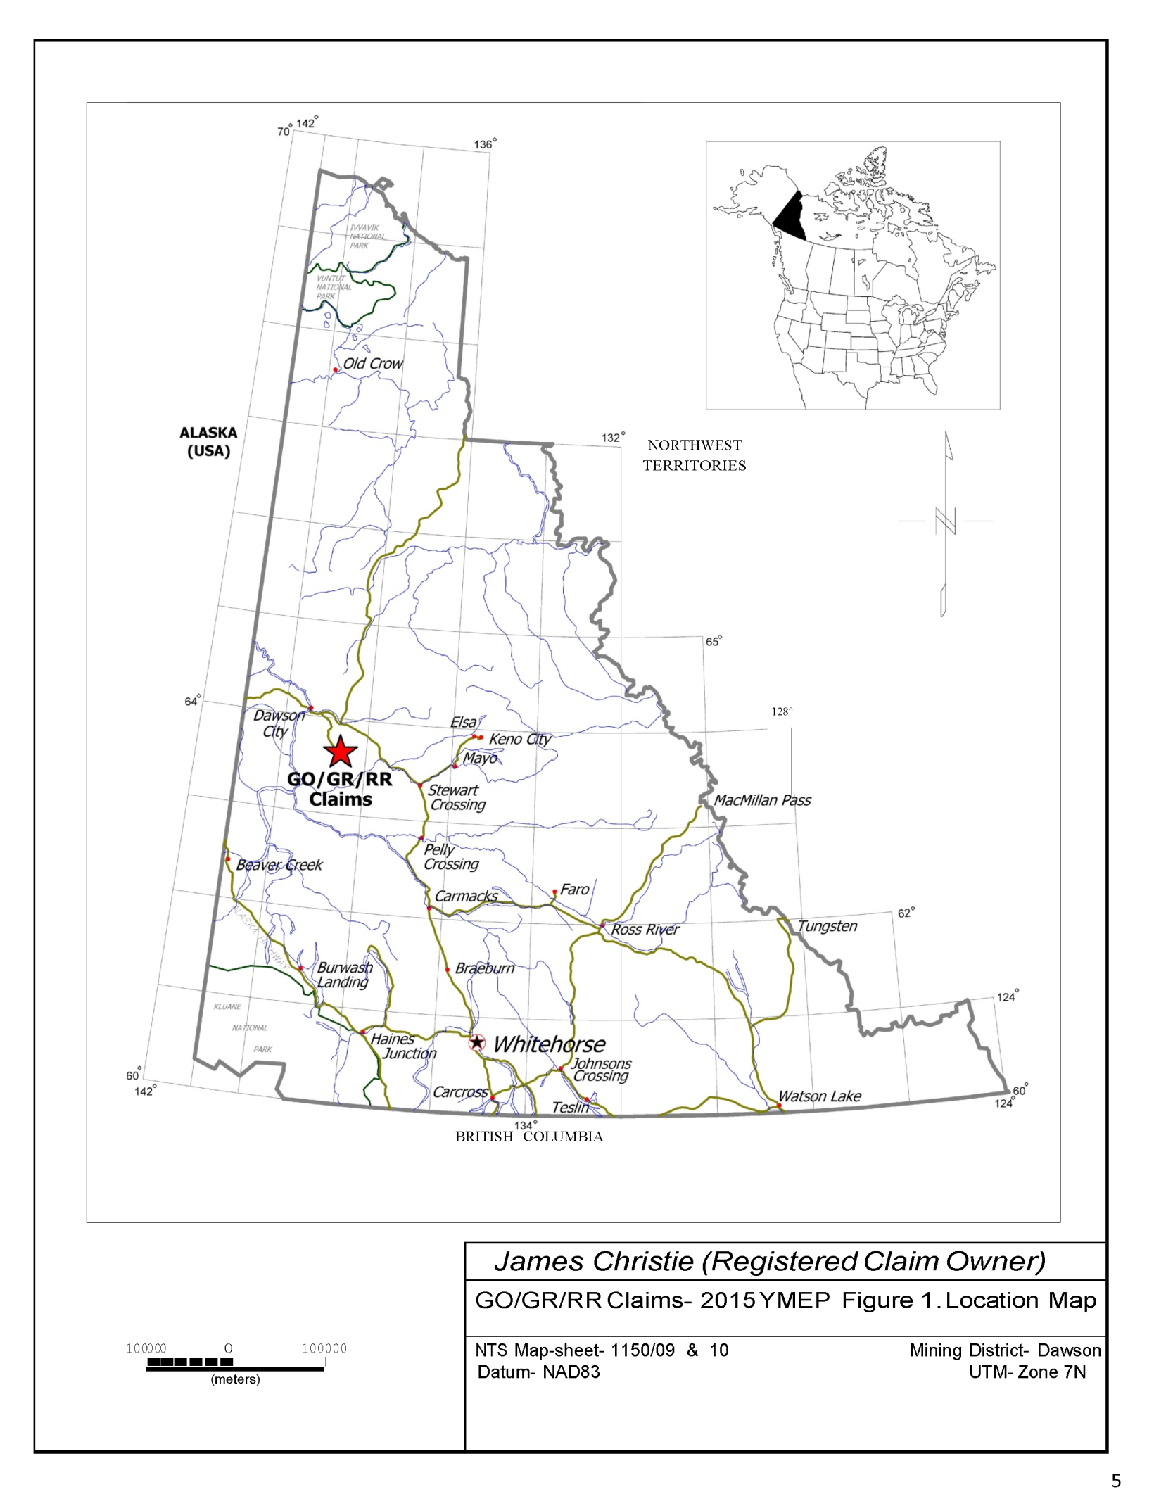

Figure 1: Yukon Location Map

Table 1: GoGr Project – Quartz Claims Summary List
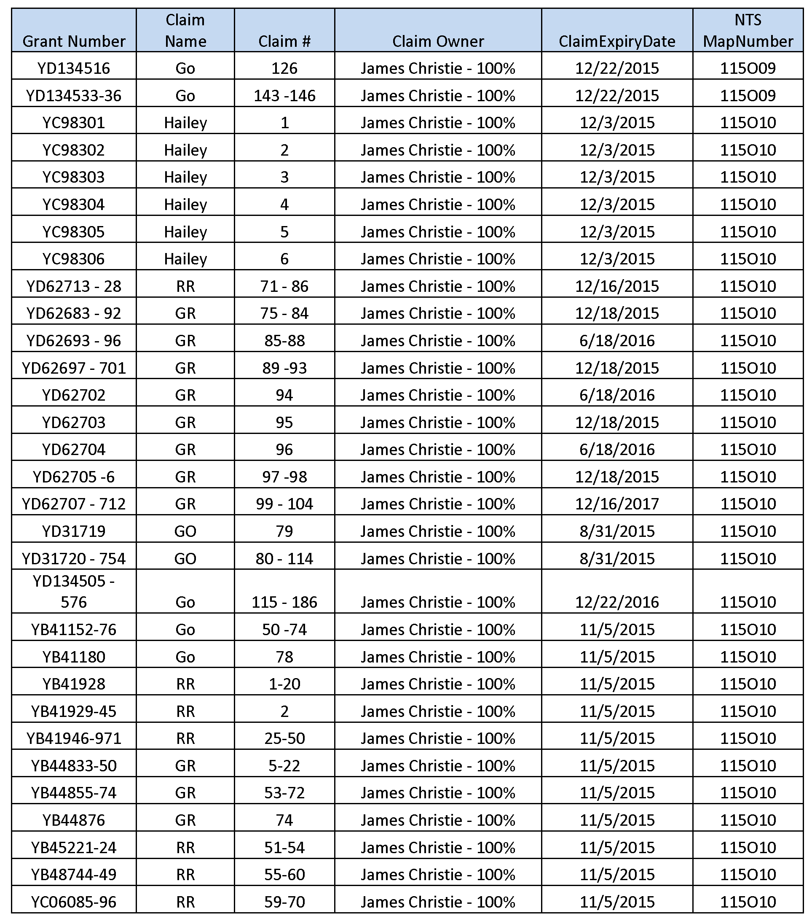

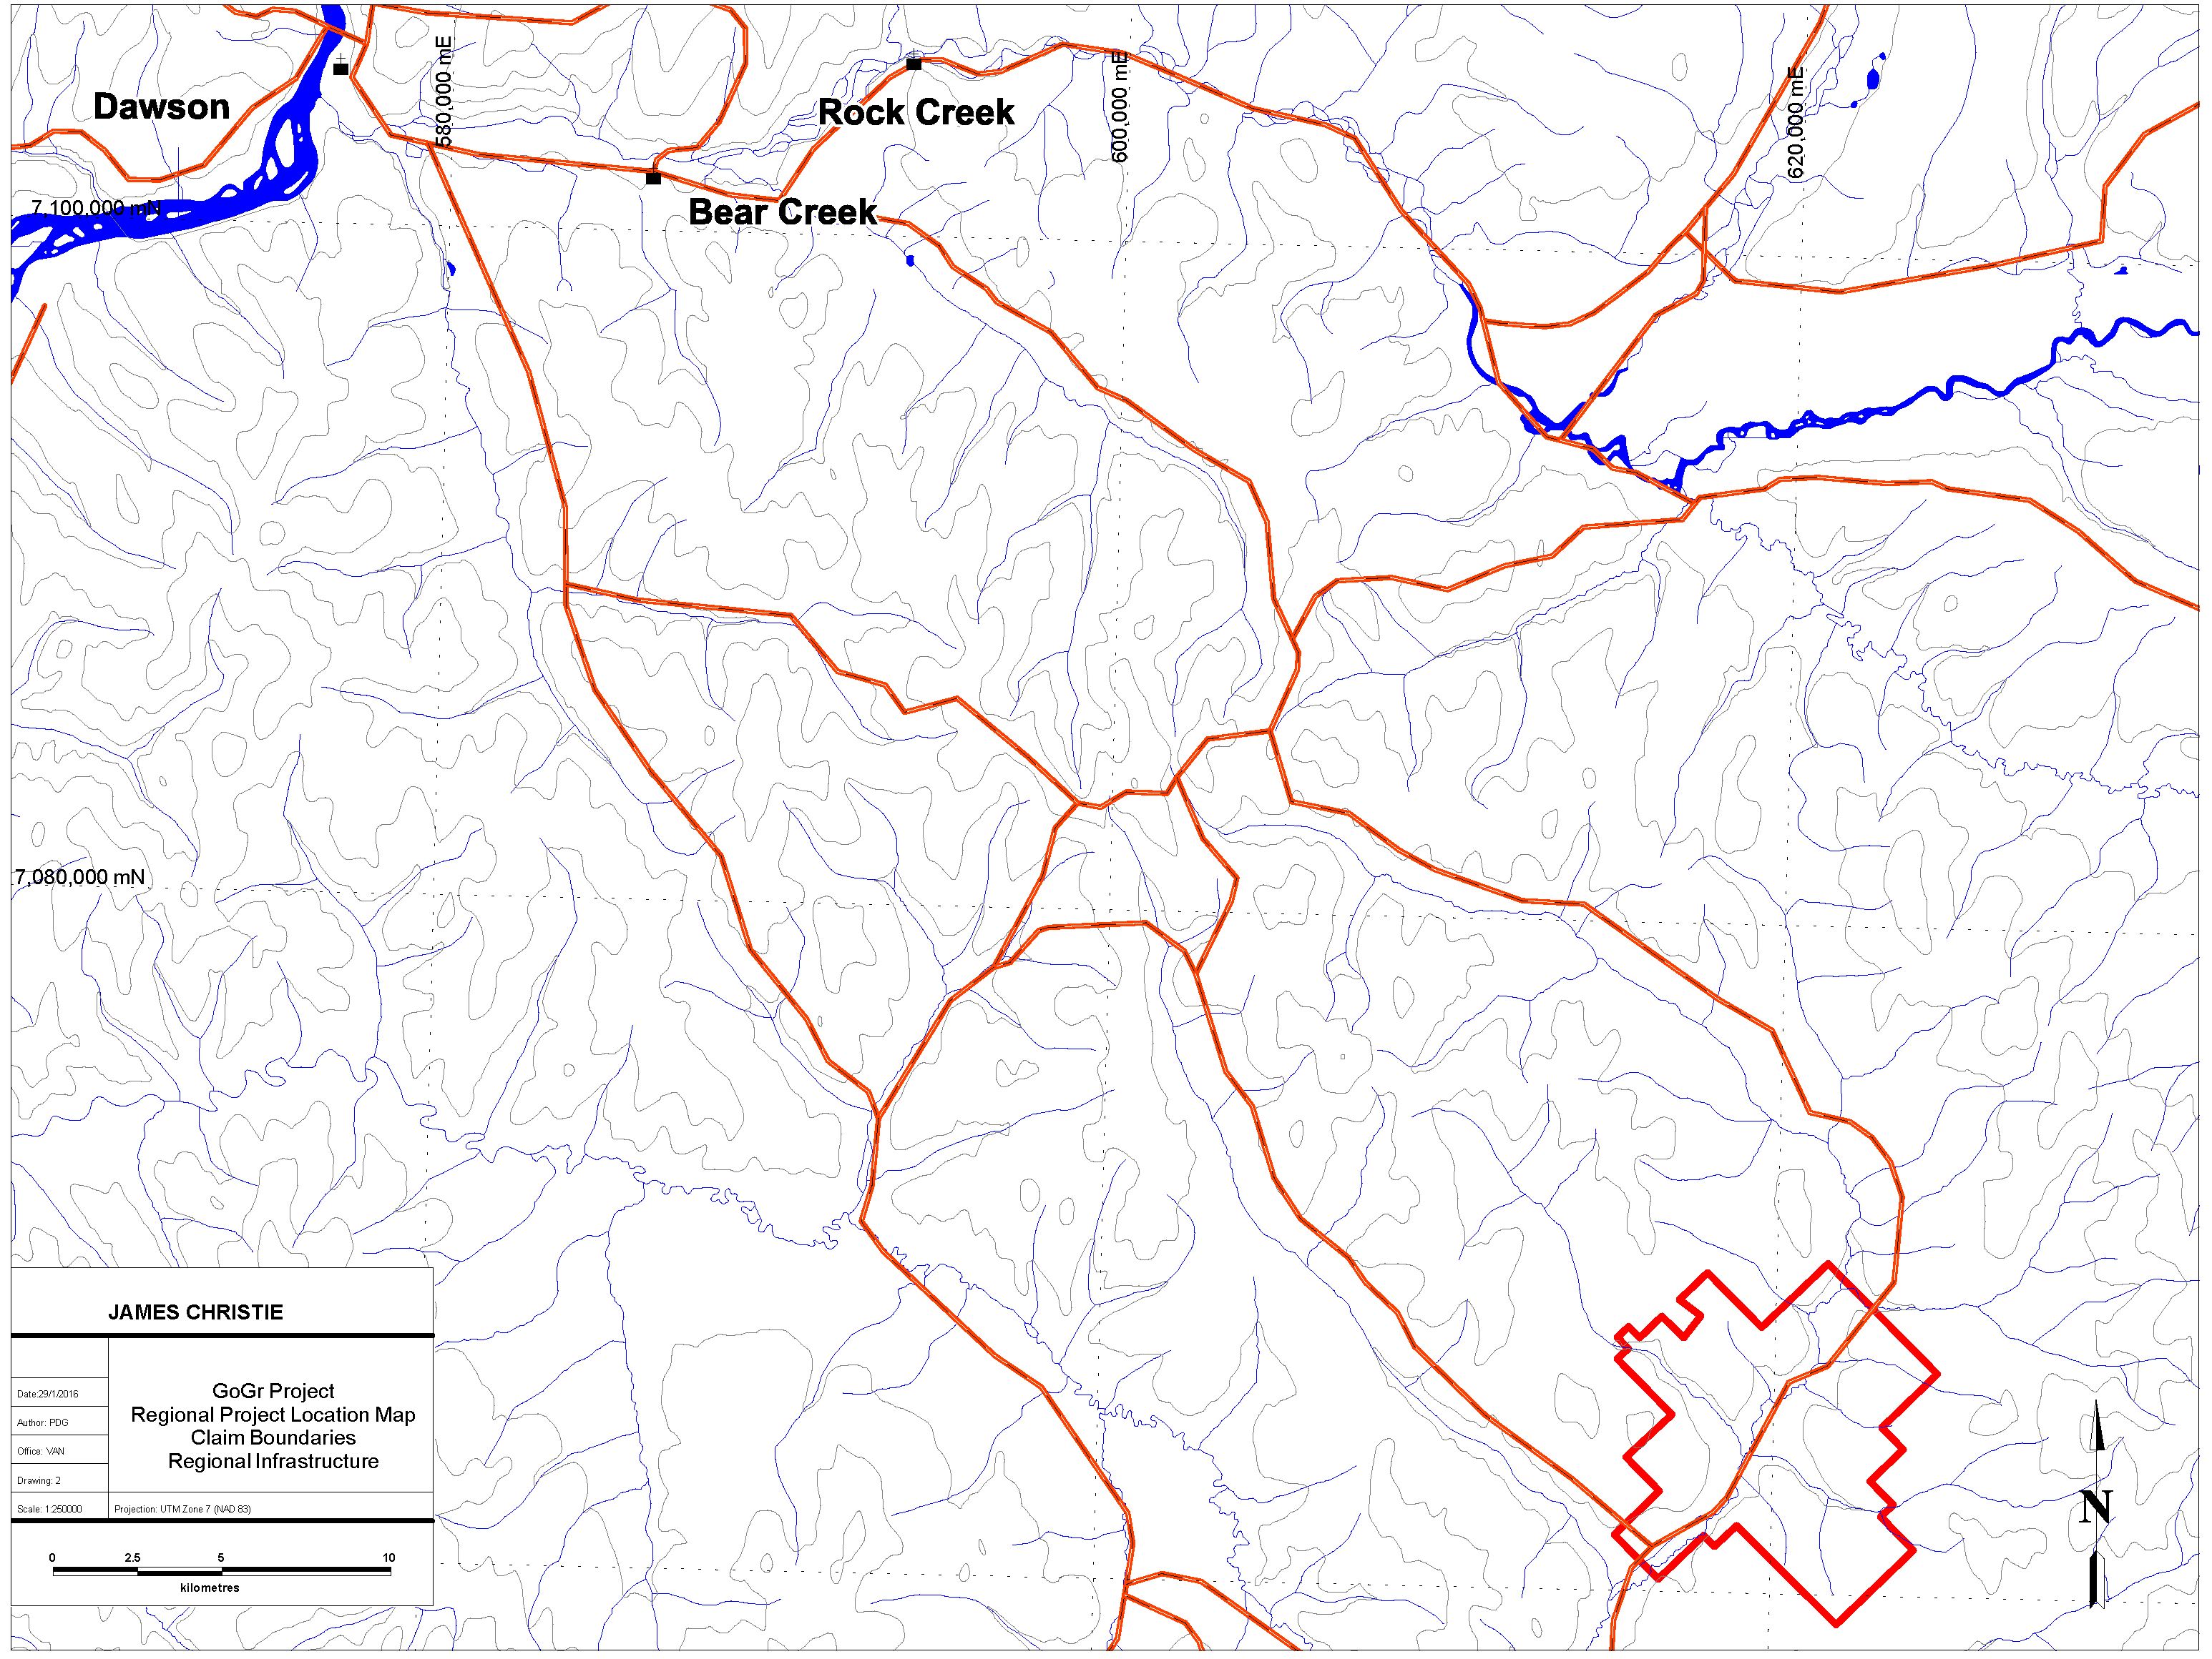

Figure 2: GoGr Project Regional Location Map – Access and Claim Block Boundary
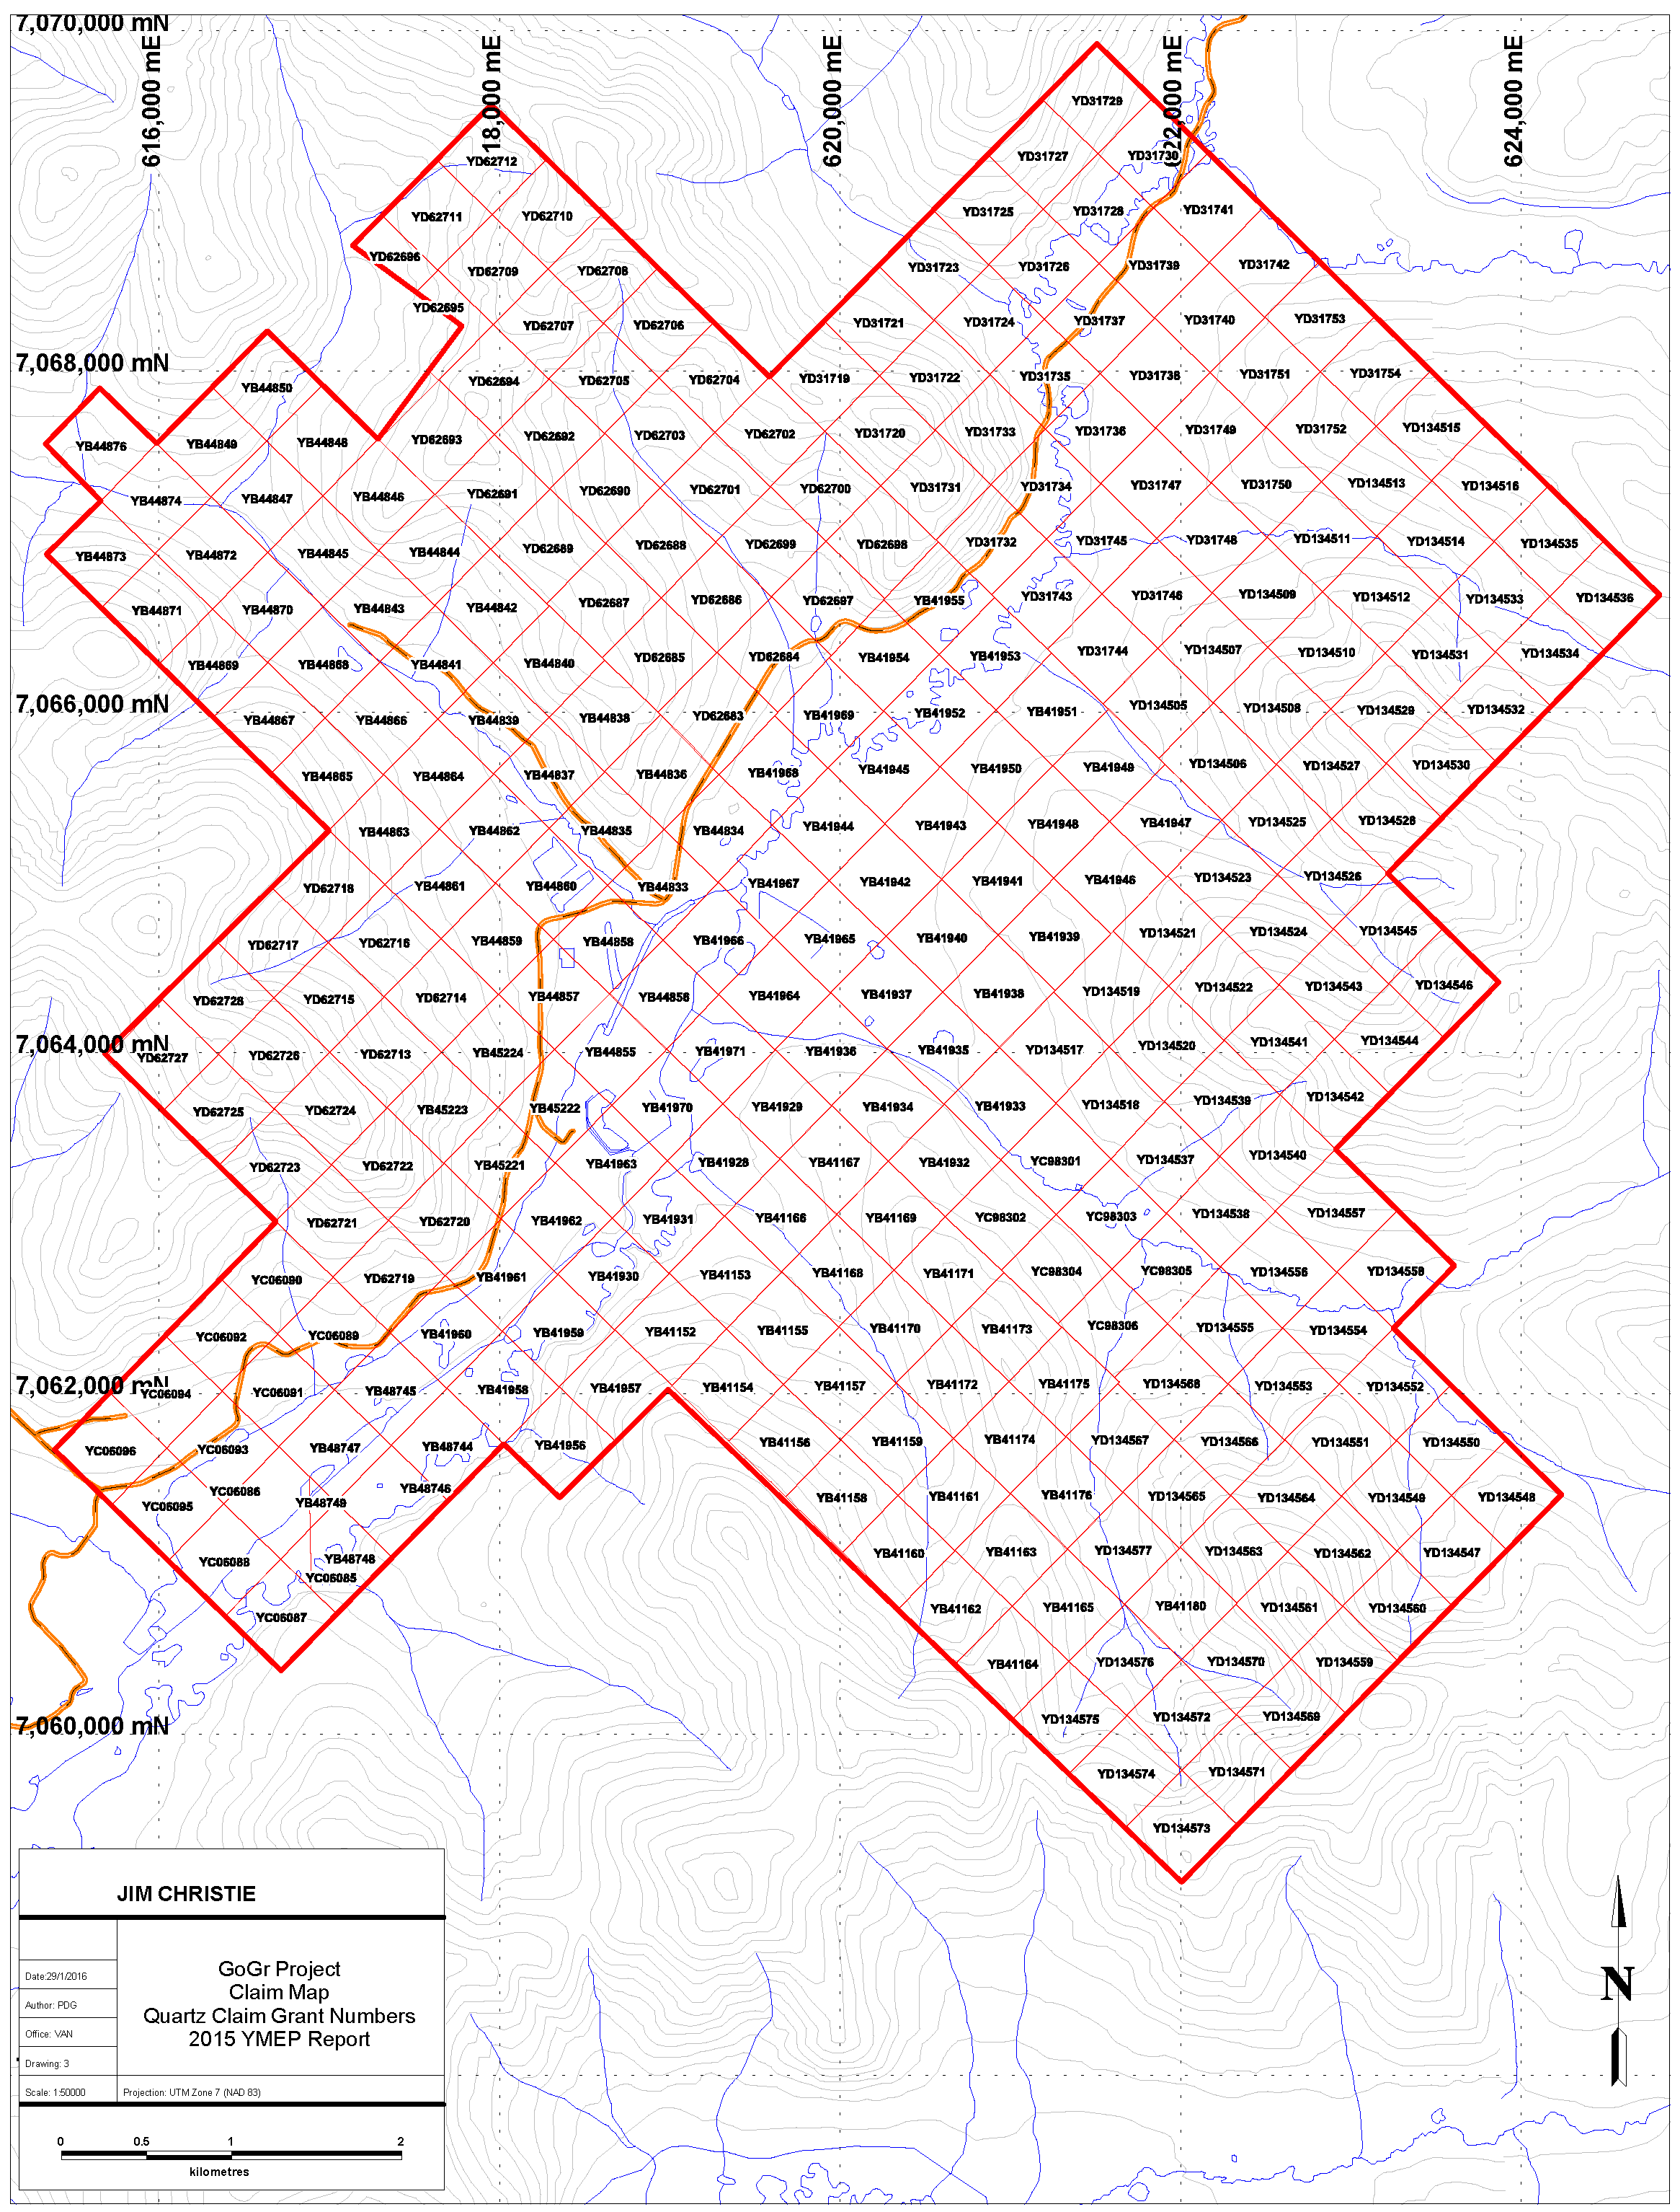

Figure 3: Tenure Map

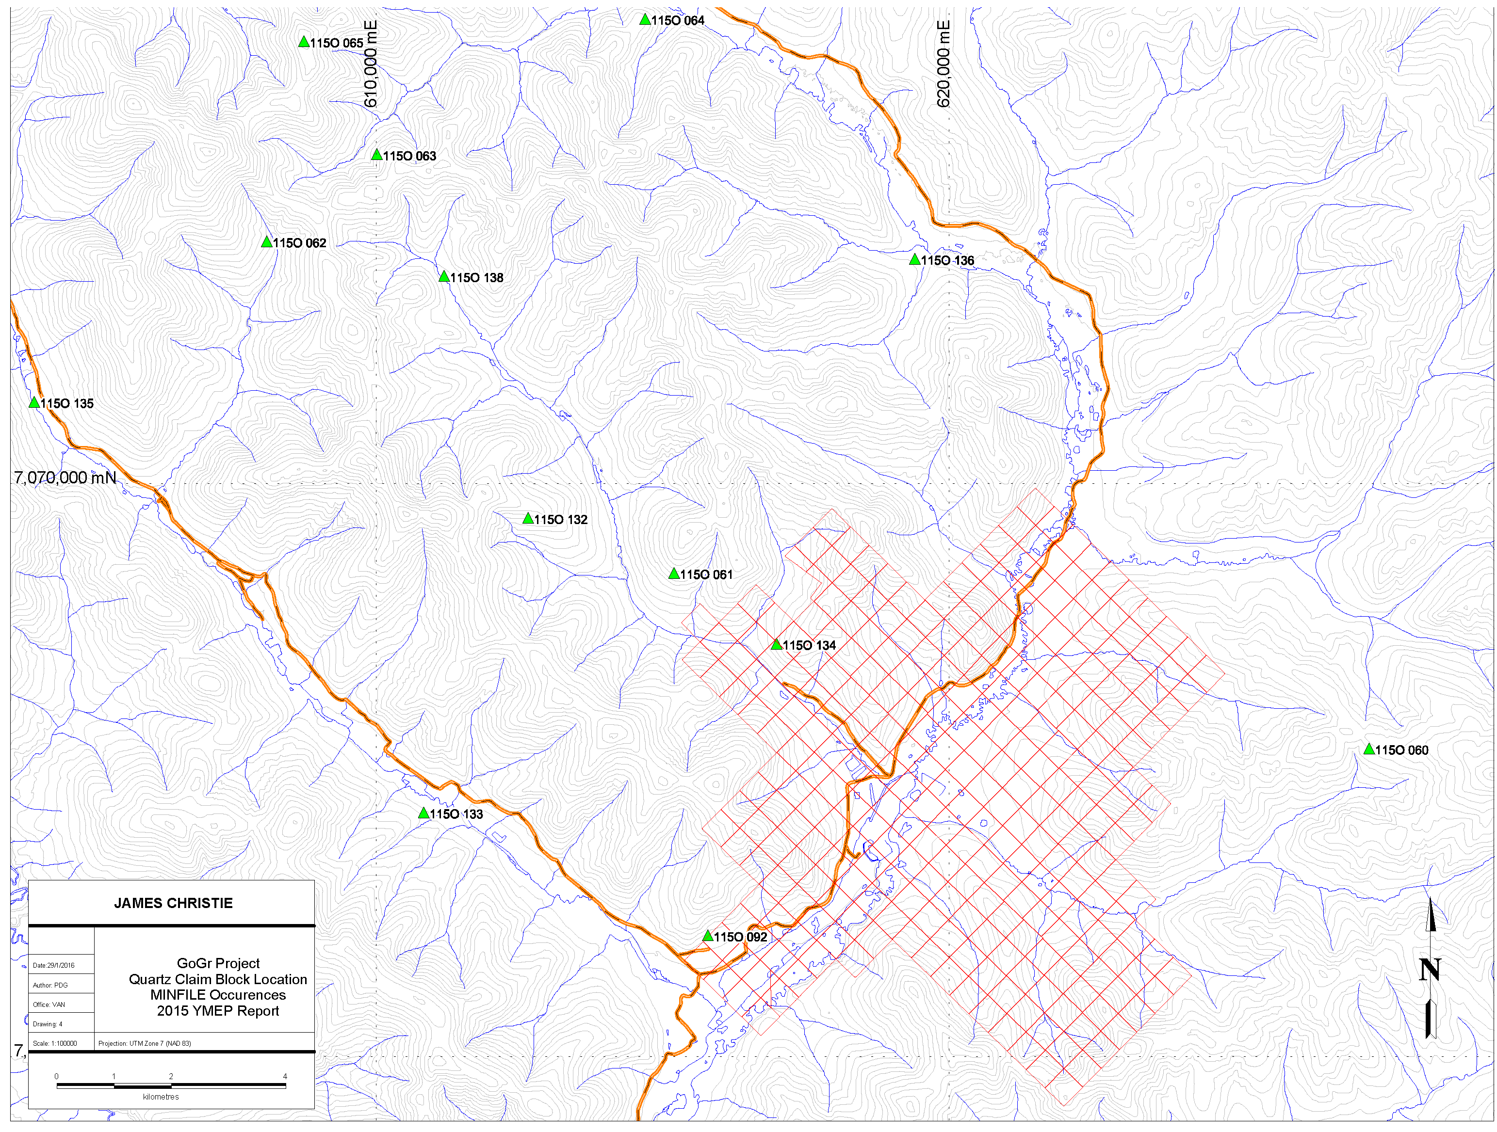

Figure 4: GoGr Project Quartz Claim Map – MINFILE Occurrences

ACCESSIBILITY, CLIMATE, LOCAL RESOURCES, INFRASTRUCTURE, PHYSIOGRAPHY

The GoGr Project claims are easily accessed by the Bonanza, Hunker and Dominion Loop roads (Figure 2) in the Klondike Gold Fields that lie approximately 55 km south of Dawson City, Yukon. Those claims that are immediately accessible via the well maintained network of existing roads are within a 1 hour drive from Dawson City. Dawson City itself is located approximately 500 km from Whitehorse, YT and is accessed via the well maintained, year-round paved, Klondike Highway. Bonanza and Hunker Creeks offer summer maintained graded gravel roads linking with Dawson City and the Klondike Highway, as well as the Dawson City airport; a full service airfield with regularly scheduled flights. Several smaller, gravel airstrips exist in the significant placer workings of the Eldorado and Indian River valley floors. Dawson City is the closest population centres and affords all facilities; hotels, restaurants, grocery/hardware stores, and fuel bunkers.
Several full service and fully supported exploration camps are located within the contemporary placer workings in the Indian River Drainage, and provide a more proximal, alternate to accommodations in Dawson City.
The GoGr Property covers an area of modest to subtly rolling terrain, with elevations that range from approximately 540 metres ASL in the valley bottoms to 860 metres ASL on the ridgelines. In general, the area is covered by second growth spruce, poplar, birch and alder, with higher elevation ridges dominated by buckbrush (willow/birch).
The climate of the claim block, and region can be described as sub-arctic, with a low annual precipitation. The “summer”, or field workable portion of the season, begins in late May and lasts through mid-October annually. A few centimetres of snow fall is common in early October and can remain on the ground therefrom. Winter temperatures can fall to -40°C during the January through February period, however in the past decade winters in the region have ben milder than in previous years. Rainfall in summers is variable as some years can be excessively dry and others excessively wet. Water supplies are commonly available at valley bottoms,
The claim block covers the most heavily placer mined and productive placer ground in the area. There is very little natural bedrock exposure and old workings are largely sloughed or backfilled. Permafrost is generally continuous but less so on south facing slopes. The region is thought to be a mature, subdued landscape by Miocene time and underwent a period of uplift and erosion in the Pliocene (Tempelton-Kluit, 1980). The area was not covered by glacial ice during the pre‐Reid (latest Pliocene in age) or later glaciations (Lowey, 1999; refer to Stewart River GEOPROCESS map by Doherty et al., 1994). However, glacial outwash (i.e., the Klondike Gravel) was deposited on high‐level terraces along the Indian River area (Lowey, 1999). Limited bedrock exposure in the area has resulted in extremely limited geological mapping and therefore no detailed mapping is available for the claim area.

HISTORY

The GoGr project is comprised of 292 contiguous claims that were staked by James Christie from the early 1990’s through to 2010, and are 100% owned by James Christie. The claims were staked to cover under-explored areas in the Klondike that were interpreted to have the potential to host precious metals mineralization given the prevalence of placer gold in the surrounding (downstream) drainages. Additionally, publicly available geophysical and geologic information from neighboring mineral exploration work identified the area as prospective. The resultant GoGr Claim Block forms ragged overall outline due to the prevalence of historic quartz claim blocks in the area combined with the fact that in part, land acquisition via staking was complicated by coeval staking from other parties.
The Klondike District is renowned for its mineral endowment, particularly within the prolific placer creeks in the area, and has been prospected, explored and exploited by individuals and companies since the late 1800’s. As such, there exist several proximal and germane MINFILE occurrences listed in Table 2 and shown in Figure 4. The majority of these MINFILE occurrences are described as Vein-Au-Quartz and there are only a few drilled prospects.
There have been several periods of focused hardrock mineral exploration in the district since the late 1800’s and specifically since 2010, there has been continuous grassroots to advanced exploration on much of the nearby claim blocks owned by other parties, particularly those owned or under option by, Klondike Gold (“KG”), Kestrel Resources (“KES”) (claims optioned from Bernie Kreft), Taku Gold Corp (“TG”) and Pacific Ridge Resources (“PR”) - claims optioned from Shawn Ryan, and the property optioned by Centerra Gold for the 2014 season.
A summary review of GoGR Property history is summarized in Table 3. In 1992 the GO claims were staked immediately adjacent to the Flug claim boundary which covered the Granville MINFILE occurrence (115 O 92). The GR (Gold Run) and RR (Rob Roy) claims were added in 1993 to the east of the original GO claims and covered the Caron MINFILE occurrence (115 O 134). After the Flug claims lapsed in June of 1993, the area was restaked as the RR 59‐‐‐70 claims by James Christie to cover the Granville MINFILE occurrence. Currently, the Claim boundaries cover the original Granville & Caron MINFILE occurrences as well as the surrounding region which includes the Gyppo (Veronica) Creek Placer deposit discovered in 1992. Figure 4 highlights the documented MINFILE occurrences that are nearby the GoGr Property, and Table 2 has a summary list of the MINFILE occurrences.
In addition to the recent work by the exploration companies listed above, the Yukon Gold Project, led by the Mineral Deposit Research Unit (“MDRU”) of the University of British Columbia joined with industry partners to undertake a large-scale study of the Region beginning in 2012. This study targeted the poorly understood geology of the west-central Yukon in relation to mineralization styles, particularly in the White Gold Area, where exploration successes by Underworld Resources on the White Gold Property and Kaminak Gold Corporation on their Coffee Project have led to a new understanding of the genesis of mineralization in this region of the Yukon.
The MDRU report is focused on new geological information that was garnered from the period of intense exploration from 2010 to 2012 and concentrated on the evolution of these recently discovered gold deposits. In summary of this study’s findings, gold-bearing orogenic veins in the Klondike and White Gold Areas of west-central Yukon have been shown to be Jurassic in age (Figure 7 and Table 4) and host rock compositions are referenced as important controls on the metal associations. In the Klondike Schist, the mineralization is thought to be low grade VMS style with typical Au- AS-Pb+/- Cu-Zn signatures.

Table 2: Germane MINFILE occurrences near GoGr Claim Block
Minfile number |  | Name | Description | Status
115O | 60 | BURNHAM |  | Anomaly
115O | 61 | PAYNE (AIME,KENTUCKY LODE) | Vein Au-Quartz | Prospect
115O | 92 | GRANVILLE |  | Unknown
115O | 132 | DEVINE (KENTUCKY LODE) | Vein Au-Quartz | Propsect
115O | 133 | SULPHUR |  | Drilled Prospect
115O | 134 | CARON | Vein Au-Quartz | Drilled Prospect

Table 3: Property History
YEAR | COMMENTS
Aug-74 | Originally staked as Ancient Mariner by D. McCrae (Y89745).
1984‐86 | Restaked as Sul claims (YA80135) in a joint venture by United Keno Hill Mines Ltd and Falconbridge Ltd which performed mapping, sampling and trenching in In 1986, the RU claims (YA88064) were added to the east and both the Sul and RU claims were explored with mapping, VLF‐‐EM, geochemical surveys and trenching.
1990 | Wealth Resources Ltd staked 192 Gulf claims (YB39274) 3.5 km to the southwest in 1990 and explored with reconnaissance mapping, soil sampling and a bulldozer cut.
1992 | The GO 48‐‐79 claims (YB41150‐‐81) are staked up to the Flug claims by J. S. Christie. Reconnaissance soil sampling and prospecting is completed (see Assessment Report 093127).
1993‐94 | In August 1993 C. Little restaked a portion of the Gulf claims as Flug claims 1‐‐40 (YB45415) for Faith Mines and Calais Resources Ltd. (both companies are associated with Arbor Resources Ltd.). In June and July 1994, Faith Mines carried out soil sampling and magnetic/ VLF‐‐ EM surveys over portions of the claims. In August 1995 Faith Mines carried out a soil sample survey on Flug claims 33, 35 and 37, in the southeast corner of the claim group.
1993-97 | The GO claim block is expanded to the adjacent part of Dominion Creek valley and lower Gold Run Creek by J.S. Christie who performed soil sampling and auger drilling. The GR and RR claims are staked to the west and covers the Caron MINFILE occurrence (115 O 134).
1997 | The original MINFILE occurrence (115O 092‐‐ Granville) is restaked as RR claims 59‐‐70 (YC06085) by J.S. Christie in October 1997 to tie onto the GO claims.
2009 | J.S. Christie completes a YMIP funded auger drilling program focused on the GO claim block to target Au‐‐anomalies. Locates an anomaly on the east‐‐side of Veronica Creek covered under two large mud stripping piles. The claim block is expanded to the North and East.
2011 | J.S. Christie completes a YMIP funded program with 256 soil samples and 7.5 km of Induced Polarization survey. All of the new data and the historical data from the property have been compiled into a database that can be used in various mapping programs.
2014 | Gimlex Enterprises Ltd. Completes a 15 hole auger drilling program on the Rob 23‐28 placer claims on Veronica Creek

The GO claims are comprised of the original mineral claim block staked in 1992 to cover the drainage of Veronica (Gyppo) Creek, a small left limit tributary of Dominion Creek. In the early 1990’s Gyppo Mining had discovered a small, high-grade placer deposit in the lower part of the drainage and the mineralization concept was to search for a bedrock source of that placer gold via utilization of conventional prospecting and geochemistry. A reconnaissance soil‐sampling program funded through YMIP was eventually conducted and several strong gold anomalies were identified. This initial exploration program was followed‐up with grid-based soil sample geochemical surveys, where the strongest geochemical anomalies were checked with backhoe trenches to bedrock as well as limited auger drill holes. While interesting, the anomalous zones seemed to be small and discontinuous.
In the course of the work an elevated auriferous gravel terrace was found higher on the slope above the anomalous soil samples and was suspected to be the source of Gyppo Creek gold. During the 1992‐93 season, shallow pits were dug with an excavator to explore an intense soil anomaly and alteration anomaly.
During 1993‐97 the claim block was expanded to the adjacent part of Dominion Creek valley and lower Gold Run Creek. A small amount of soil sampling and some auger drilling were done in these areas but results were not very conclusive. Permafrost at a shallow depth limited the effectiveness of soil sampling, and some of the auger holes were deep and contaminated from slough of the walls. Contamination by overlying loess was a concern.
In 2009, a YMIP‐funded program was completed on the claims which intended to test one of the main anomalous zones (the east side of Veronica Creek) via auger drilling. The holes averaged 3 metres and a soil and rock sample was collected in each hole. The average depth to bedrock was 1.3 metres and the most anomalous samples reported Au <391 ppb for soil and <178 ppm rock. The soil anomalies occur along the lower slope above a placer mined area discovered and worked by Gyppo Mining from 1991 to 1998. In 2009 there was an unexpected discovery. It was believed the placer miners had completely buried the principle gold anomaly under two large mud‐stripping piles and it was impossible to properly test the strongest soil anomaly. In the 2011 program, the anomaly was not reproduced and subsequently we have learned that the placer miner had sluiced the original soil anomaly material and then covered it with mud.
The gold anomalies discovered in 1992 were east of Gyppo Creek and were scattered along a reconnaissance soil line at the base of the slope. Anomalous gold ranged from 25‐900 ppb and was associated with high chromium and nickel response over a distance of approximately 600 metres. The chromium and nickel geochemical association suggests that the anomalous gold is present in the Ni‐Cr bearing Anvil ultramafic lithologies. Furthermore, a covered target area that is approximately 600 x 350 metres and elongated to the northwest (parallel to Gyppo Creek) is indicated by geochemistry above the placer workings. Placer gold recovered by Gyppo was about 90% pure, compared to Dominion Creek at 85%. Quasi-crystalline to dendritic looking gold with very delicate texture was observed; this texture suggests that the gold is locally derived.
Three very old test pits were found in the area. Follow‐up soil sampling plus a few backhoe pits and 5 shallow auger drill holes gave more anomalous Au‐numbers but did not highlight specific targets. A chip sample from a backhoe pit returned strongly anomalous Au, Cr and Ni values from sieved fine, coarse, and washed fractions (refer to Christie, 1993). The relationship between gold, chromium and nickel is not clearly understood, however, the Anvil ultramafics present on the claims are associated with elevated nickel and chromium and these element associations have been found in some of the recent work in the White Gold, 60 mile and Klondike areas. The geochemical correlations from 2009 are found in Figure 5: and persisted in the
2011 work. During sampling in 2009, visible gold was found in a quartz layer in the rusty orange bedrock near the main 1992 anomaly, seen in Figure 6.

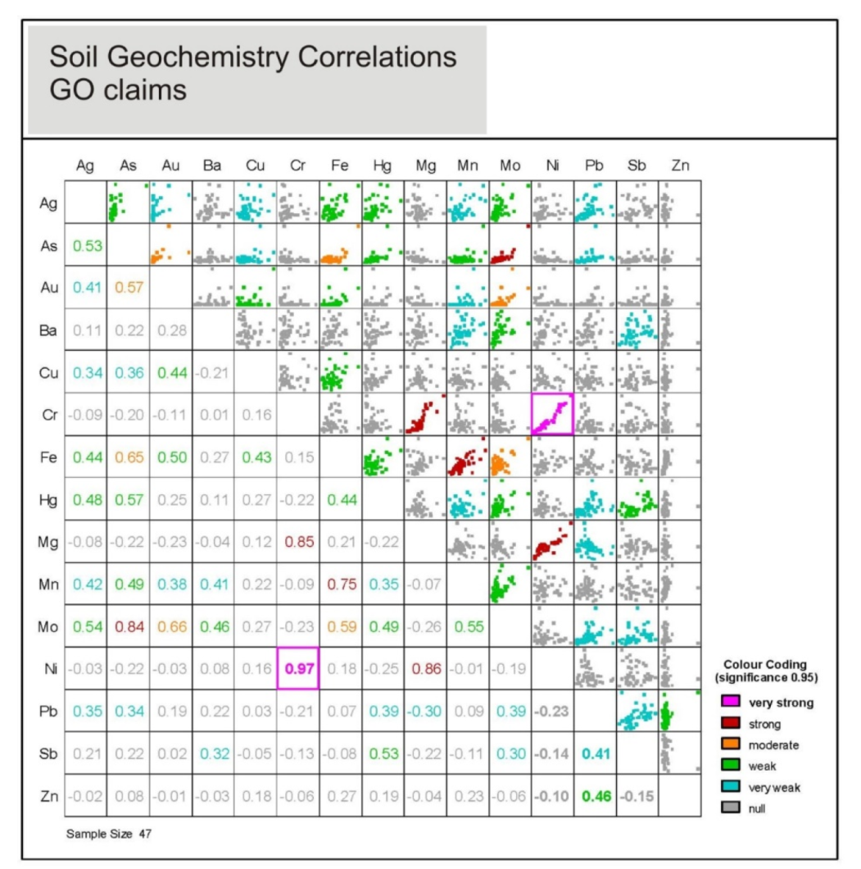

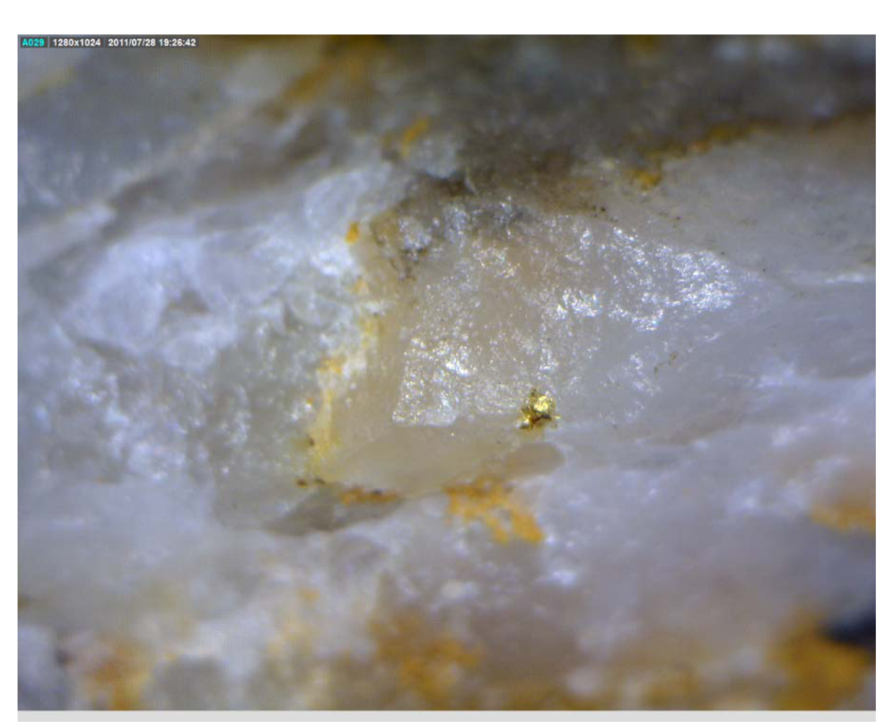
Figure 5: Geochemical Correlations of selected elements from 2009 Soils analyses – GoGr Project

Figure 6: Photograph of visible gold – 2009 – Go Property

Figure 7: Distribution of age determinations for mineralization at White Gold and the Klondike, in reference to crystalline ages of post-metamorphic magmatic units in the Yukon Tanana Terrane. From Allan, et al., 2012.

Table 4: Documented characteristics of selected orogenic lode systems in the west-central
Yukon. (Note: MINFILE 066 Lloyd is near the claim block). From Allan, et al., 2012.

In the Klondike region, the Klondike Schist is noted to have regional variations in composition, with orogenic enrichment of the metals/elements of: Au, As, Pb, Cu, Hg, and Ag as highlighted in Table 4 above. The mineralization and alteration are pyritic, and ferroan, carbonate and quartz associations are common. Moreover, pyrite, arsenopyrite, galena, tetrahedrite, are predominantly associated with occurrences of gold mineralization. The mineralization in the Klondike is structurally controlled, and Allan et al. (2012) suggest that the reactive rock units, inclusive of the magnetite bearing mafic Klondike Schist, may control gold mineralization in the district via sulphidation.
Gold bearing vein orientations in the area are interpreted to trend along three main directions; North, 120° and 90°, indicating N-S, E-W and SE structures have been mineralized. Allan, et al. (2012) mapped portions of the interpreted fault structures inferred to be related to Jurassic orogenic gold mineralization from the White Gold and Klondike (shown overlain on a regional magnetic survey compilation) and their observations collaborated similar EW structures had not been found in the Klondike region.

Veronica Creek / Gyppo Zone History
The Gyppo Zone was identified in 1991 when Gyppo Mines discovered a significant placer gold deposit from an exploratory drilling program. During the subsequent placer mining operation of this deposit it was found that the gold had a texture and purity that made it plausible to reason that Gyppo Creek gold had different source than the gold found in Dominion Creek.
In 1992, James Christie staked the land draining to the Gyppo Zone and carried out a field program that included prospecting and a soil survey traverse around Veronica Creek. The soil survey resulted in a gold-in-soil zone being identified near the confluence of Veronica and Dominion Creek. The anomalous zone consisted of multiple anomalous gold-in-soil sample sites in a row (along the survey traverse) and three isolated gold-in-soil anomalies.
In 1993, James Christie followed up the results from the 1992 program with 12 auger drill-holes that tested the Gyppo pit and gold-in-soil anomalies. The seven Gyppo pit drill holes were each drilled to 1.8 metres in depth and one drill-hole (DHG2b) returned a gold-in-rock assay of 285ppb. All other samples taken from the other drill holes returned gold-in-rock assays less than the detection limit of the analysis. The five drill-holes testing the soil anomalies identified were drilled to depths between 2.7 and 6.7 metres. Each hole that was sampled at multiple depths returned gold-in-rock assays that were greater at shallower depths. Three holes returned gold-in-rock assays of 80 ppb (DHC389-A), 195 ppb from 8 to 13 feet (DHC678) and 105 ppb from 3 to 7 feet (DHC689). A soil survey traverse from Veronica Creek to Rob Roy Creek was also collected and returned multiple gold-in-soil anomalies.
In 2009, James Christie returned to the Gyppo Zone and carried out 43 auger drill-holes to follow up on the encouraging 1993 results. Holes were drilled in a grid orientation with 3 lines spaced approximately 122 metres and station spacing approximately 30.5 metres from a base line with stations every 15.3 metres. Overburden was on average 1.3 metres and the holes on average went to a depth of 3 metres. A soil sample was taken at the bottom of the overburden and a rock sample was taken from the bottom of the hole. Five holes returned Au-in-rock assays between 92 and 178 ppb.
Building on the successful holes of the 2009 drill program, James Christie carried out an extensive drill program during the 2011 exploration season. The 2011 drill program successfully delineated a 140m east-west Au-mineralized zone (Gyppo Zone) as well as a number of other mineralized areas that merit further work. In total one-hundred-seventeen holes were completed and 23 holes returned Au-in-rock assays greater than 100ppb, 6 of which returned assays greater than 300 ppb.
In 2014, James Christie retuned to Veronica Creek and carried out a 15 auger drill-hole program. The program consisted of two lines across Veronica Creel approximately 1km southeast of the mineralized zone delineated in the 2011 drill program. No samples were submitted for analysis.

The work carried out by each of the above described exploration programs is summarized in Table 5.

Table 5: Veronica / Gyppo Zone Property Work History Summary
Year of Work | Geochemistry | Drilling | Geophysics | Trenching | Assessment Report
1992 | Soils (184)  Rocks (4) |  |  |  | 93127
1993 | Soils (109)  Rocks (37)  Drill (22) | 12 Holes (37.5m) |  |  | 93221
2009 | Soils (43)  Drill (43) | 43 Holes  (131.1m) |  |  | YMEP  2009
2011 | Soil (80)  Drill (117) | 117 Holes |  |  | YMEP  2011
2014 | Soil (2)  Drill (2) | 15 Holes |  |  | Current Report

REGIONAL GEOLOGY AND MINERALIZATION

Regional Geology

YUKON-TANANA TERRANE
The Bonanza-Eldorado-Hunker region is dominated by the Devonian-Mississippian Klondike Schist, member of the Yukon-Tanana Terrane, a macro-geological terrane which extends from east from Alaska to the southern Yukon and into British Columbia. The Yukon-Tanana Terrane include lithologies of continental affinity which are in turn overlain by volcanic arc assemblages; including back-arc and island arc formations (e.g: Colpron, 2001; Piercey et al., 1999; Murphy, 2004).
The Klondike Schist and its associated terrane members have been tectonically deformed over multiple periods and therefore are characterized by a range of metamorphic grades from lower greenschist to amphibolite facies on a Regional Scale (e.g., Mortensen et al., 1992; Roots et al., 2003). These polydeformed lithologies have been intruded by Mississippian to Permian aged granitoids (e.g., Nelson et al., 2000, Liverton et al., 2005). Mortensen et al. (1992) and D’El-Rey Silva et al. (2001) present detailed structural analyses that indicate the terrane is consistent with protracted deformation during a continuous east-northeast directed accretion and resultant crustal shortening (Liverton, 2011).
The Yukon-Tanana Terrane is preserved along this paleo-accretionary wedge in a series of fault-bounded fragments which extend from southern B.C. to Alaska (Nelson and Friedman, 2004; Dusel-Bacon et al., 2004) representing a remnant continental margin within which the later Paleozoic volcanic assemblages were emplaced. Nelson and Friedman (2004) postulate the Yukon-Tanana Terrane represents the basement for the Quesnellia Terrane which was, at that time, sutured to Yukon-Tanana.

Yukon-Tanana Structure

Within the Klondike and the Yukon-Tanana Terrane similar styles of deformation including F1 folding which has been rearranged from original bedding into alignment with axial planar foliation, the result of which is that F1 fold hinges are rarely exposed. It was during this period of ductile that the lithologies were metamorphosed to chlorite-biotite facies (and more rarely, to amphibolite facies grades). F2 folds have been defined as isoclinal, predominantly E to NE vergent. In the Klondike, third folding F3 produced open folds over the district and this deformation is pervasive at outcrop scales (Liverton, 2011).
The Klondike region is underlain by three thrust fault bounded assemblages that make up the mid Permian Klondike Schist (Rushton et al., 1993).
- Assemblage III – a carbonaceous quartz-muscovite phyllites, schists and marbles
- Assemblage II – a micaceous and chloritic quartzite, feldspathic quartzite, marble and calcareous schists which is intruded by the Mt. Burnham orthogneiss.
- Assemblage I – complex assortment of:
  - Quartz augen schists
  - The Sulphur Creek orthogneiss
  - Chloritic schists, metagabbros, amphibolites, quartzites and felsic schists.

Figure 8: Simplified Regional Geology. (from Allan, et al, 2012)

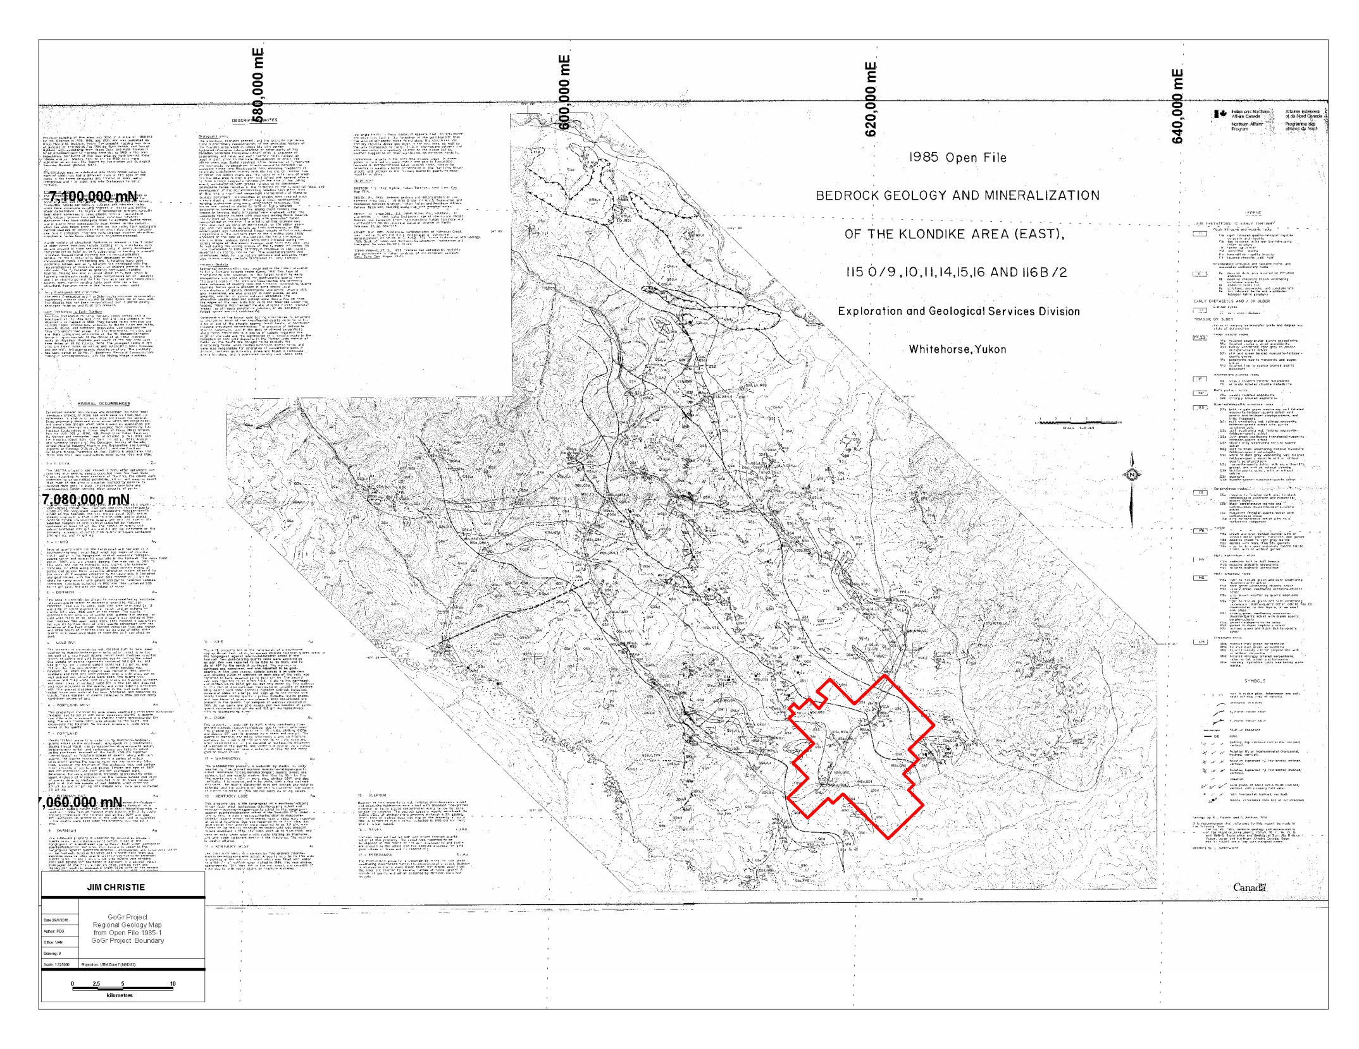

Figure 9: Regional Geology – modified from Open File 1985-1 – GoGr Claim Boundary Shown

PROPERTY GEOLOGY AND MINERALIZATION

Geology

The local property geology is poorly understood, as there is no natural bedrock exposure in the main area of interest. In the Gyppo Mining pits (dug in 1992‐93) minor faults and foliation were measured to have steep northwesterly trends. Rocks are highly deformed, siliceous, mica‐ and chlorite‐schists to gneiss (Nasina Assemblage/Finlayson equivalent) with variable disseminated pyrite, quartz veinlets and segregations. Bedrock tends to be deeply oxidized and decomposed at surface. In the areas with anomalous gold the soil and decomposed bedrock is bright orange brown in colour similar to weathering colours of pyritic or ankeritic altered rocks (this likely represents quartz‐carbonate rock of the Anvil Group).
Regional mapping by Debicki, Mortensen, Mackenzie and others shows that the general area of the GoGr mineral claim block is underlain by Late Permian, Klondike Schist with portions of the Sulphur Creek orthogniess nearby. Bedrock exposure is sparse to non-existent in the area where the GoGr Mineral Claims were worked in 2015. That stated, subcrop and float exposures are in general agreement with the YGS mapping of the claim area. In summary, it can be stated the property is underlain by chlorite schist of the Carboniferous to Permian Klondike Schist with a relatively shallow dipping foliation.
Where exposure exists in the area, the Klondike Schist shows a well-developed L-S tectonite characterized by a combination of linear (“L”) and planar (“S”) fabrics. Workers have attributed four distinct phases of deformation (D1-D4) to progressive fabric development within the Schist, however not all the deformation phases are seen within thte lithological package. Generally, resultant fold styles are lithologically controlled (Liverton, 2011). Each of these phases of deformation is further described below:

- D1 - Ductile Phase with isoclinal folds.

- D2/S2 – Kilometre-Scale macroscopic antiformal structures.

- D3 – Tight folds of S2 with a prominent NW trend.

- D4 - Conjugate angular kink folds of the penetrative foliation.

Klondike Quartz Vein Systems

Rushton et al. (1993) presents two types of quartz veins in the Klondike District, and by extension, the GoGr Claim Block:
- foliaform veins - metres thick, concordant with transposed bedding predominatly lenticular – no gold mineralization
- discordant veins – Gold bearing, sub metre thick, continuous along strike sulphide mineralization (pyrite, minor galena, chalcopyrite and tetrahedrites)

According to YGS mapping The GoGr Project is underlain by units of felsic schists of the Klondike Schist, as well as sections of the Sulphur Creek Orthogneiss package.

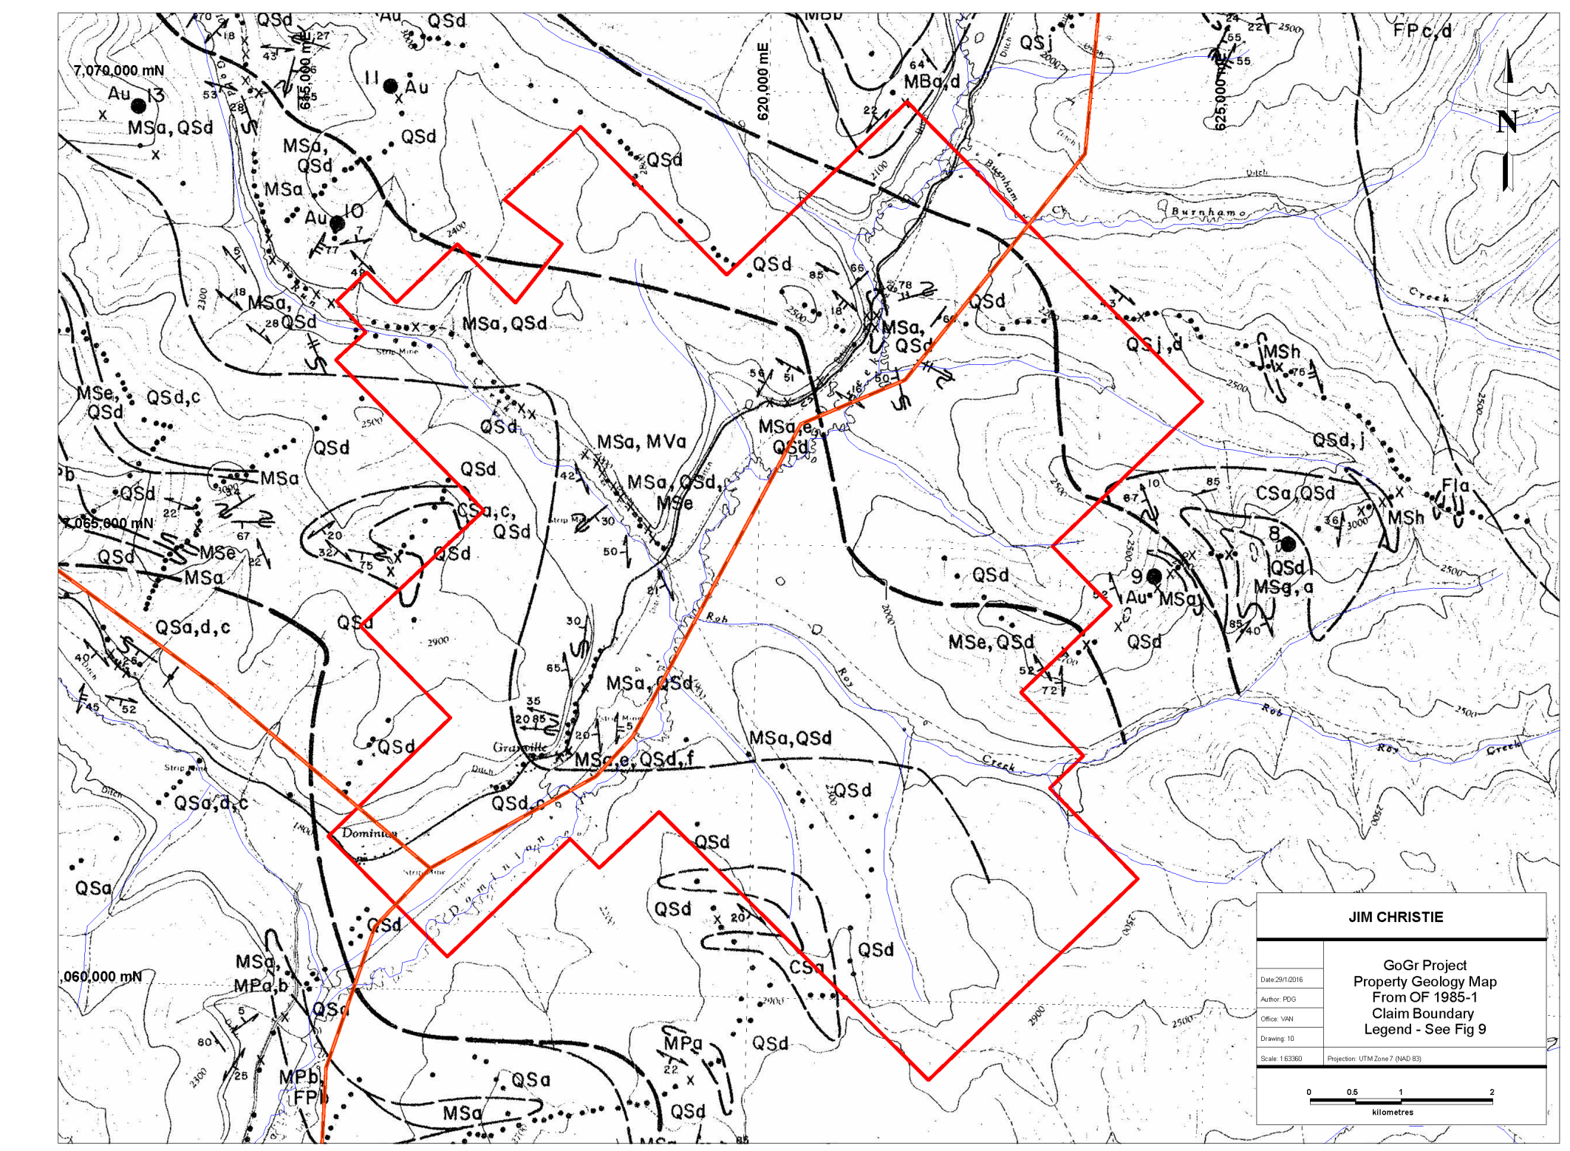

Figure 10: Property Geology – from OF 1985-1; Legend on Figure 9

2015 EXPLORATION PROGRAM

2015 Project Overview
In September 2015 a Focused Regional mineral exploration program on the GoGr Project was conducted and consisted of on-the-ground based field activities as well as follow-up laboratory testing. The project ran from September 6 - 13, 2015, and a non-field based November 12-18, 2015; for a total of 33 man-days on the Project.

Assessment work for this program was filed on Grouping HD03482 in September and October 2015, applying $20,000 of the total of $31,048.28 work program to assessment work credits and extending the mineral claims.

The 2015 GoGr mineral exploration project consisted of targeted reconnaissance and grid-type geochemical surveys combined with commiserate prospecting and geologic mapping. The primary focus of the exploration program was soils geochemistry (via complete XRF and threshold chemical analyses) and based on the anomalous As-in-soil results of historic geochemical surveys.

A total of 220 soil samples were collected and analyzed by XRF instrumentation during the 2015 exploration program. Locations of the soil sample stations were determined by GPS and are shown in Figures 11 and further defined in Appendix 4. Figure 11 highlights the location of the soils samples taken within the following detailed target areas.

Of the 220 soils collected and XRF analyzed, all were analyzed for gold via Fire Assay and 25 were selected for chemical analyses by ICP analytical methodology. The 25 soil samples selected for chemical assay were based upon threshold As and related Au pathfinder elemental XRF Results and general location (proximity to anomalously reported XRF results); analysis of the chemical assay vs. XRF assay proved a direct correlation and have bolstered the usage of XRF Instrumentation with all go-forward mineral exploration on the GoGr Claim. In addition, 16 rocks collected during the property reconnaissance sampling were selected for chemical analysis.

A total of 158 rock samples from the 2011 power auger drill program were selected for magnetic susceptibility measurements.

Six samples were collected from the Veronica Creek Zone and submitted for whole rock, major and trace element analysis. Three of these samples were selected from the 2011 power auger drill program and the other three from rocks collected from the surface. The goal of this study was to begin characterizing the rocks of the Veronica area.

Five Veronica “type” samples were submitted for thin section preparation and subsequent mineral identification and a basic mineral identification summary was prepared from these thin sections.

29 end-of-hole samples from the 2014 power auger drilling were selected and analyzed by using a portable XRF and ICP analysis. 12 rock samples from the GoldRun Zone were also collected and analyzed by ICP.
A ground magnetic survey was also carried out within in the IP Zone over the chargeability anomaly identified from the 2011 IP/Resistivity survey. The mandate of the ground magnetic survey was to determine if the chargeability anomaly also had a resolvable magnetic signature.

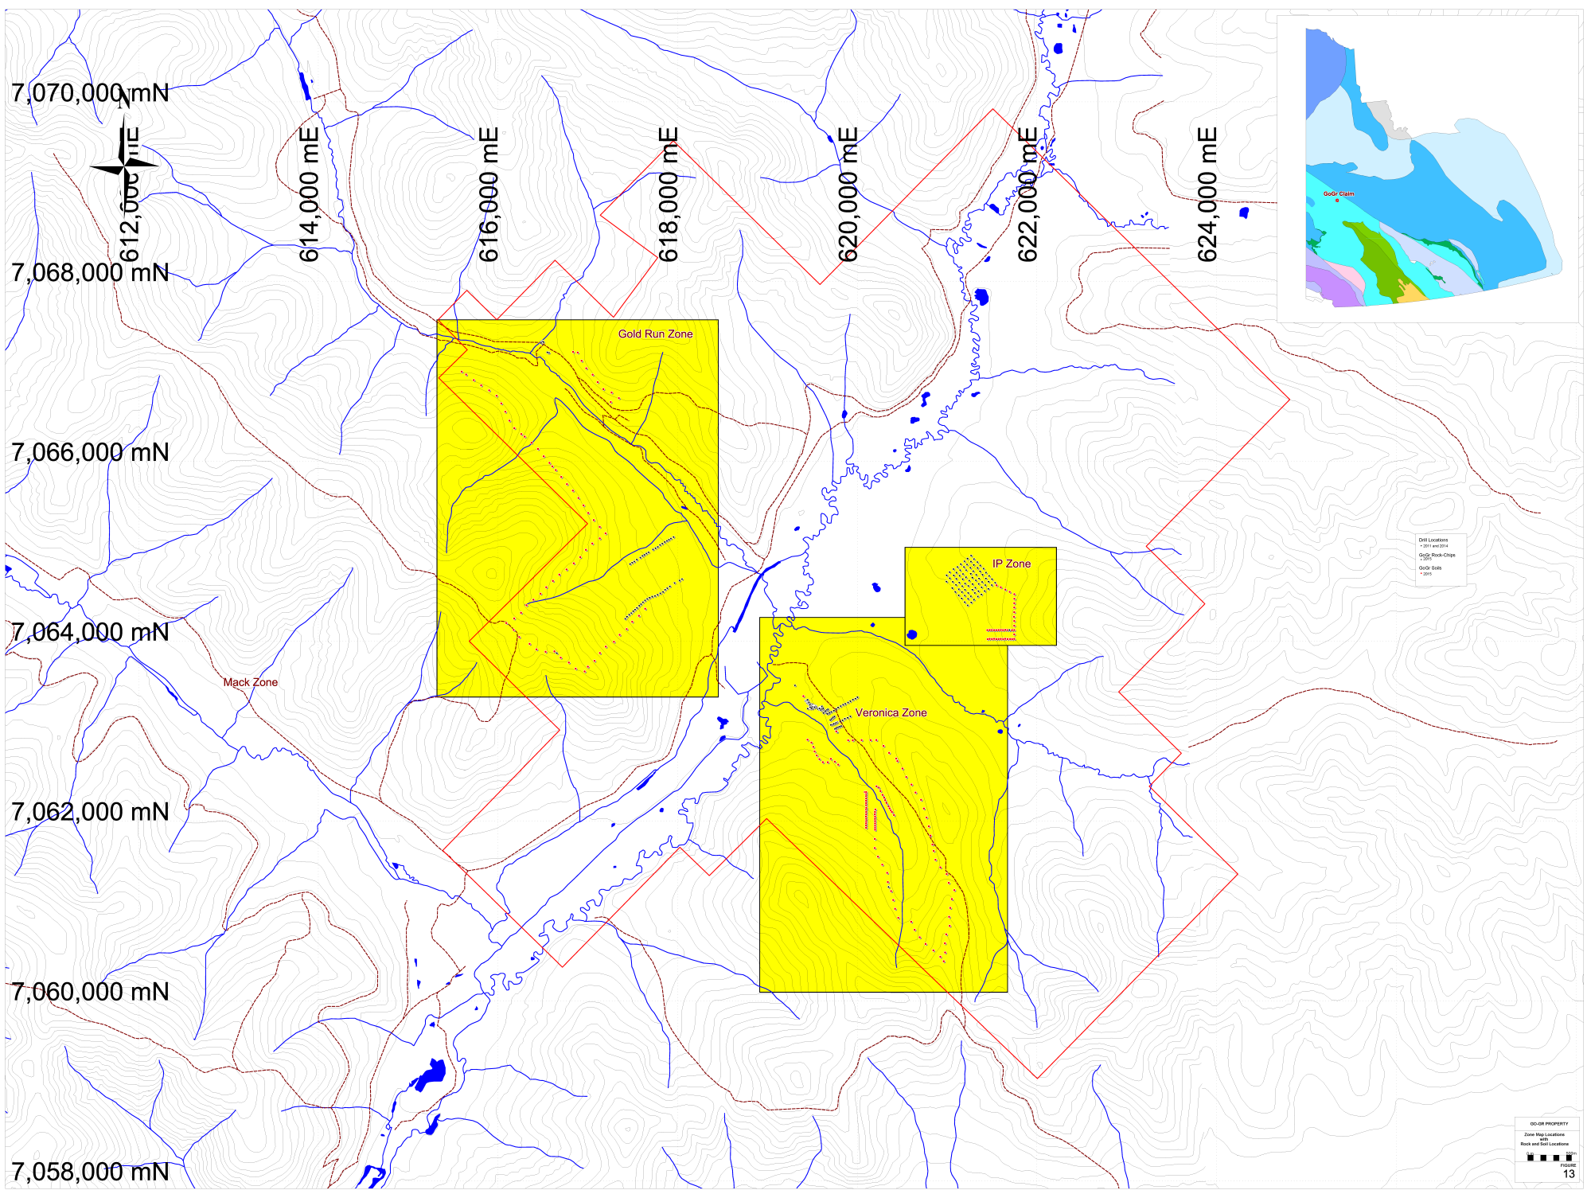

Figure 11: GoGr Project – 2015 Soils and Rock Sample Location Map - Zones

8.1 Summary of exploration work carried out in 2015
In September 2015 James Christie carried out an exploration program on the GoGr project that consisted of soil geochemical surveys, prospecting in the Veronica Creek, IP and Gold Run areas and a ground based total magnetic intensity (TMI) geophysical survey in the IP area. Samples from the 2011 power auger drilling program were measured for their magnetic susceptibility and a select group of samples were submitted for whole rock (major and trace element), verification Au and Pt and Pd analysis and petrographic analysis.
The soils surveys were successful in collecting 220 soil samples from Veronica, Gold Run and IP areas (Figure 11). All samples were analysed with a portable XRF at base camp and were submitted for gold analysis to Bureau Veritas Laboratories. In the Veronica area the XRF results suggest that Cr- and Ni-in-soils are the most useful vectors to find Au-mineralization. There is no discernable correlation to metal-in-soils and Au mineralization. In the IP area no gold mineralization was found in the soils collected.
Prospecting on the GoGr property was successful in collecting 16 rock-chip samples from Veronica, Gold Run and IP areas (Figure 11). All samples were submitted to Bureau Veritas Laboratories for gold and multi-element and analysis. One sample returned anomalous gold mineralization (GOHK-5 – 341.4ppb). Whole rock analysis suggests that there has been a moderate amount of silica addition to samples G11-63 and Veronica Type-E and Na-K addition to G11-63, Veronica Type-E and G11-61. There is no significant PGE mineralization present in the samples tested. There appears to be significant variability in the gold results between the original and the verification sample. This is most likely due to a lack of sample homogeneity before sample splits were submitted for analysis.
A ground magnetic survey was carried out in the IP area of the GoGr property. The ground survey was carried out over the chargeability anomaly identified in the 2011 IP/Resistivity survey. The mandate of the ground magnetic survey was to determine if the chargeability anomaly also had a resolvable magnetic signature. The program was successful in collecting 330 individual station readings over the 2014 auger drilling grid. The magnetic range over the grid ranged only 45 nT, however, there is strong correlation between the magnetic highs and the XRF and Au anomalous results.
8.2 Soil Surveys
A total of 220 soil samples were collected during the 2015 exploration program. Locations of the soil sample stations were determined by GPS and are shown in Figure 11 and in more detail in Figures 13, 15, 17 and 20. Samples were taken from the B/C horizon and were taken from depths between 10 and 60 cm and placed in a labelled KRAFT bag with a sample tag. All samples collected were analyzed using a portable XRF (Olympus Innov-X Delta Premium XRF). Soil samples were dried and transferred into a thin plastic bag (Glad Sandwich Bag) and placed into the XRF work station and analyzed under a 3 beam SOIL setting of 30:30:30. Soil locations and XRF results can be found in Appendix 4.
Statistical values for Ni, As, Pb, Zn and Cu are presented in Table 6. Background concentrations as well as weak and strong anomaly concentration cut-offs were established using box plots. Defining Q1 and Q3 to be the first and third quartile and IQR to be the interquartile range (Q3 – Q1), the background concentration cutoff is defined as: Background < Q3 + (1.5*IQR); A strong anomaly is defined as: Strong anomaly > Q3 + (3*IQR). A weak anomaly is defined as greater than the background but less than a strong anomaly.

Table 6: GoGr Property - XRF Statistical values for Ni-, As-, Pb-, Zn-, and Cu-inSoil
 | Ni (ppm) | Cr (ppm) | As (ppm) | Pb (ppm) | Zn (ppm) | Cu (ppm)
Min | <10 | <10 | <5 | <5 | 15 | <10
Max | 378 | 1484 | 68.2 | 79 | 208 | 302
Average | 8.4 | 82.2 | 7.1 | 10.7 | 55.9 | 22.7
Median | 3 | 60 | 4.9 | 8.2 | 47.5 | 17
Q1 | <10 | 49 | 2.7 | 6.1 | 37.4 | 11
Q3 | 12.3 | 84 | 8.9 | 11.6 | 65.3 | 28
IQR | 16.3 | 35 | 6.3 | 5.5 | 27.9 | 17
Background | 36.6 | 137 | 18.3 | 19.9 | 107.1 | 53.5
S. Anomaly | 61 | 190 | 27.8 | 28.2 | 148.9 | 79
50 %tile | 3 | 60 | 4.9 | 8.2 | 47.5 | 17
60 %tile | 6.4 | 67.4 | 6.1 | 9.4 | 53 | 20
70 %tile | 10 | 78 | 7.5 | 10.5 | 58 | 25
80 %tile | 15 | 93 | 9.6 | 13.1 | 72 | 31.2
90 %tile | 30 | 124 | 14.2 | 19.2 | 87 | 42.2
95 %tile | 35 | 178 | 20.9 | 24.7 | 106.3 | 54.1
Table 6 shows that a strong anomaly concentration is greater than the 95 percentile concentration for Ni, Cr, As, Pb, and Cu. Due to the limited number of samples collected it was deemed that there was no strong metal-in-soils anomalies found from the XRF result that could be used to vector towards gold mineralization. As such all soil samples were submitted to Bureau Veritas Laboratories for gold analysis and 25 samples were selected for a multi element analysis. Samples received by the commercial lab were dried at 60C and 100g were sieved with an 80mesh (0.180mm). From the sieved fraction 0.5 grams and 30 grams were digested in separate aqua regia solutions and analyzed with by ICP-ES (for multi-element / AQ300) and ICP-MS (for gold / AQ130). A breakdown of the gold assays is given in Table 7 and shown in Figures 15, 16, 18, 19, and 27-30. The certificate of analyses can be found in Appendix 10.
There was a good linear correlation between commercial lab (y-axis) and XRF (x-axis) results for elements: copper (slope = 1.1153, R² = 0.8195) and zinc (slope = 0.9218, R² = 0.8252) – See Figures 12 and 13. There was not good correlation between XRF and commercial lab result for chromium. This is likely due to the known problem of incomplete digestion of some Cr-minerals in an aqua regia solution.

Table 7: Summary Table Gold Assays, 2015 GoGr Project
Au (ppb)  range | No. of Samples
<12.5 | 195
12.5-25 | 11
25-50 | 4
50-100 | 3
>100 | 4

8.2.1 Veronica Gold-in-Soil Anomalies
A total of eight soil samples returned gold-in-soil values between 12.5ppb and 100ppb from three previously unidentified mineralized zones in the Veronica Creek area. Two of these areas are from the west side of Veronica Creel and one is upslope from the 2014 power auger drilling program carried out in 2014 . The gold anomalies upslope of the 2014 drilling appear to have a spatial relationship with Cr- and Ni-in-Soil. The anomalous Au-in-soil sample on the east side of Veronica Creek is also anomalous in Pb. The four samples greater than 100ppb came from mineralized area defined in the 2011 power auger drilling program. The gold results with Ni- and Cr-XRF results are shown in Figures 15 and 16.

8.2.2 Gold Run Gold-in-Soil Anomalies
A total of ten soil samples returned gold-in-soil values between 12.5ppb and 50ppb from the Gold Run area. These gold anomalies are not anomalous in any other element and there does not appear be a spatial relationship with any anomalous metal-in-soil. The gold results with Ni- and Cr-XRF results are shown in Figure 18 and 19.

8.2.3 IP Gold-in-Soil Anomalies
No soil samples collected from the IP zone returned gold-in-soil values >12.5ppb.

Figure 12: Cu XRF and Laboratory Correlation

Figure 13: Zn XRF and Laboratory Correlation

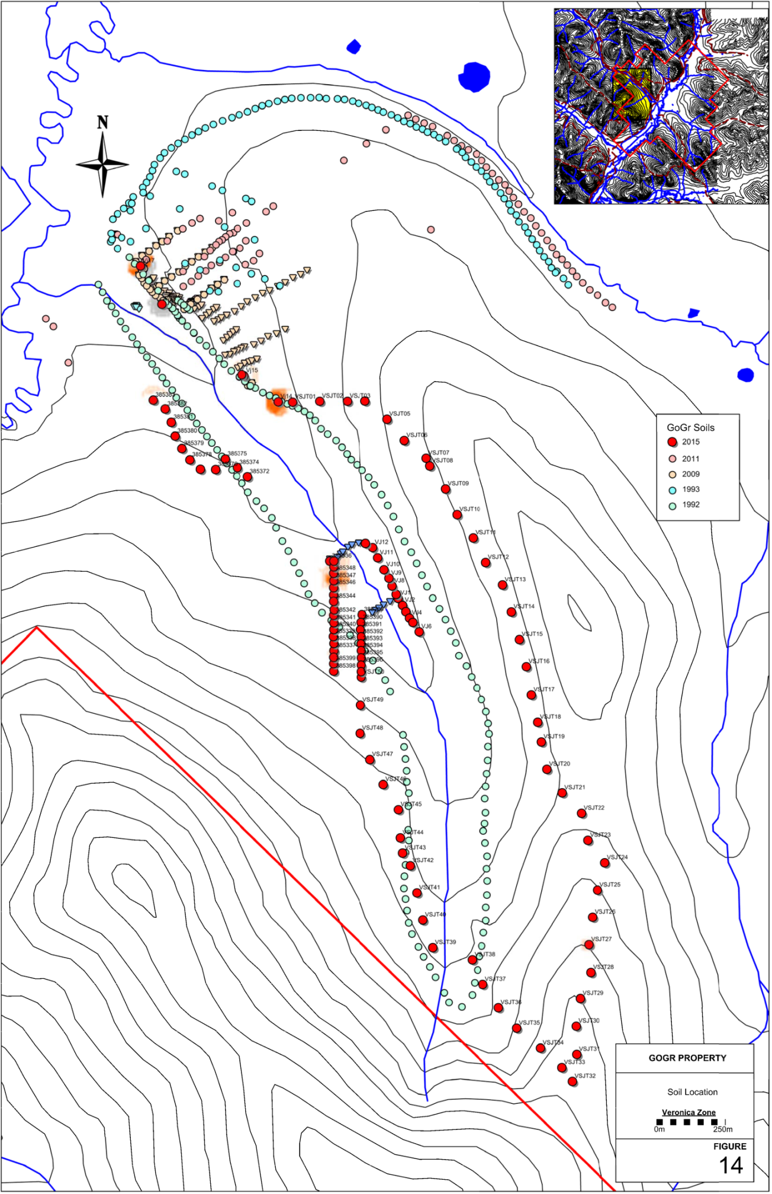

Figure 14: Veronica Zone Soil Sample Location Map
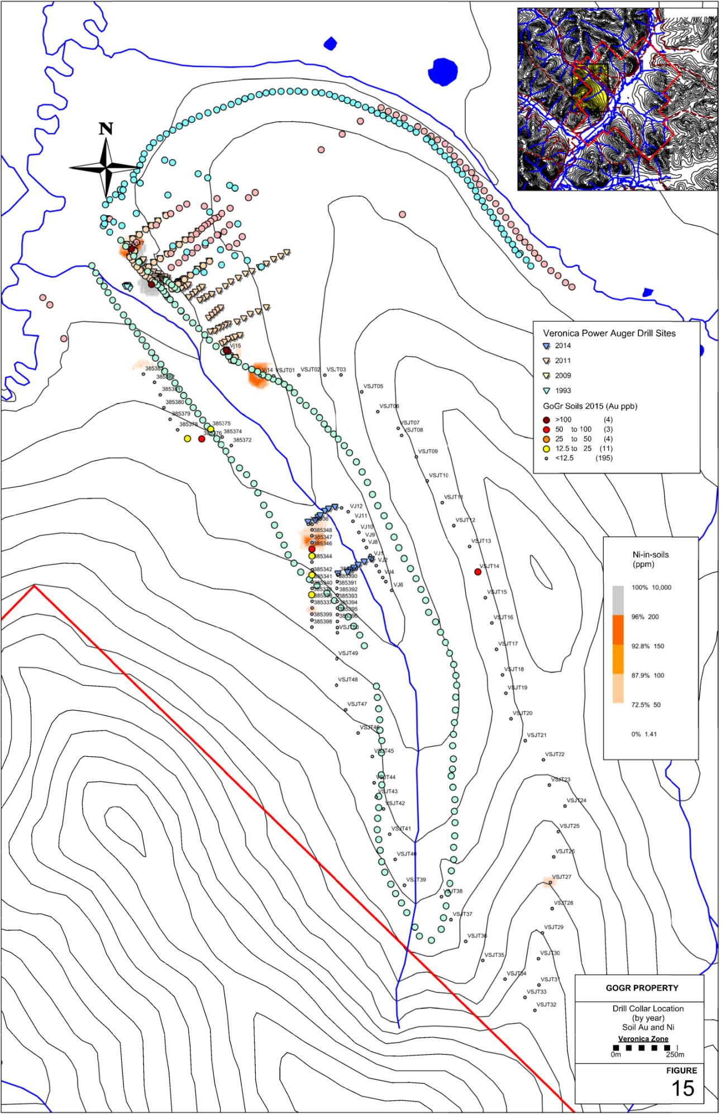

Figure 15: GoGr Project – Veronica Zone Drill collar Location Map – Soil Au and Ni
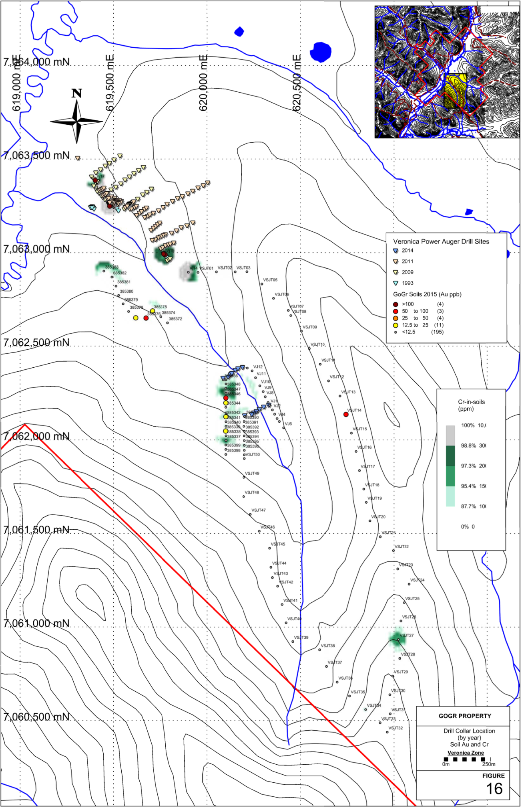

Figure 16: GoGr Project – Veronica Zone Drill Collar Location Map – Soil Au and Cr
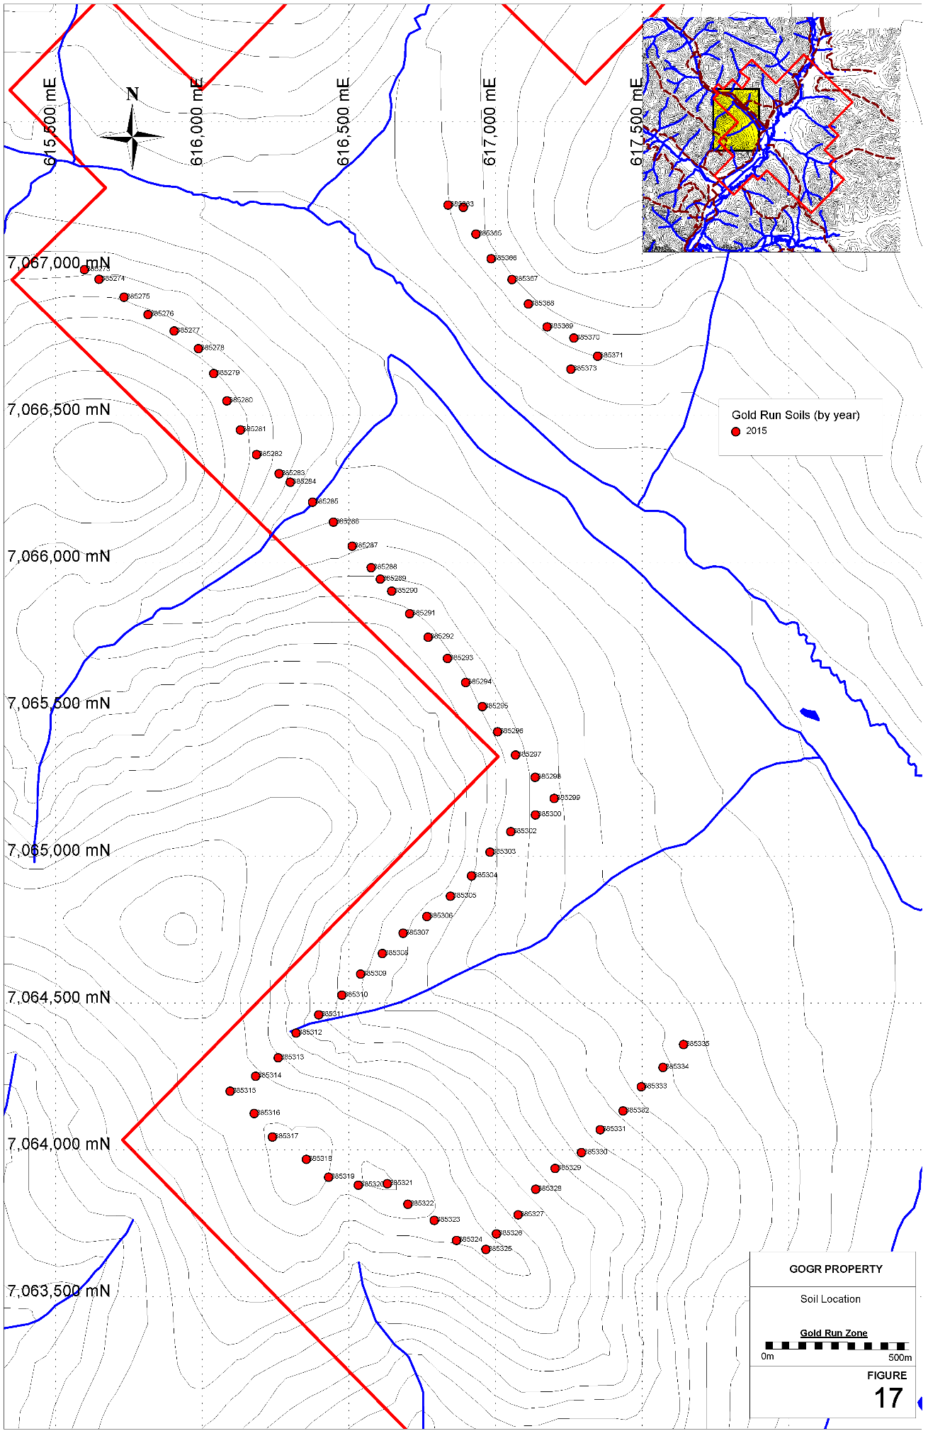

Figure 17: GoGr Project – Gold Run Zone – Soil Location Map
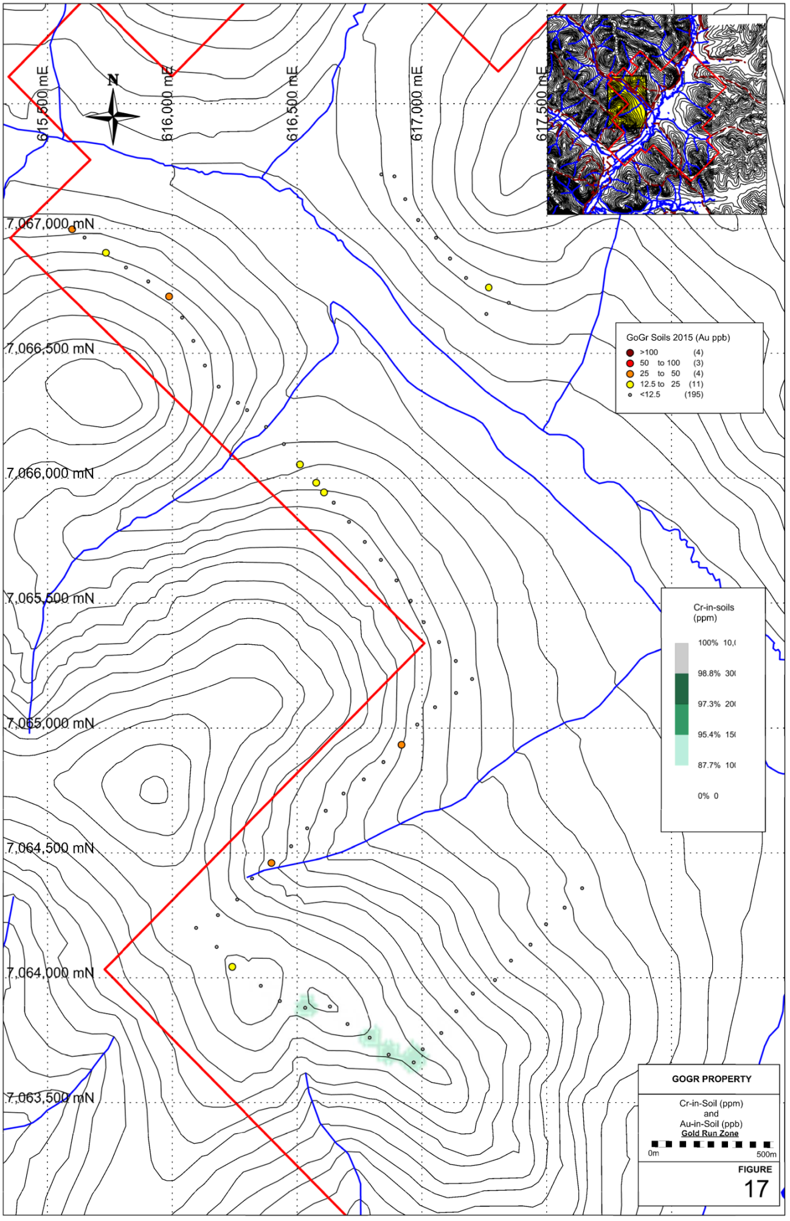

Figure 18: GoGr Project – Gold Run Zone – Cr-in-soil and Au-in-soil Map
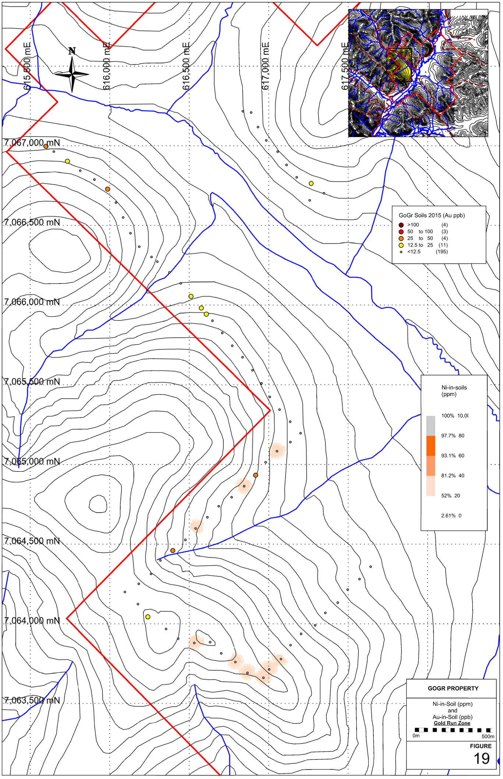

Figure 19: GoGr Project – Gold Run Zone – Ni-in-soil and Au-in-soil Map

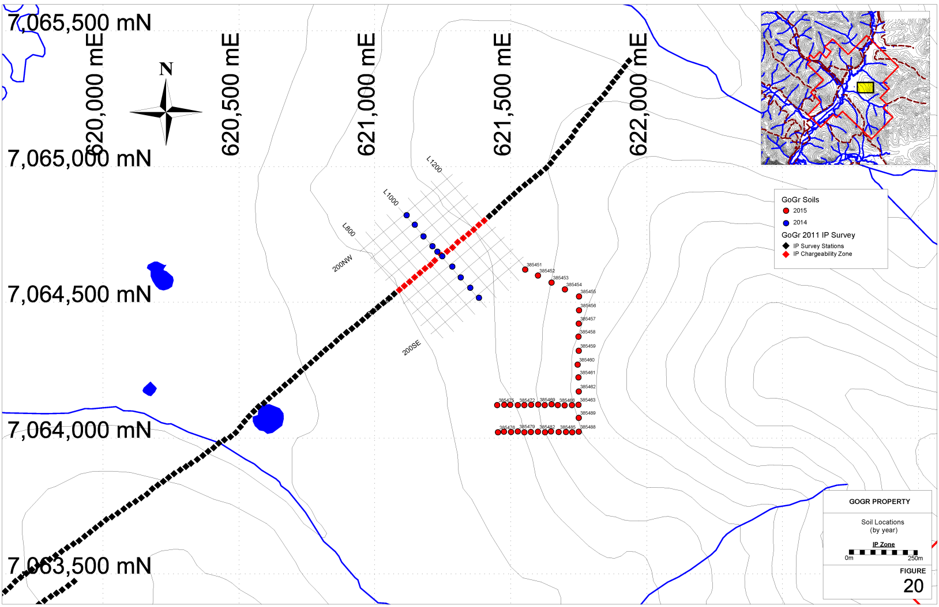

Figure 20: GoGr Project – IP Zone – Soil Location Map
9.3 Prospecting
Outcrop on the GoGr property is limited. There were four common types of subcrop/float identified on the GoGr property (quartz veins, bronze/buff weathered muscovite-biotite-quartz schist and green mafic (chlorite-actinolite-epidote) schist and green siliceous (quartz dominant chlorite-actinolite-epidote) schist. Sixty-one (61) samples were collected on the GoGr project and submitted to Bureau Veritas Laboratories for various types of analysis. Locations, descriptions and certificate of analysis of all samples collected can be found in Appendices 6 and 10. Samples collected from the Gold Run, Veronica Creek, and IP anomaly Zones are described in more detail below.

9.3.1 Veronica Creek Zone
From 1992 to 2014 a great deal of work has been carried out in this zone, by James Christie (see exploration history). Approximately 225 rocks have been collected during this period, from surface chip sampling and power auger drill sampling, and submitted for analysis. A strong Au mineralized zone, that is strongly associated with highly anomalous Ni and Cr, was identified on the East Side of Veronica creek close to the confluence between Veronica Creek and Dominion Creek (Figures 21 to 22). In the areas with anomalous gold the decomposed bedrock is bright orange in colour.
Part of the mandate of the 2015 Veronica Creek exploration program was to better classify the rocks hosting mineralization and determine a better exploration vectoring tool. In this effort rocks from the 2011 auger drilling program were measured for magnetic susceptibility, and a select few were selected for whole rock analysis and 6 rocks were selected for Au-verification and for the presence of Pt and Pd. Three felsenmeer rocks collected in the Au mineralized Zone during the 2015 season were also submitted for whole rock analysis

9.3.1.1 Au-Verification and Pt + Pd
Six samples from the 2011 power auger drilling of the Veronica Creek Zone were submitted for Au and Pt + Pd analysis. These 2011 samples were collected from altered material near the bedrock contact (subcrop soils) and were selected from the Au mineralized zone that is also strongly associated with highly anomalous Ni and Cr. The purpose of these analyses was to verify previous Au measurements and to determine if the mineralized mafic/ultramafic host rocks are PGE enriched. The results are summarized in Table 8 and compiled in Appendix 6. The analytical certificates are given in Appendix 10.

Table 8. Veronica Zone: Au-Verification and Pt + Pd results for select 2011 Drill Samples
Sample | Original Au (ppb) | 2015 Au (ppb) | 2015 Pt (ppb) | 2015 Pd (ppb)
T1-G11-78 | 232.5 | 93 | 0.8 | 1.4
T5-G11-82 | 232.0 | 40 | 0.7 | 0.9
T7-G11-84 | 118.1 | 24 | 2.9 | 3.6
T9-G11-86 | 250.1 | 177 | 1.2 | 1.7
T20-G11-97 | 738.3 | >1000 | 2.0 | 2.2
T40-G11-117 | 905.3 | 8 | 1.3 | 2.2
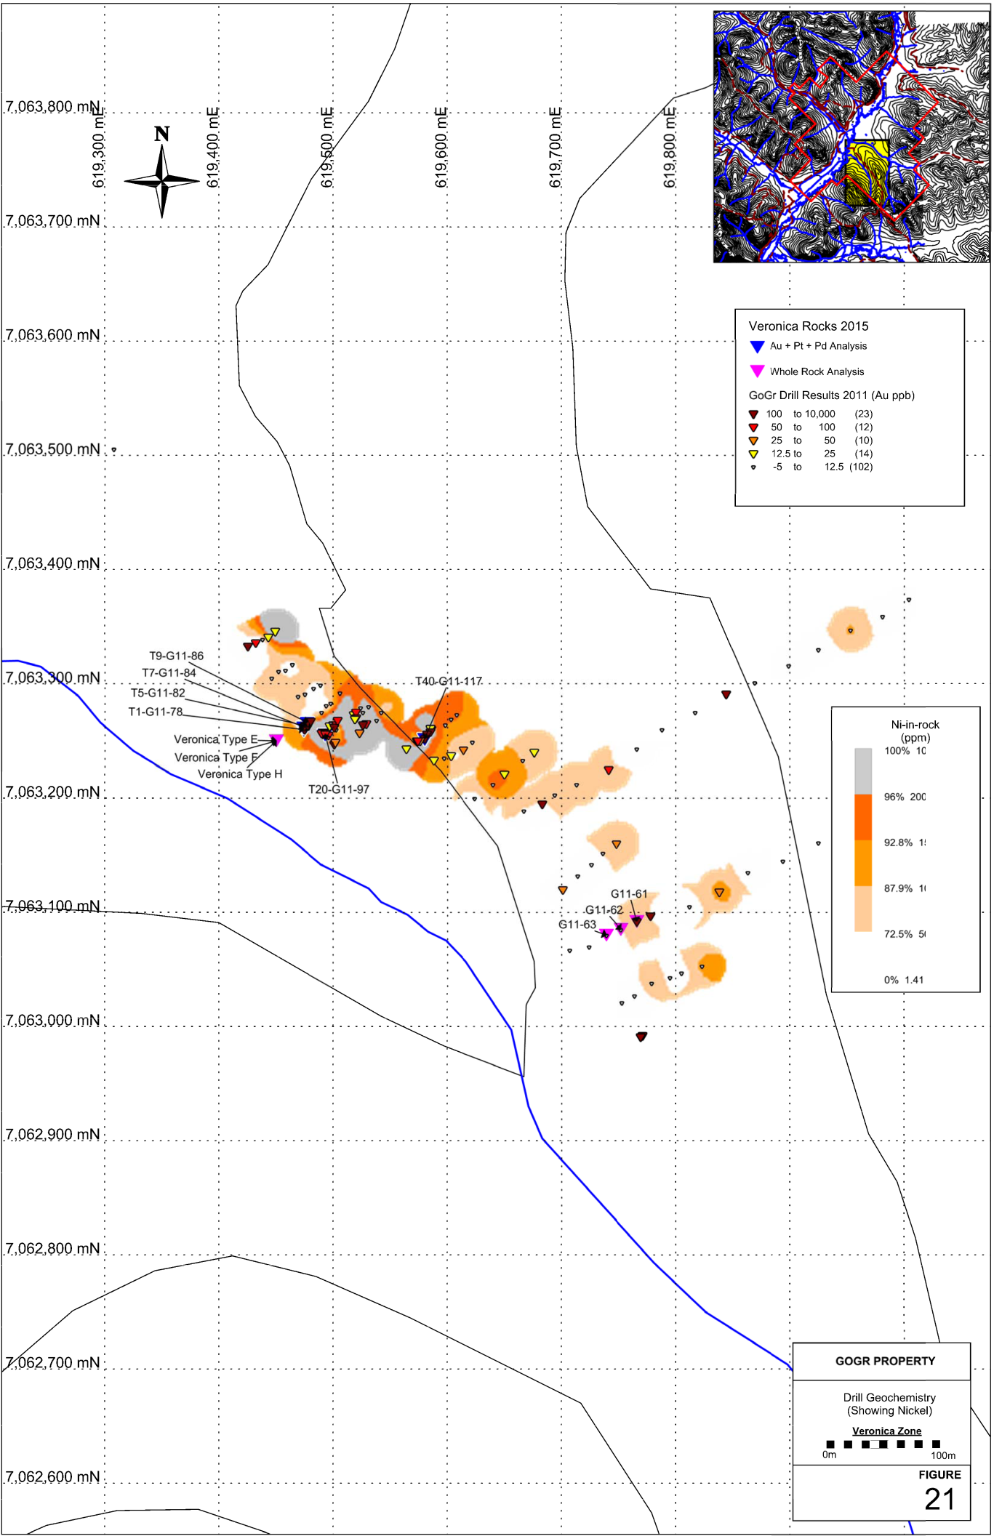

Figure 21: GoGr Project – Veronica Zone Drill Geochemistry: Ni
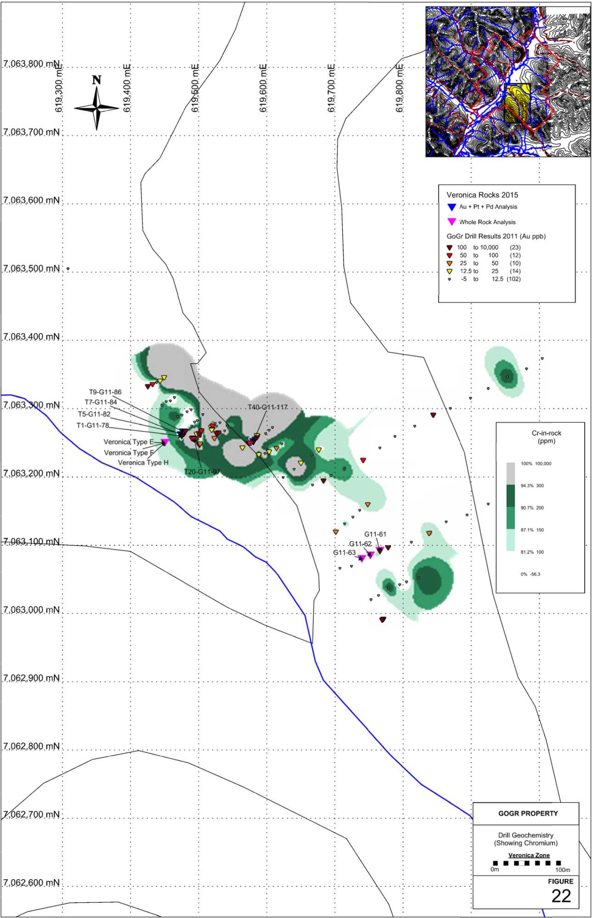

Figure 22: GoGr Project – Veronica Zone Drill Geochemistry: Cr
There is no significant PGE mineralization present in the samples tested. There appears to be significant variability in the gold results between the original and the verification sample. This is most likely due to a lack of sample homogeneity before sample splits were submitted for analysis.

9.3.1.2 Magnetic Susceptibility
A total of 158 rock samples from the 2011 power auger drill program were selected for magnetic susceptibility measurements. Results of the magnetic susceptibility measurements are shown in Figure 23 and 31. Sample measurements were as follows: All samples were measured on an empty plastic container that lifted the sample approximately 30cm above a table. A ZH instruments magnetic susceptibility meter (SM-30) (borrowed from YGS for this study) was used to make all measurements. A measurement consisted of a “zeroing” the meter while lying on the plastic container followed by a measurement of the sample when placed on the same surface. Magnetic susceptibility results can be found in Appendix 11.

Statistical values for magnetic susceptibility measurements are presented in Table 9. Background measurements as well as weak and strong anomalies cut-offs were established using box plots. Defining Q1 and Q3 to be the first and third quartile and IQR to be the interquartile range (Q3 – Q1), the background concentration cutoff is defined as: background < Q3 + (1.5*IQR); A strong anomaly is defined as: > Q3 + (3*IQR) and < Q1 – (3*IQR), respectively. A weak positive and negative anomaly is defined as greater than the background but less than a strong anomaly.

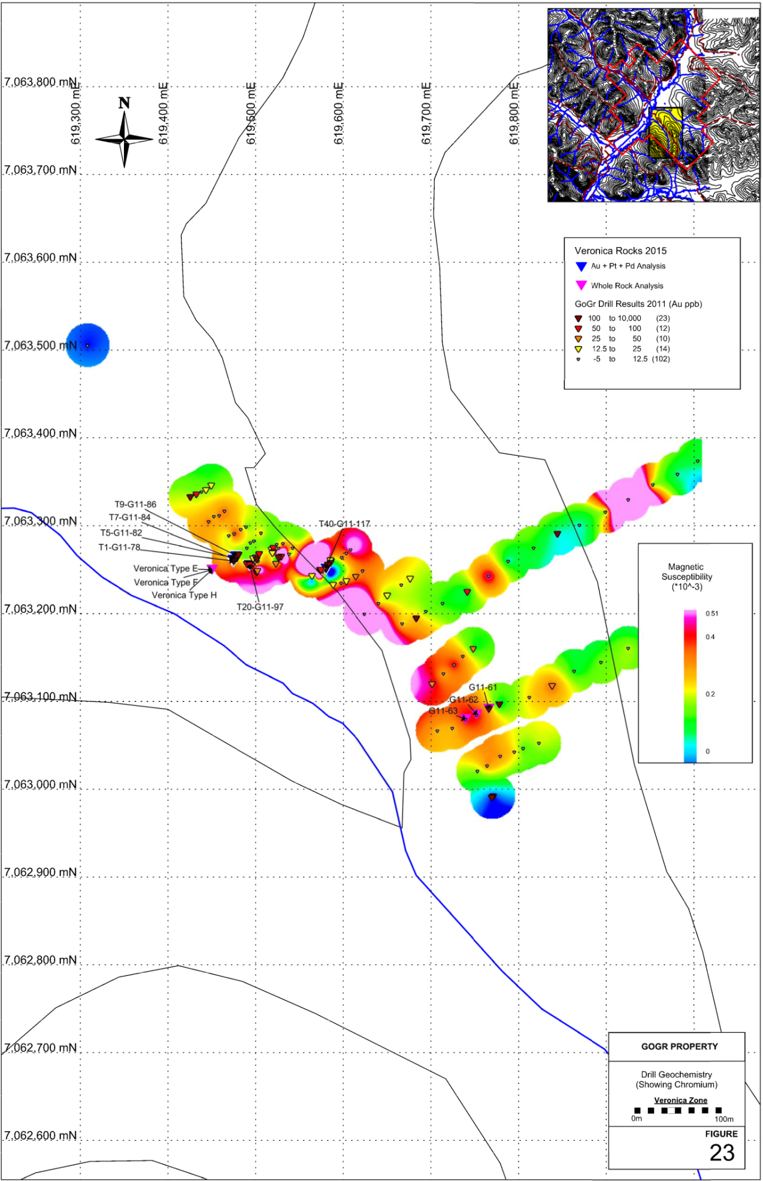

Figure 23: GoGr Project – Veronica Zone Magnetic Susceptibility Response
Table 9. Veronica Zone: Magnetic Susceptibility Statistical values for 2011 Drill Samples
Magnetic Susceptibility
(•10⁻³)
Min | 0.0642
Max | 6.56
Average | 0.30706772
Q1 | 0.1725
Median | 0.2305
Q3 | 0.3015
IQR | 0.129
Background | 0.495
SP. Anomaly | 0.6885
60 %ile | 0.262
70 %ile | 0.2889
80 %ile | 0.3166
90 %ile | 0.3724
95 %ile | 0.4759
There appears to be a spatial relationship between magnetic susceptibility highs and gold mineralization in the Veronica Creek area.

9.3.1.3 Whole-Rock Chemical Analysis
Six samples were collected from the Veronica Creek Zone and submitted for whole rock, major and trace element analysis. These samples were analyzed at Bureau Veritas Commodities via their LF200 package, Total Whole Rock Characterization.

Three rocks were selected from the 2011 power auger drill program and three rocks collected from the surface were selected. The goal of this study was to begin characterizing the rocks of the Veronica area. The analytical certificates of the whole rock analysis are given in Appendix 10. Complete sample compilation for whole rock analyses can be found in Appendix 6, and are shown in Figures 21 and 22.

The first step in classifying the green mafic (chlorite-actinolite-epidote) schists of the Veronica zone is choosing a discrimination diagram that identifies volcanic rock type (the presumed protolith of this mineral assemblage), even when the volcanic rock is highly altered. The IUGS (International Union of Geological Sciences) recommended classification diagram is the TAS (total alkali-silica) diagram. The TAS diagram is based on two axes: one (Na₂O + K₂O) a measure of alkalinity and the other (SiO₂) a measure of degree of fractionation (evolution) of the magma. In another words the TAS diagram uses the highly mobile elements K, Na and Si for rock classification. Floyd and Winchester (1978) showed that NB/Y (ppm) versus Zr/Ti (ppm) diagram provides an alteration-insensitive equivalent to the TAS diagram. Samples are plotted on both discrimination diagrams Figures 24 and 25 and summarized in Table 10.

Table 10. Veronica Rock types based on TAS and Nb-Y-Zr-Ti discrimination diagrams
Sample | TAS | Zr/Ti vs.  Nb/Y | Magnetic Susceptibility  (•10⁻³)
G11-61 | Basaltic Andesite | Basaltic Andesite | 0.3
G11-62 | Basalt | Basaltic Andesite
  0.41
G11-63 | Dacite | Andesite | 0.412
Veronica Type E | Trachy-andesite | Andesite | 0.256
Veronica Type F | Basalt | Basaltic Andesite | 0.372
Veronica Type H | Basaltic Andesite | Basaltic Andesite | 0.476

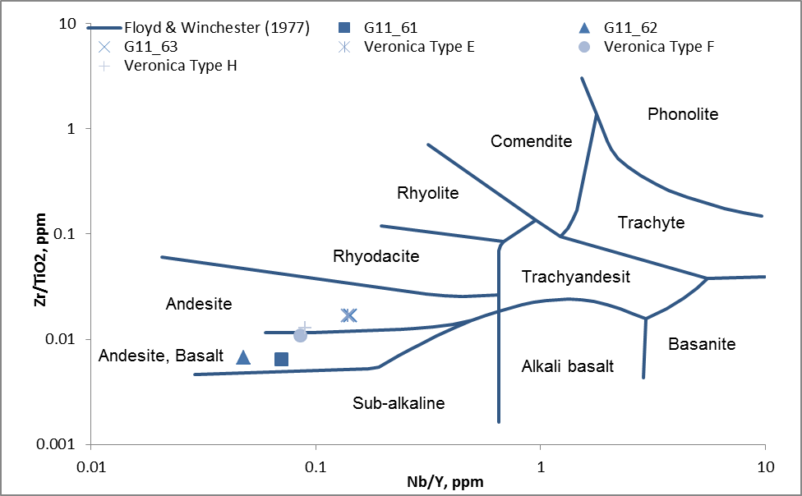

Figure 24: TAS Discrimination Diagrams for 2015 Veronica Zone Samples
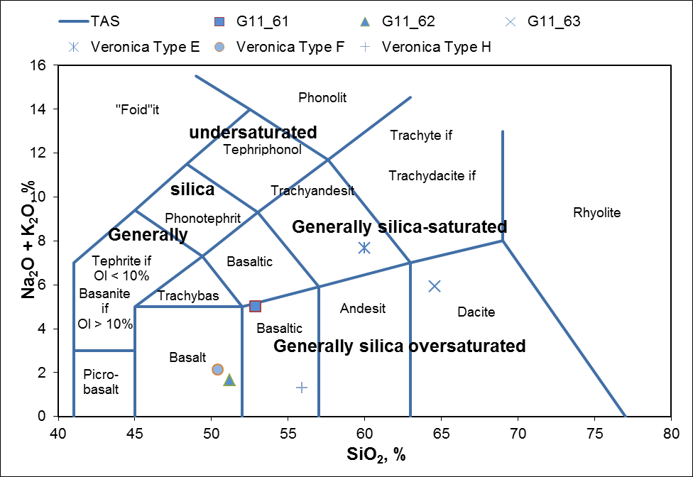

Figure 25: Nb-Zr-Ti-Y Discrimination Diagram for 2015 Veronica Samples

The TAS discrimination diagram shows much wider variety of rock types than the Nb-Zr-Ti-Y discrimination diagram. Taking into consideration the proximity of the samples taken to each other and that the REE E-morb normalized plots (Figure 24) form a tight group, it becomes easier to suggest that the Nb-Zr-Ti-Y discrimination diagram better predict the protolith rock type of these samples than the TAS diagram. This suggests that there has been a moderate amount of silica alteration to samples G11-63 and Veronica Type-E and Na-K alteration to G11-63, Veronica Type-E and G11-61. The REE plot in Figure 26 also suggests that the protolith to these rocks was formed in an E-Morb setting.

Figure 26: REE Plot for Veronica 2015 Samples

9.3.1.3 Petrographic Analysis

Five Veronica “type” samples were submitted for thin section preparation and subsequent mineral identification. While detailed petrographic analysis was not conducted, a basic mineral identification summary is provided in Table 11 and Photomicrographs can be found in Appendix 9.

Table 11: Veronica Rock Types: Mineral Assemblages
Sample | Petrographic  Minerals
VRJT-4A | Q, M, Bi Chl,
Veronica Type C | Stilp Q, Chl, Act, Ep
Veronica Type E | Q, Chl, Act, Ep
Veronica Type F | Chl, Act, Ep, Q
Veronica Type H | Ep, Act, Chl, Cal, Q

9.3.2 IP target Zone
In 2011, James Christie carried out an IP survey that identified a strong chargeability anomaly on a gently sloping hillside between Rob Roy and Eagle Creeks (see exploration history). This chargeability anomaly was followed up with an 82 site power auger drill program in 2014. Most holes went to depths between 30 and 40 feet, with the exception of one hole that went to a depth of 70 feet. Drill cuttings were collected whenever there was a noticeable change in the material making it to surface and at the end of the hole.

During the 2015 exploration season end-of-hole samples from the 2014 power auger drilling were analyzed by using a portable XRF (Olympus Innov-X Delta Premium XRF). Samples were dried and transferred into a thin plastic bag (Glad Sandwich Bag) and placed into the XRF work station and analyzed under a 3 beam SOIL setting of 30:30:30. Drill locations and XRF results can be found in Appendix 5.

Statistical values for Ni-, Cr-, As-, Pb-, Zn- and Cu-in-rock are presented in Table 12. Background concentrations as well as weak and strong anomaly concentration cut-offs were established using box plots. Defining Q1 and Q3 to be the first and third quartile and IQR to be the interquartile range (Q3 – Q1), the background concentration cutoff is defined as: Background < Q3 + (1.5*IQR); A strong anomaly is defined as: Strong anomaly > Q3 + (3*IQR). A weak anomaly is defined as greater than the background but less than a strong anomaly.

A total of 29 end-of-hole samples were submitted to Bureau Veritas Laboratories for gold analysis with the aim of submitting the rest in the future. Samples received by the commercial lab were crushed, split and pulverized to 200mesh (0.074mm). From the sieved fraction 30 grams were acid digested and analyzed with by ICP-MS for gold (AQ130-IGN). XRF results for Ni-, Cr-, Cu-, Zn- and Au-in-rocks and –soil are shown in Figures 27 to 30. The certificate of analyses can be found in Appendix 10 with XRF sample compilation presented in Appendix 5.

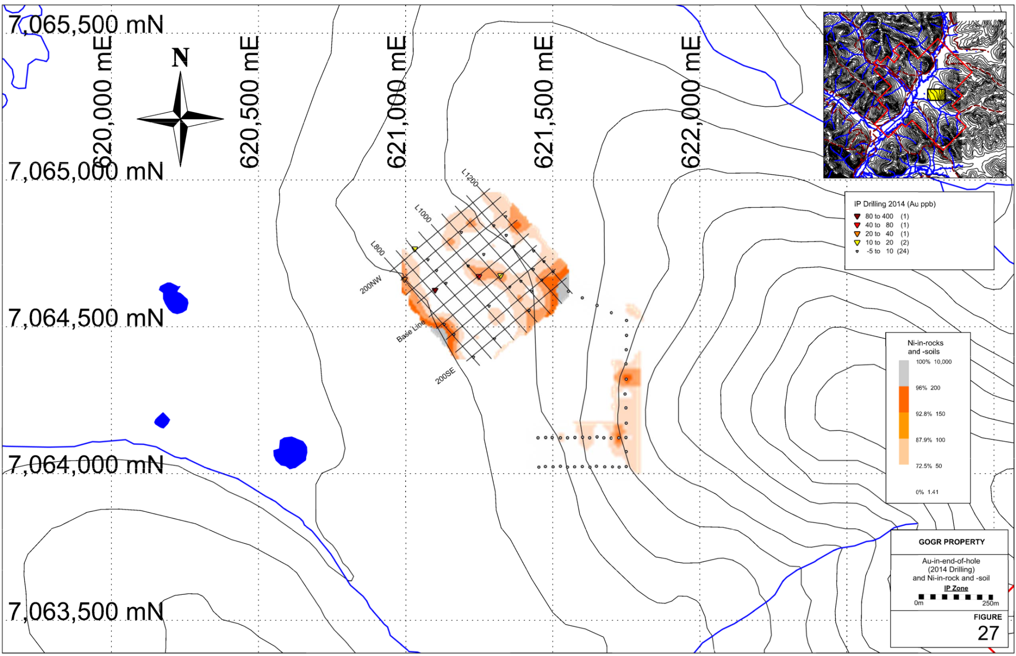

Figure 27: GoGr Project – IP Zone Gold in Drillhole with Ni-in-Soils

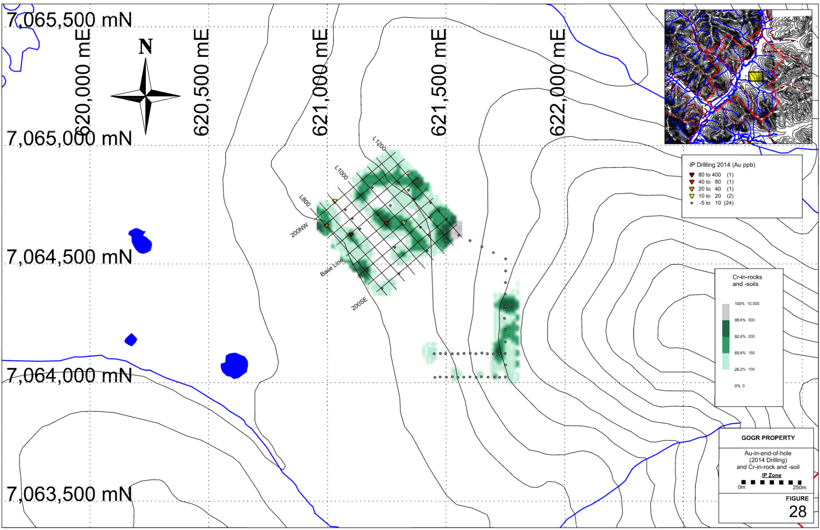

Figure 28: GoGr Project - IP Zone Gold in Drillhole with Cr-in-Soils

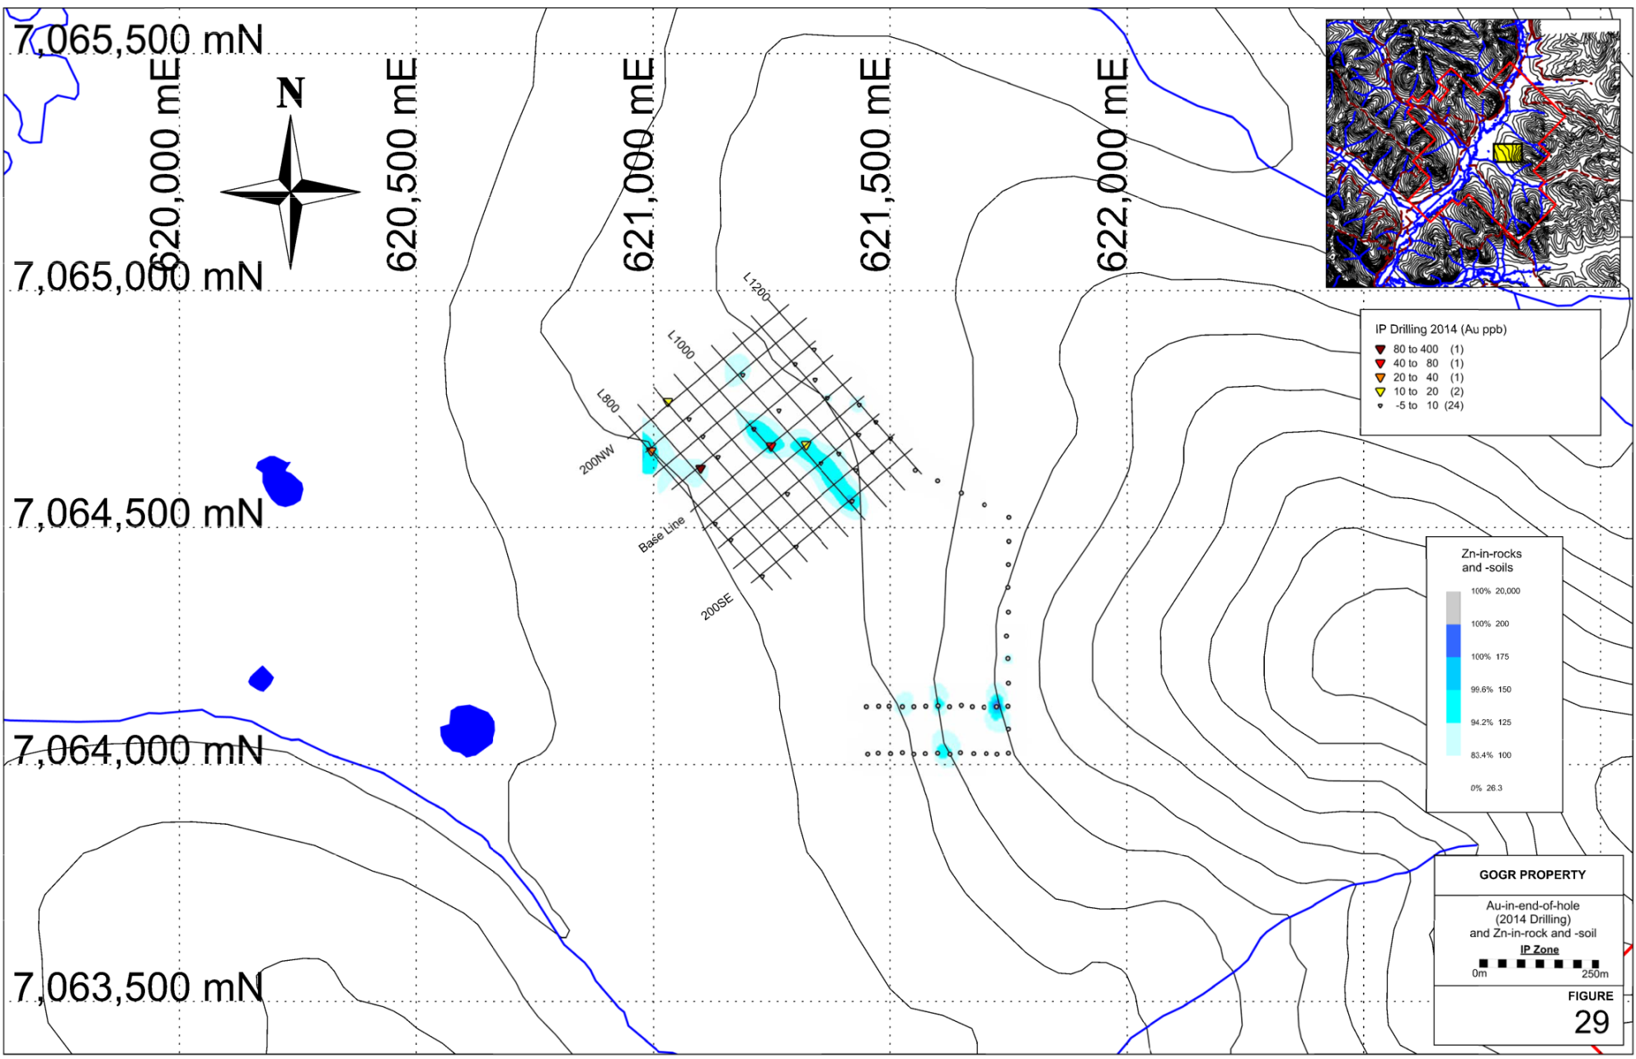

Figure 29: GoGr Project - IP Zone Gold in Drillhole with Zn-in-Soils

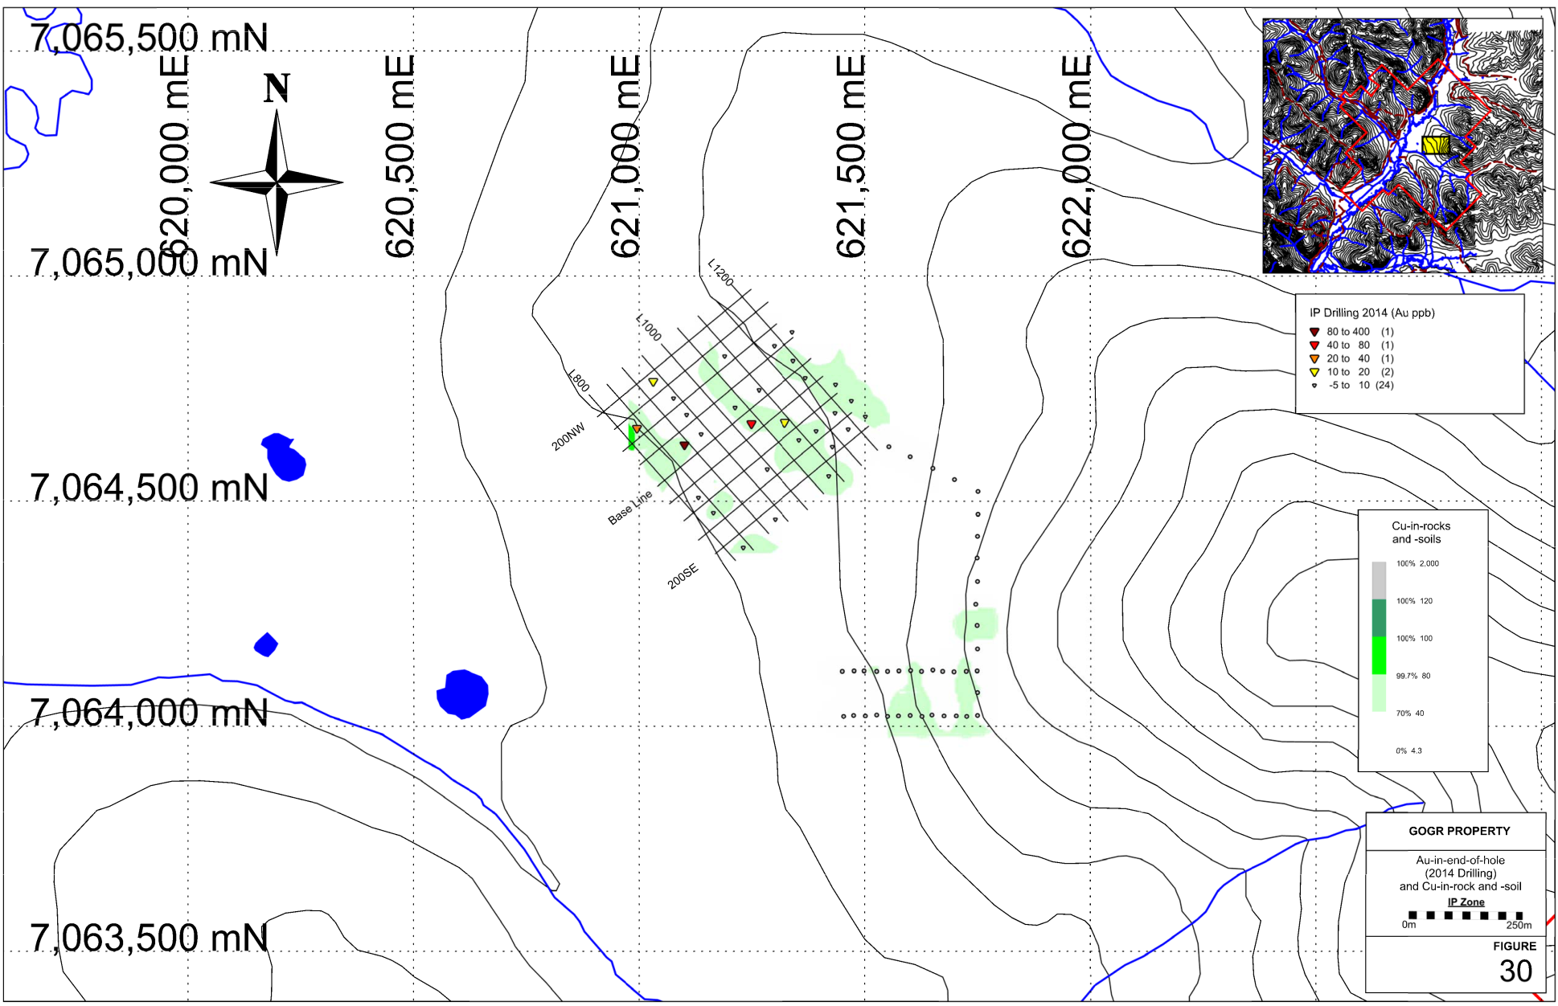

Figure 30: GoGr Project - IP Zone Gold in Drillhole with Cu-in-Soils

Table 12: IP Area: XRF Statistical values for Ni-, As-, Pb-, Zn-, and Cu-in-rock
 | Ni (ppm) | Cr (ppm) | As (ppm) | Pb (ppm) | Zn (ppm) | Cu (ppm)
Max | 93 | 343 | 72.7 | 43.5 | 170 | 75
Min | <10 | 30 | <5 | <5 | 26.3 | <10
Average | 22.05 | 132.05 | 9.435 | 12.83125 | 81.81625 | 32.3625
Media | 15.5 | 135 | 6.5 | 11.8 | 73.5 | 32
Q1 | 6.75 | 84.75 | 3.025 | 8.55 | 63 | 18.75
Q3 | 32.25 | 154.75 | 10.475 | 14.55 | 92.25 | 43.25
IQR | 25.5 | 70 | 7.45 | 6 | 29.25 | 24.5
Background | 70.5 | 259.75 | 21.65 | 23.55 | 136.125 | 80
S. Anomaly | 108.75 | 364.75 | 32.825 | 32.55 | 180 | 116.75
50 %tile | 15.5 | 135 | 6.5 | 11.8 | 73.5 | 32
60 %tile | 23 | 141.4 | 7.48 | 12.84 | 79.6 | 36.8
70 %tile | 30.3 | 151 | 8.88 | 13.99 | 90 | 40.3
80 %tile | 38.2 | 163.2 | 11.24 | 16.76 | 95 | 49.2
90 %tile | 56.1 | 213.5 | 19.19 | 19.21 | 128.6 | 55.1
95 %tile | 67.2 | 237.8 | 37.14 | 23.055 | 153.25 | 58.05

9.3.3 Gold Run Zone
In 2011, James Christie carried out an IP survey and power auger drill program on the west side of Gold Run creek. End-of-hole samples were collected and submitted to a commercial lab for gold analysis. Splits of the end-of-hole samples had there magnetic susceptibility measured in the 2015 exploration program and are shown in Figure 31. The magnetic susceptibility measurements indicate that rocks become more magnetic the closer they are to Gold Run creek. This observation is consistent with airborne magnetic data (Figure 32). There is no discernable spatial relationship between magnetic susceptibility measurements and gold-in-rock values.
A total of 12 surface-rock-chip samples were collected during the 2015 exploration program and submitted to Bureau Veritas Laboratories for gold analysis. Samples received by the commercial lab were crushed, split and pulverized to 200mesh (0.074mm). From the sieved fraction 0.5 grams and 30 grams were digested in separate aqua regia solutions and analyzed with by ICP-ES (for multi-element / AQ300) and ICP-MS (for gold / AQ130-IGN). One sample returned anomalous gold (341.4 ppb - GOHK-5). Rock sample locations are shown in Figure 31 and the certificate of analyses can be found in Appendix 6. The certificate of analyses for these samples can be found in Appendix 10.

9.4 Ground-Mag Geophysical Survey
A ground magnetic survey was carried out in the IP area of the GoGr property. The ground survey was carried out over the chargeability anomaly identified in the 2011 IP/Resistivity survey. The mandate of the ground magnetic survey was to determine if the chargeability anomaly also had a resolvable magnetic signature. A government airborne magnetic survey was carried out in 2001 (GSC Open File 4308) with a line spacing of 500m the resolution in this survey could not identify a magnetic feature that corresponds to the chargeability anomaly. The residual magnetic field for the magnetic airborne survey is shown in Figure 32 with the GoGr claim outline shown and the position of the IP survey line and chargeability anomaly.
Figure 33 shows the IP area with residual total magnetic field from the airborne survey (Figure 33a) and the residual total magnetic field from the ground survey carried out during the 2015 field season overlain on the residual total magnetic field from the airborne survey (Figure 33b). From comparison of Figure 33a and 33b it can be noted that the ground survey has identified a magnetic anomaly between flight-path lines (IP Zone) and that there are subtle magnetic linear features that are only detectable in the detailed ground mag surveys.
Statistical values for the residual magnetic field are presented in Table 13. Magnetic high and low anomalies were defined as those values more than the 90th percentile and less than 10th percentile, respectively.

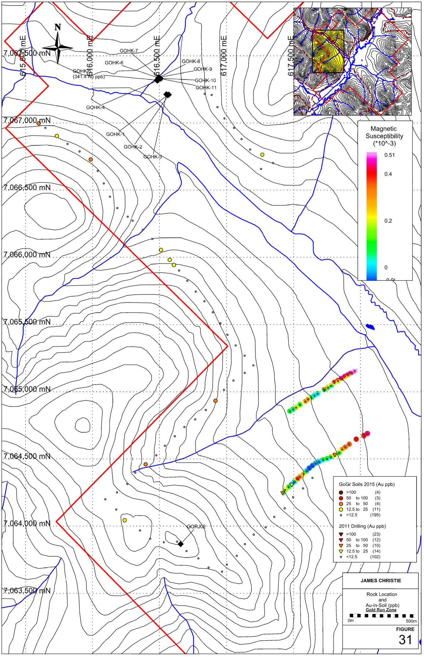

Figure 31: GoGr Project – Gold Run Zone Rock Location Au-in-Soil with Magnetic Susecptibility

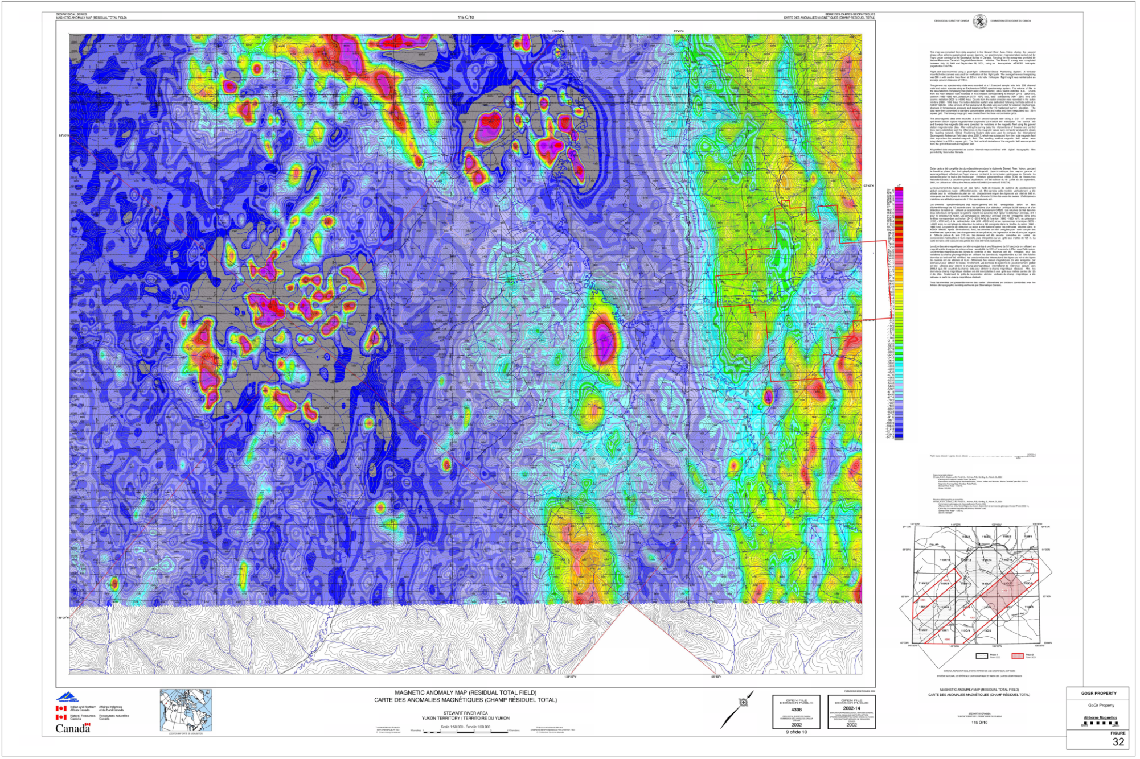

Figure 32: GoGr Project - Residual Total Field Magnetic Anomaly Map – after OF 2001-8
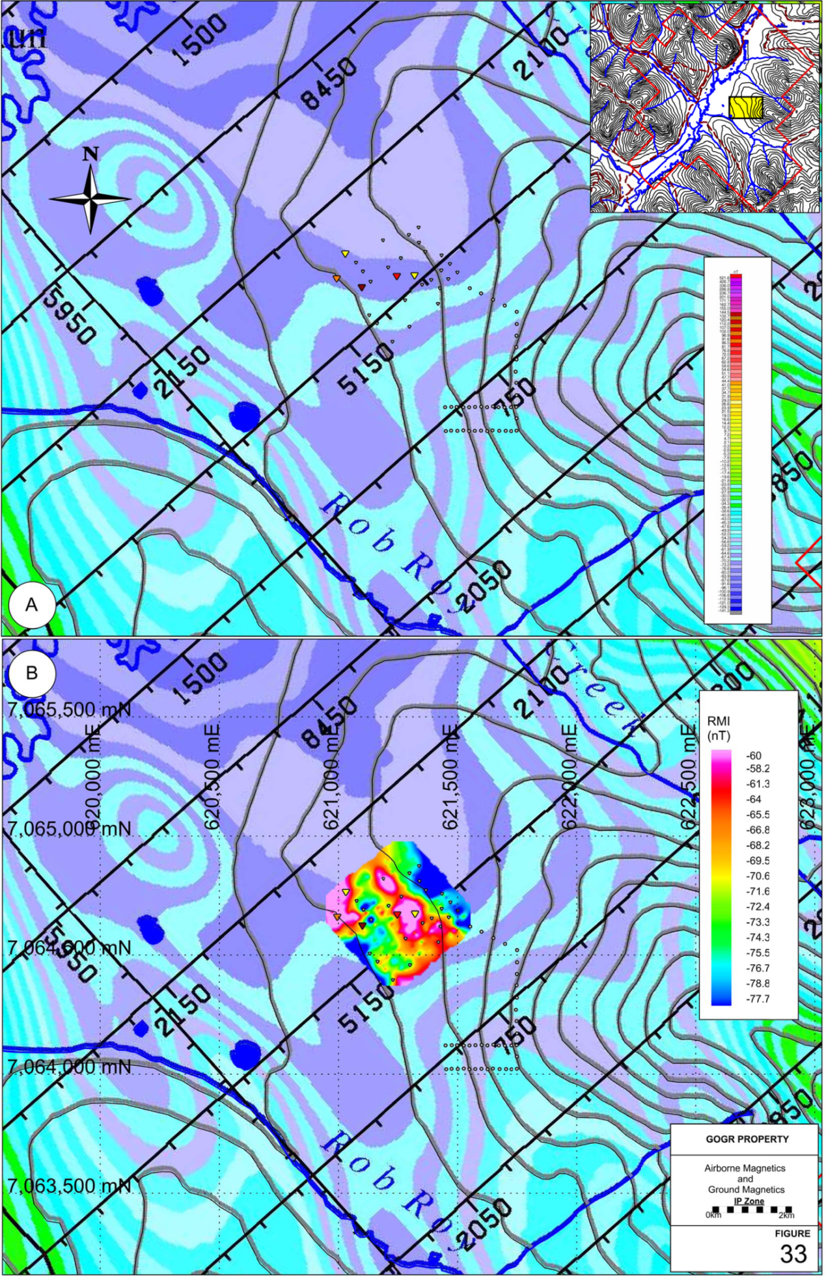

Figure 33: GoGr Project – IP Zone Residual Total Field Magnetic Anomaly Map – after OF 2001-8
Table 13: GoGr Property: Residual Magnetic Field Statistics
 | RMF (nT)
Min | -87.29
Max | -42.7
Average | -69.5193
5%ile | -79.556
10 %ile | -77.716
Q1/25 %ile | -74.17
Q2/50 %ile | -70.92
Q3/75 %ile | -65.565
90 %ile | -59.958
95 %ile | -56.1355

Grid Information
A total magnetic field surveys was carried out in the IP area. The power auger drilling grid made in 2014 was used to carry out the survey. The grid consists of 9 parallel lines 400m in length and spaced 50m apart. Station spacing was on average every 12.5m along these cut lines. There were 330 individual station readings covering an area of 0.16km².

Survey Parameters and Instrumentation
The magnetic survey utilized a stationary base unit to record the magnetic field to allow for the removal of the diurnal variation in the measured data. The base station recorded data at 3 second intervals. The mobile units recorded the total magnetic field every 12.5m alone the grid line traverses. Calibration measurements were taken by the mobile units at the start and end of each day to account for level shifts between the different instruments and to get a sense of the error in the data. The physical location of the base station and the calibration station are 561808594859E/7062541N and 618078E/7062524N, respectively.

Geophysical Techniques – Magnetic Survey Method
Magnetic intensity measurements are taken along survey traverses and are used to identify metallic mineralization related to magnetic material in the ground (e.g., magnetite and/or pyrrhotite). Magnetic data are also used as a mapping tool to distinguish rock types and to identify faults, bedding, structure and alteration zones. Line and station intervals are usually determined by the size and depth of the exploration targets.

The magnetic field has both amplitude and direction. The most common technique used in mineral exploration is to measure just the amplitude component using an overhauser magnetometer. The instrument digitally records the survey line, station, total magnetic field and time of day at each station. After each day of surveying, data are downloaded to a computer for archiving and further processing.

The earth’s magnetic field is continually changing (diurnal variations) so field measurements are calibrated to these variations. The most accurate technique is to establish a stationary base station magnetometer to continually monitor and record the magnetic field over the course of a day. The base station and field magnetometers are synchronized on the basis of time and computer software is used to correct the field data for the diurnal variations.

Data Processing – Acquisition and Quality Assurance Measures
On each day of surveying, geophysical and location information was dumped to external computers for archiving and data processing. Initial quality control of the data was completed by the survey crew at the camp for final quality control, processing and mapping.

Location information measured in the field (ground distances, slopes, azimuths, and GPS control points) are imported into a database. Within the database, automatic calculations are performed to generate UTM coordinates for every survey station. A visual review can then be performed to verify the locational information.

The Magnetic data is corrected for diurnal variation using the following formula:

Data_{res}=Data_{raw}−Data_{base}

where Data_{res} is the residual corrected data, Data_{raw} is the raw data from the mobile magnetometer, Data_{base} is the base station reading for the same time period. In the final spreadsheet, suspect or poor quality points are flagged and removed. Calibration readings are verified to ensure the morning and afternoon readings are within set tolerances to determine instrumentation repeatability and noise of operator. In addition, any static shifts (differences) between multiple the instruments or even between the different days can be corrected for.

Equipment – GSM-19 Overhauser combination Magnetometer & VLF-EM

Resolution: 0.01 nT, magnetic field gradient
Accuracy: 0.2 nT over operating range
Range: 20,000 to 120,000 nT
Gradient Tolerance: Over 10,000 nT/meter
Reading: Initiated by keyboard depression, external trigger or carriage return via RS-232C
Input/Output: 6 Pin weatherproof connector, RS-232C, and optional analog output
Power Requirements: 12V 200 mA peak (during polarization)
30 mA standby
300 mA peak in gradiometer
Power Source: Internal 12V, 1,9 Ah sealed lead-acid battery standard, other optional
External 12V power source can be used
Battery Charger: Input: 110/220V AC, 50/60 Hz and/or 12V DC
Output: 12V dual level charging
Oper. Temperature: -40C to 60C
Battery Voltage: 10V min. to 15V max.

DISCUSSION AND CONCLUSIONS

The 2015 GoGr Project mineral exploration program was successful in completing detailed geological, geochemical and geophysical surveys over three target areas of the project, the IP, GoldRun and Veronica Zones. The YMEP funded program concentrated on expanding in-the-field coverage of the known anomalous zones and built up a baseline of geological information (geochemical and geophysical) for future exploration initiatives on the Project.
XRF Instrumentation proved to be a reliable exploration tool for identification of potentially mineralized structures and should be utilized to augment all exploration going forward on the GoGr Project. Moreover, ground magnetic surveys also were demonstrated to be a useful exploration tool towards the identification of structural trends and lithological boundaries.
Follow-up soils surveys should focus on determination of soil profiles on each of the target areas and utilize a powered auger to increase sample collection depth – this will allow for the review of sample depth in relation to element analysis.
Targeted follow-up exploration work by systematic soils and rock sampling programs involving access construction, extended and in-fill soil sampling, trenching is warranted.
Continued, ridge and spur based soil geochemical surveys across the Property are strongly encouraged as there is high potential to discover additional mineralized zones and structures.
The GoGr Project lies within an area well known for placer gold deposits, the lode source of which has never been determined, and as such, offers an intriguing Project for prospecting and more advanced mineral exploration programs. The 2015 program has begun, baseline type data collection for the Project area, and in the process has defined multiple soil anomalies which require further exploration.

RECOMMENDATIONS

- Follow-up program of grid based soil sampling to extend the Veronica, IP and GoldRun soil anomalies and grids to the North, East, West and South on 50m spaced lines on 25 m centres.

- Target regional airborne magnetics low that transects the centre of the Project with soils and ground based magnetics to delineate mineralization potential of linear

- Follow-up base metals anomalies with tight soils grid and ground prospecting

- Continued usage of XRF Instrumentation as exploration tool

- Power auger soil sampling program (full soil profile analysis) – correlation to hand auger results

- Future geochemical programs should focus on nickel, copper, zinc and chromium as a primary vector to Au mineralization along with Au geochemistry

- The Veronica Zone is the highest priority target and Ni and Cr should be used as pathfinder elements for all exploration programs

- Additional and extended petrographic analysis of collected hand samples with sulphide mineralization

- Detailed review of soil transport directions on targets areas – downslope/cross slope movement

- Property wide Terrain Suitability Analysis (with soils compilation analysis)

- Reinterpretation of structures from the available airborne datasets

- Ground Magnetics grid extensions

- Access construction – exploration trails (quad) for Mack Zone ingress

- Completion of Ridge and Spur style exploration of remaining portions of project

Respectfully submitted,

_______________________
Paul D. Gray, P.Geo.
Vancouver, British Columbia
January 31, 2016

Appendix 1: References

REFERENCES

Allan, M.M., Hart, C.J.R., and Mortensen, J.K. (eds.), 2012, Yukon Gold Project Final Technical Report, Mineral Deposit Research Unit, University of British Columbia, 196 p.
Allan, Murray M., Mortensen, J.K., Hart, Craig J.R., Bailey, Leif A., Sanchez, Matias G., Ciolkiewics, Witold, McKenzie, Greg G. and Creaser, Robert A,. 2013. Magmatic and Metallogenic Framework of West-Central Yukon and Eastern Alaska, Society of Economic Geologists, Inc. Special Publication 17, pp. 111–168
Chapman, R., Mortensen, J., Crawford, E., and Lebarge, W., 2010a, Microchemical studies of placer and lode gold in the Klondike district, Yukon, Canada: 1. Evidence for a small, gold-rich, orogenic hydrothermal system in the Bonanza and Eldorado Creek area: Economic Geology, v. 105, p.1369–1392.
—— 2010b, Microchemical studies of placer and lode gold in the Klondike district, Yukon, Canada: 2. Constraints on the nature and location of regional lode sources: Economic Geology, v. 105, p. 1393–1410.
Christie J.S. and T.M., 2011. Final report for a target evaluation program on the GO - GR - RR quartz claims, YMIP 2011-016.
Armstrong, RL. 1988. Mesozoic and early Cenozoic magmatic evolution of the Canadian Cordillera. In: Clark, S.P., Burchflel, B. and Suppe, J., (eds.): Processes in continental lithospheric deformation. Geol. Soc. Amer. Special Paper 218 p. 55-91.

Beranek, L.P. and Mortensen, J.K. 2011. The timing and provenance record of Late Permian Klondike Orogeny in northwestern Canada and are-continent collision along western North America. Tectonics, in press.

Chapman, R.J., Mortensen, J.K., Crawford, E.C. and LeBarge, W.P. 2010. Microchemical studies of placer and lode gold in the Klondike District, Canada: 2. Constraints on the nature and location of regional lode sources. Economic Geology 105: 1393-1410.

Colpron, M. 2001. Geochemical characterization of Carboniferous volcanic successions from YukonTanana terrane, Glenlyon map area (105L), central Yukon. In: Yukon Exploration and Geology 2000, D.S. Emond and L.H. Weston (eds.), Exploration and Geological Services Division, Yukon, Indian and Northern Affairs Canada, p. 111-136.

Cox, S.F. 1999. Deformational controls on the dynamics of fluid flow in mesothermal gold systems. In., McCaffrey, K.J.W., Lonergan, L. and Wilkinson, J.J. (eds.) Fractures, fluid flow and mineralization. Geological Society of London, Special Publications, 155, 123-140.

D'el-Rey Silva, L.J.H., Liverton, T., Paradis, S. and Roots, C. 2001 a. A structural analysis of the upper Swift River area (105B/3), Yukon, Part I: Dan Zn occurrence and implications for sulphide mineralization In: Yukon Exploration and Geology 2000, D.S. Emond and L.H. Weston (eds.), Exploration and Geological Services Division, Yukon, Indian and Northern Affairs Canada, p. 289-300.

D'el-Rey Silva, L.J.H., Liverton, T., Roots, C. and Paradis, S. 2001b. A structural analysis of the upper Swift River area (I 05B/3), Yukon, Part II: the TBMB claims and implications for the regional geology. In: Yukon Exploration and Geology 2000, D.S. Emond and L.H. Weston (eds.), Exploration and Geological Services Division, Yukon, Indian and Northern Affairs Canada, p. 301-310.

Dumula, M.R. and Mortensen, J.K. 2002. Composition of placer and lode gold as an exploration tool in the Stewart River map area, western Yukon. In: Yukon Exploration and Geology 2001, D.S. Emond L.H. Weston and L.L. Lewis (eds.), Exploration and Geological Services Division, Yukon Region, Indian and Northern Affairs Canada, p. 87-102.

Dusel-Bacon, C., Wooden, J.L. and Hopkins, M.J. 2004. U-Pb zircon and geochemical evidence for bimodal mid-Paleozoic magmatism and syngenetic base-metal mineralization in the Yukon-Tanana terrane Alaska. Bulletin of the Geological Society of America, 116: 989-1015.

Groves, D.I., Goldfarb, R.J., Robert, F. and Hart, C.J.R 2003. Gold deposits in metamorphic belts: Overview of current understanding, outstanding problems, future research, and exploration significance. Economic Geology, 93: 1-29.

Hart, C.J.R., Baker, T. and Burke, M. 2000. New exploration concepts for country-rock-hosted, intrusionrelated gold systems: Tintina Gold belt in Yukon. 145-171. In: The Tintina Gold Belt: Concepts, Exploration, and Discoveries. Special Volume 2, Cordilleran Roundup January 2000, British Columbia and Yukon Chamber of Mines.

Hart, C.J.R., Goldfarb, R.J., Lewis, L.L. and Mair, J.L. 2004. The northern mid-Cretaceous plutonic province: ilmenite/magnetite series granitoids and intrusion-related mineralization. Resource Geology, 54 (3): 253-280

Hoymann, K.-H., 1989. Gold and sulfide mineralization in the Hunker Creek area, Yukon Territory, Canada. Thesis from the Institut fur Mineralogie and Lagerstattenlehre, RTWH Aachen.

Knight, J.B., Morison, S.R. and Mortensen, J.K. 1999. The relationship between placer gold particle shape rimming, and distance of fluvial transport as exemplified by gold from the Klondike district, Yukon Territory, Canada. Economic Geology, 94: 635-648.

Knight, J.B., Morison, S.R. and Mortensen, J.K. 1999. Lode and placer gold composition in the Klondike district, Yukon Territory, Canada: Implications for the nature and genesis of Klondike placer and lode gold deposits. Economic Geology, 94: 649-664.

Kreft, Bernie., 2010. Trenching and Sampling Report on the GR 1-44 Quartz Claims.

Lindsay, M.J., Baker, T., Oliver, N.H.S., Diment, R and Hart, C.J.R 2000. The magmatic and structural setting of the Brewery Creek gold mine, central Yukon. In: D.S. Emond and L.H. Weston (eds.): Yukon Exploration and Geology 1999. Exploration and Geological Services Division, Yukon, Indian and Northern Affairs Canada, p. 219-227.

Liverton, T., Mortensen, J.K. and Roots, C.F. 2005. Character and metallogeny of Permian, Jurassic and Cretaceous plutons in the southern Yukon-Tanana Terrane. In: Yukon Exploration and Geology 2004. D.S. Emond, L.L. Lewis and G.D. Bradshaw L.H. (eds.). Yukon Geological Survey, p. 147-165.

Liverton, T., 2011. Geology and Summary of the Lonestar Claim Group (Klondike Goldfield), Yukon Territory. 43-101 Report.

MacKenzie, D.J., Craw, D., Mortensen, J.K. and Liverton, T., 2007. Structure of schist in the vicinity of the Klondike goldfield. In: Yukon Exploration and Geology 2006, D.S. Edmond, L.L.Lewis and L.H. Weston (eds.), Yukon Geological Survey, p. 197-212.

MacKenzie, D.J., Craw, D. and Mortensen, J. 2008a. Structural controls on orogenic gold mineralization in the Klondike goldfield, Canada. Mineralium Deposita, 43: 435-448.

MacKenzie, D., Craw, D. and Mortensen, J.M. 2008b. Thrust slices and associated deformation in the Klondike goldfields, Yukon. In: Yukon Exploration and Geology 2007, D.S. Emond, L.R Blackburn, R.P. Hill and L.H. Weston (eds.), Yukon Geological Survey, p. 199-213.

MacKenzie, D., Craw, D., Mortensen, J.M. and Liverton, T. 2008c. Disseminated gold mineralization associated with orogenic veins in the Klondike Schist, Yukon. In: Yukon Exploration and Geology 2007, D.S. Emond, L.R. Blackburn, R.P. Hill and L.H. Weston (eds.), Yukon Geological Survey, p. 215-234.

Mortensen, J.K., 1992: Pre-mid-Mesozoic tectonic evolution of the Yukon-Tanana terrane, Yukon and Alaska; Tectonics, v. 11, no. 4, p. 836-853.

Mortensen, J.K. 1996. Geological compilation maps of the Northern Stewart River map area, Klondike and Sixtymile districts. Indian and Northern Affairs Canada Yukon Region, Open File 1996-1 (G).

Mortensen, J.K., Chapman, R, LeBarge, W. and Crawford, E. 2006. Compositional studies of placer and lode gold from western Yukon: Implications for lode sources. In: Yukon Exploration and Geology 2005, D.S. Emond, G.D. Bradshaw, L.L. Lewis and L.H. Weston (eds.), Yukon Geological Survey, p. 247-255.

Mortensen, J.K., Nesbitt, B.E. and Rushton, R 1992. Preliminary observations on the geology and geochemistry of quartz veins in the Klondike district, west-central Yukon. In: Bremner, T.J. (ed.): Yukon Geology, Vol. 3. Exploration and Geological Services Division, Indian and Northern Affairs Canada, p. 260-270.

Nelson, J.L. and Friedman, R. 2004. Superimposed Quesnel (late Paleozoic-Jurassic) and Yukon-Tanana (Devonian-Mississippian) arc assemblages, Cassiar Mountains, northern British columbia: field, U-Pb, and igneous petrochemical evidence. Canadian Journal of Earth Sciences, 41: 1201-1235.

Nelson, J., Mihalynuk, M., Murphy, D.C., Colpron, M., Roots, C.F., Mortensen, J.K. and Friedman, RM. 2000. Ancient Pacific Margin: A preliminary comparison of potential VMS-hosting successions of the Yukon-Tanana Terrane, from Finlayson Lake district to northern British Columbia. In: Emond, D.S. and Weston, L.H. (eds.): Yukon Exploration and Geology 1999. Exploration and Geological Services Division, Yukon, Indian and Northern Affairs Canada, p. 79-86.

Piereey, S.J., Hunt, J.A. and Murphy, D.C. 1999. Lithogeochemistry of meta-volcanic rocks from YukonTanana trrane, Finlayson Lake region, Yukon: preliminary results. In: Roots, C.F. and Emond, D.S. (eds.): Yukon Exploration and Geology 1998. Exploration and Geological Services Division, Yukon, Indian and Northern Affairs Canada, p. 125-138.

Roots, C.F., Liverton. T. and Heaman, L. 2003. Geology and U-Pb zircon geochronology of Upper Dorsey assemblage near the TBMB claims, upper Swift River area, southern Yukon. In: Emond, D.S. and Lewis, L.L. (eds.): Yukon Exploration and Geology 2002. Exploration and Geological Services Division, Yukon, Indian and Northern Affairs Canada, p. 199-212.

Rushton, R.W., Nesbitt, B.E. and Mortensen, J.K. 1993. A fluid inclusion and stable isotope study of Au quartz veins in the Klondike district, Yukon Territory, Canada: A section through a mesothermal vein system. Economic Geology, 88: 647-678.

GSC Open File 1985-1: Bedrock Geology and Mineralization of the Klondike Area (East), 115O/9,10,11,14, 15,16 and 116B/2, Yukon, - by R.L. Debicki, Scale: 1:50,000 map with marginal notes.

GCS Open File 2001-8: Airborne geophysical survey, Stewart River area, Yukon Territory, NTS 115N/14 / Levé géophysique aérien, Stewart River area, Territoire du Yukon, SNRC 115N/14; Shives, R B K; Carson, J M; Ford, K L; Holman, P B; Gordey, S; Abbott, G. Geological Survey of Canada, Open File 3992, 2001, ; 10 sheets, doi:10.4095/212591.
Yukon Energy, Mines and Resources/YGS Website – http://www.emr.gov.yk.ca/mining/mapsdatapubs.html

Appendix 2: Statement of Expenditures

STATEMENT OF EXPENDITURES
GO PROJECT
September 6-September 13, 2015
November 12-18, 2015

Salaries:

J. Thom 14 days @ $400/day Soil Tech $4,800.00
P. Gray 1 day @ $500/day Geologist $ 500.00
H. Kuikka 5 days @ $275/day Geologist $1,375.00
J.S Christie 8 days @ $500/day Geologist $4,000.00
D. Christie 8 P/T days @ $150/day First Aid/ Camp/Logis. $1,200.00

Total Salaries $ 11,875.00

Travel (in Yukon) Vehicles, Flights, Fuel, Hotels, etc. $ 2,450.38

Analytical (Bureau Veritas – 277 samples) $6,597.90

Camp/Daily Field Expenses 33 person days @ $100.00/day $ 3,300.00

Contractors/Equipment Rentals
XRF rental 2,400.00
Mag 400.00
Thin Sections 125.00
Mag. susc, Lab XRF, and Thin section analysis – J. Thom 900.00

Report Writing – Printing/Graphics/Plots 6 days @ $500.00/day $3,000.00

TOTAL COSTS $31,048.28

Appendix 3: Claim Data

Appendix 4: Compiled Tabulated Results - Soils XRF

Appendix 5: Compiled Tabulated Results – Rock XRF

Appendix 6: Compiled Tabulated Analytical Results – Rocks Analytical

Appendix 7: Compiled Tabulated Results – Soils Analytical

Appendix 8: Compiled Tabulated Ground Magnetic Data

Appendix 9: Petrographic Summary Tables

Appendix 10: Certificates of Analysis

Appendix 11: Geophysical Survey Data

Appendix 12: Geologists Certificates

GEOLOGISTS CERTIFICATE

I, Paul D. Gray, P. Geo., do hereby certify:

THAT I am a Professional Geoscientist with offices at Suite 250 2237 2nd Avenue, Whitehorse, YT Y1A 0K7
THAT I am an author of the Technical Report entitled “2015 Geochemical Report on the GoGr Project” and dated January 30, 2016, relating to the GoGr Property (the “Assessment Report”). I personally oversaw the GoGr 2015 Program.
THAT I am a member in good standing (#29833) of the Association of Professional Engineers and Geoscientists of British Columbia.
THAT I am a graduate of Dalhousie University, Halifax, in the Province of Nova Scotia, with a Bachelor of Science degree (Honours) in Earth Sciences
THAT I have practised my profession as an exploration geologist in the mineral exploration industry continuously since 1997. I have worked on base, precious and industrial metals exploration projects as a geologist in Canada, the United States of America, Asia, and South and Central America.
THAT I am the Principal of PDG Geological Consultants
THAT I have read the definition of "qualified person" set out in National Instrument 43-101 ("NI 43-101") and certify that by reason of my education, affiliation with a professional association (as defined in NI 43-101) and past relevant work experience, I fulfill the requirements to be a "qualified person" for the purposes of NI 43-101.

Dated at Vancouver, British Columbia, this 31th day of January, 2016.

_____________________
Paul D. Gray, P. Geo.

GEOLOGISTS CERTIFICATE

I James G.M. Thom certify that:

1. I am a mineral exploration consultant residing at 118B West 14th Ave, Vancouver BC, V5Y 1W9 and can be contacted at thomjgm@gmail.com

2. I obtained a B.Sc. in Earth and Ocean Sciences at the University of Victoria [2002] and graduated with a M.Sc. in Geology from the University of Toronto [2003].

3. I have worked in the mineral exploration industry since 1999

4. I carried out (along with a Field Assistant) the 2015 exploration program described in this report

5. I regularly carry out ground magnetic surveys regularly for the mineral exploration industry and was responsible for the data correction and QA/QC for the ground magnetic data collected in this report.

6. I operated the portable XRF unit that was used in the data collection described in this report

Dated at Vancouver, British Columbia, this 31th day of January, 2016.

_____________________
James G.M. Thom, MSc.

