Dawson City, 16 October 2016

Geological and geophysical report about
Fox Property (Fox 1-13)
at California Creek.

Dawson District
Map Nr 116C01

Grant № P516225 - 37 (grouping#: GD01075)

First geophysical surveying: Dec. 20-21, 2015
Second surveying: Aug. 19 and Sept. 2, 2016
Third surveying: Oct. 12, 2016 and Oct. 16, 2016

Report written by:
Boris Logutov, geologist/geophysicist

Field-helper/Technician: Logutov Misha
Victor Gumovsky
Introduction

All these geophysical surveys were conducted by geophysicist/geologist Boris Logutov by using 2 different Ground Penetrating Radars (GPR): EasyRad Pro+ equipped with antennas of 100MHz and Zonda Phyton3 with antennas of 100 MHz; both radars are of Russian/Ucrainan/German construction.
The lines of geophysical surveying have been performed on the claims Fox 1-13 (P516225 – 37, grouping # GD01075), along 7 different cross-sections of California Creek, during periods included between Dec. 20 to Dec. 21 (2015), Aug. 19 - Sept. 2 (2016), and Oct. 12 - Oct. 16 (2016).
This survey required a total of 7 days of work and the employment of two people.

METHODOLOGY AND RESULTS OF THE GEOPHYSICAL CAMPAIGN.

A total of 7 lines of GPR (ground penetrating radar) were conducted during the field works, for a total length of 1,800 m; the distances between lines are approximately of 30 – 70 m. The actual location of the surveyed lines is visible on map named “picture #2” (see next pages). The original data of electro-magnetic survey are presented on CD (as attachment 2).
The coordinates of the surveyed lines are visible here below on Table 1.
The coordinates of the pits and tested areas are recorded on Table 2.

Table1.
Lines ## | Points of survey | Coordinates of the “start” and “end” points |  | Elevation of the points (m) .
1 | Start | 64 05 00 | 140 21 20 | 640
 | End | 64 04 50 | 140 21 19 | 638
2 | Start | 64 04 43 | 140 21 37 | 621
 | End | 64 04 33 | 140 21 37 | 615
3 | Start | 64 04 40 | 140 21 47 | 636
 | End | 64 04 39 | 140 21 36 | 649
4 | Start | 64 04 32 | 140 21 43 | 625
 | End | 64 04 28 | 140 21 43 | 625
5 | Start | 64 04 29 | 140 21 45 | 626
 | End | 64 04 19 | 140 21 44 | 619
6 | Start | 64 04 15 | 140 21 48 | 639
 | End | 64 04 19 | 140 21 29 | 635
7 | Start | 64 04 16 | 140 21 23 | 635
 | End | 64 04 05 | 140 21 22 | 597

Table 2
Pits ## | Coordinates |  | Elevation of the points (m) .
1 | 64 04 56 | 140 21 19 | 633
2 | 64 04 10 | 140 21 22 | 603

As already mentioned in the introduction, the Electro-magnetic survey was conducted by using GPR “Python” (during December 2015) and “EasyRad PRO+ (during the two campaigns of 2016), both devices were equipped with antennas for frequency of 100 MHz with resolution 0.2 m; the results of the survey was later analyzed by using software «Prizm 2.0; 2.5».
The effective depth of this survey is estimated to be up to 8.0 m.
The results of these conducted surveys confirmed the strong ability of recognition of the main lithological units at the radar’s-images such as:

«Permafrost»- thickness – 1.3 – 2.1 m;
«Overburden»- thickness 0.8-2.1 m;
«Alluvial»- thickness 1.1-7.6 m;
«Bedrock surface» – at the depth up to 7.6 m.

The results of the final interpretation and analysis of the received data of GPR surveys are presented in pictures 3; 4; 5; 6; 7; 8; 9.

Photos about working with radar and geomorphology are visible as pictures 10-18.

TEST PITS.

Three test pits were completed in the limits of the lines 1, 7. The pits have been dug to bedrock and were recorded and described from the top to the bottom: turf deposits with thickness 1.7 to 2.1 m, and alluvium with thickness 1.6-1.9m.
The alluvial deposits were tested by panning on site. Approximately 200 litres of gravel have been washed. The results of testing show a grad of the Au ranging between 0.9 and 1.6 g/cubic meter.
GEOLOGICAL MAP

Pic. 1
Map 116C01

LOCATION OF GEOPHYSICAL LINES AND TEST PITS

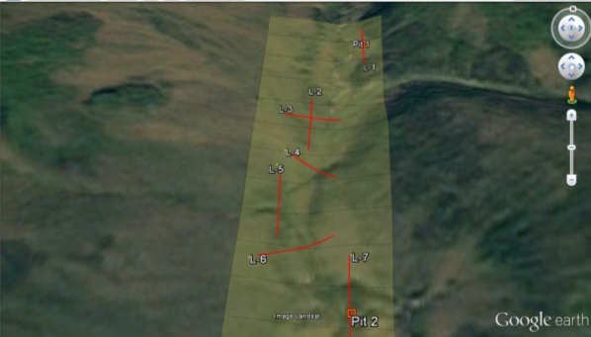
Pic. 2
GPR DIAGRAMS (CROSS-SECTIONS) AFTER INTERPRETATION

(depths and distances are well marked in meters)

Pic. 3
Pic. 4

Pic. 5
Pic.6

Pic. 7

Pic.8
Pic. 9

CONCLUSION

This geological-geophysical research was performed by geophysicist/geologist Boris Logutov with the help of two field-workers/technicians, along the existing Fox claims (1-13), a medium-size property staked along the central part of California Creek (Map 116C01). The campaign was conducted during three different periods (Dec. 20 – 21 of 2015, Aug. 19 - Sept. 2 of 2016, Oct. 12 - 16 of 2016).
The purposes of this campaign were:
- to collect reliable data from the GPR survey, regarding the depth and profile of bedrock.
- to analyze the different thickness of soil layers (overburden, gravel, presence of permafrost, clay, etc.).
- to evaluate the consistence of the Quaternary deposits along the different analyzed cross-sections.

The results of this geophysical survey are fully described in this report.

After conducting the geophysical survey, two test pits have been excavated along two different lines, in order to confirm the results derived by the geophysical/geological interpretation of Mr. Logutov. Both the pits confirmed the accuracy of the observations.
During the sampling campaign performed by panning on site the gravel extracted from the pits, fine gold has been found and recovered.
The good results obtained during this preliminary exploration campaign of 2015-16, are encouraging to plan a more extensive bulk-testing campaign to be conducted here at Fox Property during the next mining season (2017).

Boris Logutov, geophysicist/geologist
President of 47129 Yukon Inc.

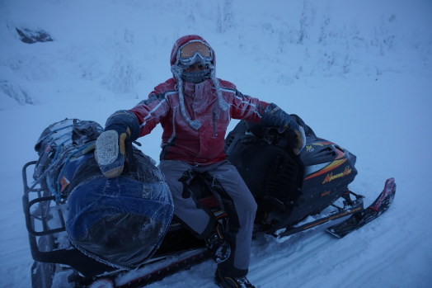
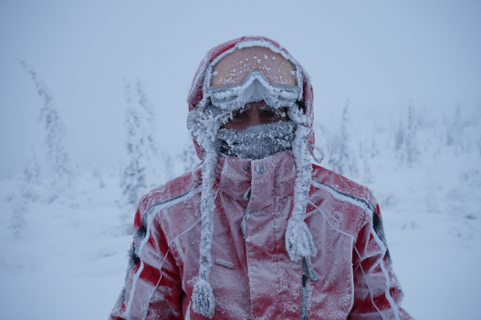
Dec. 2015

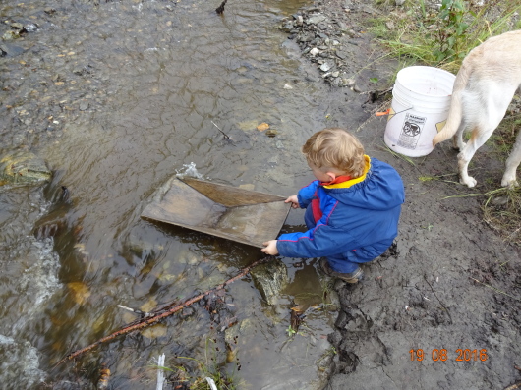

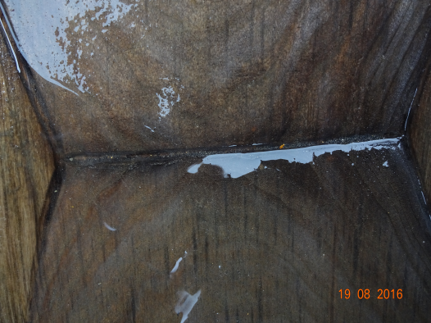
Aug. 2016

